
The Map of Mutual Cooperation Values Towards People’s Lifestyle
Vol. xx, No. x Tahun 20xx | xxx -xxx
(Peta Nilai Gotong Royong terhadap Pola Hidup Masyarakat)
Febriani^{1*}, Adhis Tessa², Ridho Utami¹, Wipsar Sunu Brams Dwandaru^{1**}
¹Physics Education Department, Faculty of Mathematics and Natural Sciences, Universitas Negeri Yogyakarta, Jl. Colombo No. 1, Yogyakarta, 55281, Indonesia
²Sociology Education Department, Faculty of Social Sciences, Universitas Negeri Yogyakarta, Jl. Colombo No. 1, Yogyakarta, 55281, Indonesia

Author Correspondence: Febriani.sandr@gmail.com*; wipsarian@uny.ac.id**

Article Information |  | ABSTRACT
History :  Accepted  Revision  Published | :  :  : | Mutual cooperation is a cultural value that becomes the identity and basis of the Indonesian nation. However, currently mutual cooperation underwent a shift that may affect the lifestyle of the Indonesian people, especially in this case of individualist lifestyle. The objective in this study is to study the map of mutual cooperation values in Tamanan village, Banguntapan, Bantul, Special Region of Yogyakarta (DIY). The research method used is qualitative and quantitative methods (i.e.: mixed methods). Qualitative and quantitative methods have been carried out through interviews and surveys with villagers in nine hamlets of Tamanan village. Based on the mutual cooperation map the results obtained from this study show that Kragilan, Kerobokan, and Glagah Kidul hamlets have the strongest mutual cooperation values, whereas Rejokusuman and Tamanan hamlets have the weakest mutual cooperation values. This shows that the strength of mutual cooperation does not depend on the proximity of the hamlets from the city of Yogyakarta. Moreover, the mutual cooperation map is reciprocal to the individualist lifestyle of the people in the hamlets, i.e.: the stronger the mutual cooperation values the weaker the individualist lifestyle of the people.
Keywords:
Mutual Cooperation Map, people’s lifestyle, individualist lifestyle

 |  | ABSTRAK
Kata Kunci:  Peta Gotong-Royong, pola hidup masyarakat, sifat individualis |  | Peta Nilai Gotong-Royong Terhadap Pola Hidup Masyarakat. Gotong-royong merupakan nilai budaya yang menjadi identitas dan dasar dari bangsa Indonesia. Akan tetapi, saat ini gotong-royong mengalami pergeseran yang berpengaruh terhadap pola hidup masyarakat Indonesia, khususnya dalam hal ini sifat individualis. Tujuan penelitian ini adalah mempelajari peta nilai gotong-royong di Kelurahan Tamanan, Banguntapan, Bantul, Daerah Istimewa Yogyakarta (DIY). Metode penelitian yang digunakan adalah metode kualitatif dan kuantitatif (metode campuran). Metode kualitatif dan kuantitatif telah dilakukan melalui wawancara dan survei dengan warga desa Tamanan di sembilan padukuhan desa Tamanan. Berdasarkan peta gotong-royong diperoleh hasil bahwa padukuhan yang paling kuat nilai gotong-royongnya adalah Kragilan, Kerobokan, dan Glagah Kidul. Sedangkan padukuhan dengan nilai gotong-royong yang paling lemah ada di Rejokusuman dan Tamanan. Hal ini menunjukkan kuat-lemahnya nilai gotong-royong tidak bergantung pada jauh-dekatnya letak padukuhan tersebut dari kota Yogyakarta. Selanjutnya, peta gotong-royong ini berbanding terbalik dengan peta sifat individualis dalam masyarakat, yakni semakin kuat nilai gotong-royong dalam masyarakat semakin lemah sifat indvidualis dalam masyarakat.
Copyright © 2018 Febriani, et al. All Right Reserved

Introduction

Indonesia was born on the basis of mutual cooperation. The philosophy of the Indonesian nation, which is contained in five precepts in the Pancasila can be squeezed into one term, namely mutual cooperation. Therefore, preservation of the mutual cooperation culture in the community should continue to be carried out to maintain the standing of the Republic of Indonesia. Mutual cooperation arises from the encouragement of awareness and enthusiasm to work and bear the consequences of a work together without regard to religion, ethnicity, and race simultaneously and in crowds, without thinking and prioritizing benefits for themselves (Efendi, 2013; Sudrajat, 2014).

Mutual cooperation is currently experiencing a shift in its values. This is caused by various social changes, such as the development of industrial technology and information as well as the increasingly complex activities level of society that influences the peopole’s lifesytle in the community itself. This shift occurs spatially from rural areas to urban areas. In urban areas the behavior of mutual cooperation is increasingly rare because the community submits work to an event organizer or a group that is paid to complete the work to make it more practical (Rochmadi, 2012). Thus, the mutual cooperation no longer uses people’s power (non-material), but is replaced by money (material) [Sari, 2015]. Of course, this has caused the public to increasingly indulge in individualist lifestyle that is not in accordance with the ideals of the founding fathers and consequently will weaken the state of the Republic of Indonesia, which is then vulnerable to disintegration.
Methods
This study uses a mixed method, namely qualitative and quantitative methods. The method is used because this study requires qualitative and quantitative analysis in drawing the conclusions. The model that has been used is a sequential exploratory model, where qualitative method is carried out first and then followed by the quantitative method. The qualitative method in this study uses a grounded theory data analysis approach, whereas the quantitative method uses a descriptive statistical data analysis approach.
The data collection technique is done in ways that are shared in the qualitative and quantitative methods together. In the capacity of the qualitative method, the data collection technique is carried out by interview, observation, documentation, and literature study. For the quantitative method, the data collection technique is aimed at the object of the study with respondents through statistics whose sample is determined purposively. The research variables in this study may be observed in Table 1.

Table 1. Research variables in this study.
No. | Variable | Factor | Indicator | Questionnaire Item Number
1. | Mutual cooperation values (X) | Frequency | Weekly | 25
1. | Mutual cooperation values (X) | Frequency | Monthly | 24
1. | Mutual cooperation values (X) | Frequency | Incidental | 27
1. | Mutual cooperation values (X) | Frequency | Specific Events | 28
1. | Mutual cooperation values (X) | Participants | All residents | 18
1. | Mutual cooperation values (X) | Participants | Community leaders | 13
1. | Mutual cooperation values (X) | Participants | Certain age groups | 10
1. | Mutual cooperation values (X) | Participants | Gender | 8
1. | Mutual cooperation values (X) | Contribution | Physique | 31
1. | Mutual cooperation values (X) | Contribution | Material | 20
2. | People’s lifestyle (Y) | Characteristics of the community | Collectiveness | 19, 21, 25, 26, 30, 33
2. | People’s lifestyle (Y) | Characteristics of the community | Individualist | 19, 23, 27, 30, 34

The population of this study is the community of Tamanan village, Banguntapan, Bantul, DIY, which is over 15 years old. The population obtained from the local government data in Bantul Regency is 9576 people. The sampling technique for the qualitative method is purposive sampling. The technique of collecting data via interviews was conducted on nine (9) hamlet leaders who were considered to know the conditions of their own hamlet and five (5) residents. The sampling technique in the quantitative method was proportionate stratified random sampling because the population level of the Tamanan village is proportional. The level referred to in this study are groups of the 9 hamlets found in Tamanan village, while the sample size of 338 people was selected based on Isaac and Michael's table with a precision level of 5% (see Table 2).

Table 2. Number of Residents above the age of 15 years old as samples.
Hamlet | Population Number per Hamlet | Sample Calculation | Sample Number
Kragilan | 1388 | (1388/9576) x 336 = 48.70 | 49
Glagah Lor | 874 | (874/9576) x 336 = 30.67 | 31
Glagah Kidul | 883 | (883/9576) x 336 = 30.98 | 31
Krobokan | 952 | (952/9576) x 336 = 34.12 | 34
Kauman | 926 | (926/9576) x 336 = 32.49 | 32
Grojogan | 830 | (830/9576) x 336 = 29.12 | 29
Tamanan | 1297 | (1297/9576) x 336 = 45.51 | 46
Dladan | 1219 | (1219/9576) x 336 = 42.77 | 43
Rejokusuman | 1275 | (1275/9576) x 336 = 42.70 | 43
Total | 9576 | 337.06 | 338
(Source: Local Government Data of Bantul Regency Semester 2 Year 2018)

We have carried out descriptive data analysis, so that the strength of the qualitative narrative is in the depth of the data and analysis of the data. Qualitative description narratives are then supported by quantitative data that have been analyzed with descriptive statistical approaches through the help of tabulation of data using MS Excel. The results of the statistical analysis are then juxtaposed with the qualitative narratives. This mixed method process has been carried out in several stages, namely: i) transcribing the quantitative and qualitative data, ii) coding the data, iii) sorting the data according to the need to answer the objectives of the study, iv) testing the quantitative data statistically, v) interpreting the existing data by looking at the connectedness of the data with the theory so that an in-depth and systematic analysis process is produced, and vi) writing it in narrative form so that it can reveal the depth of the data information and strong in analysis.
The process of drawing conclusions for each research objective is a map of the mutual cooperation values in Tamanan village, obtained from the results of qualitative description analysis and the results are made into a color gradation map to show the shift in the values of mutual cooperation at the research site. Furthermore, to strengthen the qualitative data we used the results of descriptive statistic analysis in the form of data tabulation. The last stage is conducting data interpretation and drawing conclusions. The conclusions are obtained from qualitative and quantitative data that has been previously reduced.
Results and Discussion
This research began in March 2019. The study began with conducting initial observations to the research site. This is done to arrange permits and conduct direct observations in Tamanan village, Bantul, DIY. The permit letter is obtained by giving an introduction letter to the Tamanan vllage office then from the village office giving a copy of the letter as an introduction to each hamlet in Tamanan village to carry out the permits. In addition, we also arrange permits to obtain primary data on the population of Tamanan village per hamlet over the age of 15 years old at local government office of Bantul, DIY. The results of this primary data are as shown in Table 2.
The next activity was improving the qualitative and quantitative instruments, which are then validated by two reviewers, namely Dr. Pujianto and Adi Cilik Pierawan, PhD; both are lecturers of Universias Negeri Yogyakarta. After that, a revision was carried out in accordance with the input from the two validators. The instrument validation is done by one shoot technique so that we took the data using the instrument. Retrieval of the data is conducted as follows. First, interviewing 9 heads of hamlets in Tamanan village. Furthermore, transcripts, data reduction, codification, and analysis were carried out. Based on the study that has been done qualitatively a hypothesis was found regarding mutual cooperation activities in each hamlet in Tamanan village. Second, the quantitative method is used to prove the hypothesis by distributing questionnaires to the respondents. The quantitative data is processed to test the validity and reliability of the instrument and we obtain that the instrument is valid and reliable (see Appendix 2). Moreover, the data is processed by tabulation to find out the mutual cooperation behavior of the community and people’s lifestyle, especially individualist behavior that is formed in each hamlet in Tamanan village. As mentioned previously, Tanaman village consists of 9 hamlets, viz.: Kragilan, Rejokusuman, Tamanan, Dladan, Kauman, Krobokan, Grojogan, Glagah Lor, and Glagah Kidul.

Based on the results of the data analysis obtained through qualitative and quantitative methods the result in this study is a map of the mutual cooperation in Tamanan village, which is given in Figure 1. The map is obtained based on the results of interviews conducted on 9 hamlet leaders and of questionnaires to several communities in Tamanan village. Moreover, we also obtained the map of indualist lifestyle level, which may be observed in Figure 2. The map is also obtained from the interviews and questionaires.

The map above (Figure 1) is made with the rules of color degradation where the dark blue indicates mutual cooperation in the hamlet is still strong, while the lighter blue colour shows a weaker mutual cooperation in the village. Hence, the lighter the blue colour the weaker the mutual cooperation. The results of this observation are interesting because there is a hamlet near the city of Yogyakarta where the mutual cooperation is still strong, i.e.: Kragilan and Krobokan. Thus, the assumption so far that the spatial shift in the value of mutual cooperation is getting weaker when approaching the city of Yogyakarta is not observed (false).
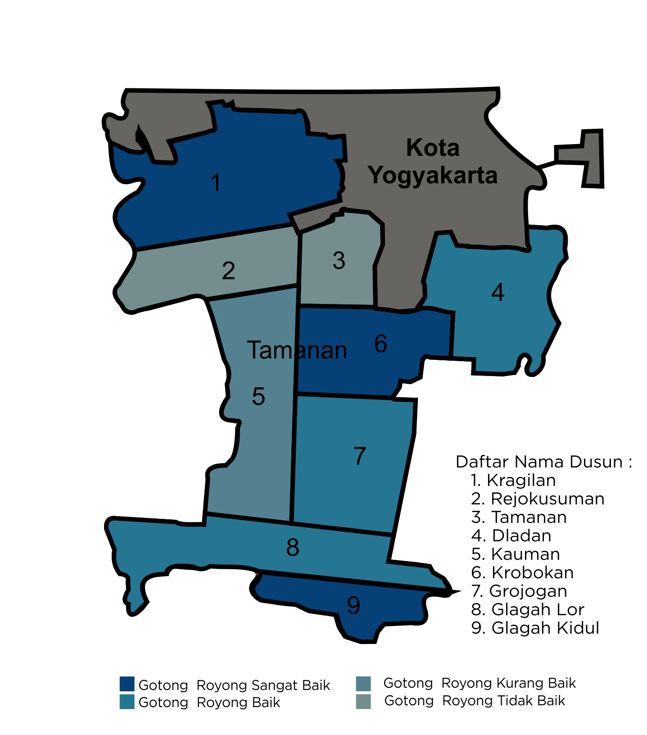
Figure 1. Map of mutual cooperation in Tamanan village, Bantul, DIY.

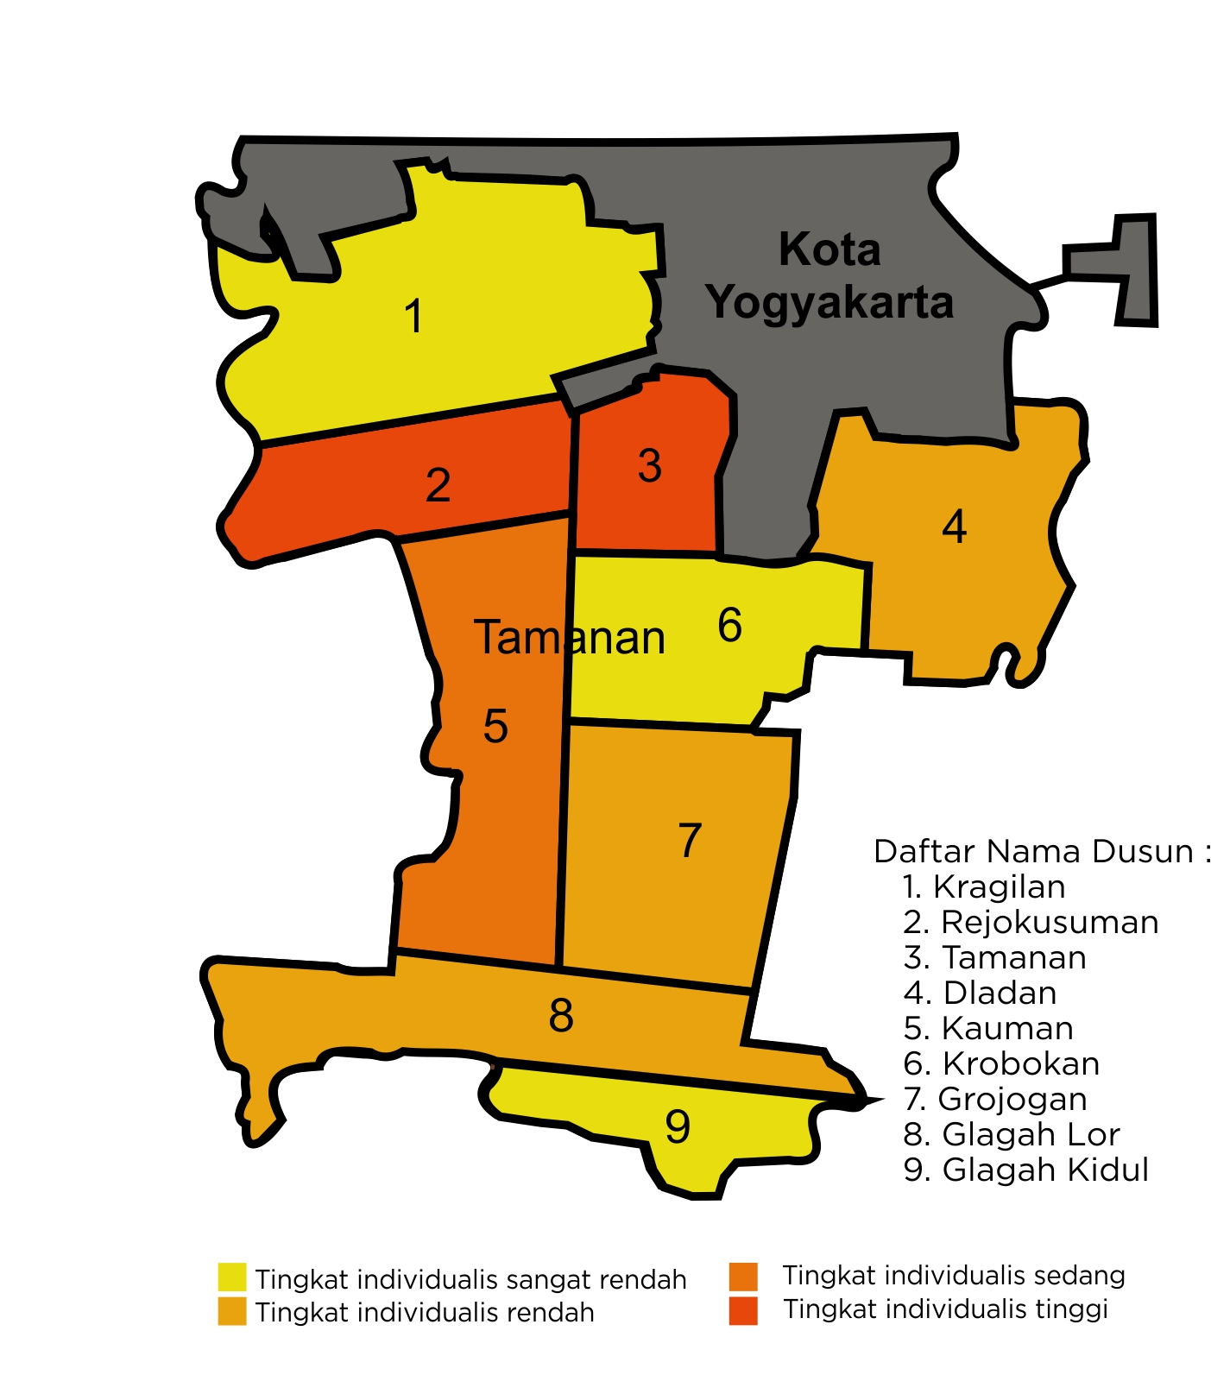

Figure 2. Individualist level map of Tamanan village, Bantul, DIY.

Furthermore, Figure 1 shows that Glagah Kidul (9), Krobokan (6), and Kragilan (1) is dark blue in colour, which shows the value of mutual cooperation is still strong. This is reinforced by the quantitative data, which produce 97%, 86%, and 91% of the people in the three hamlets, i.e.: Glagah Kidul, Krobokan, and Kragilan, respectively, always participate in the mutual cooperation activities. On the other hand, Glagah Lor (8), Grojogan (7), and Dladan (4) are coloured light blue, which indicates that the mutual cooperation begin to diminish. This is reinforced by the quantitative data that produce 74%, 72%, and 61% of the people in the three hamlets, i.e.: Glagah Lor, Grojogan, and Dladan, respectively always participate in the mutual cooperation activities. These results of the mutual cooperation activities in Glagah Kidul, Krobakan, and Kragilan are higher than in Glagah Lor, Grojogan, and Dladan.

Furthermore, the Kauman (5) hamlet is lighter in colour, which indicates that the mutual cooperation in the hamlet is also diminishing. This is reinforced by the quantitative data, which produces only 43% of the people who always participate in the mutual cooperation activities. The lowest mutual cooperation activities occur in the Rejokusuman (2) and Tamanan (3), which can be observed in the faded (most light) blue colour. This is again reinforced by the quantitative data, which yields only 23% of the people in both hamlets always participate in the mutual cooperation activities. It can be observed that the reduction in mutual cooperation activities is not influenced by the proximity or distance of the hamlets to the city of Yogyakarta. This means that getting to the city does not mean that the mutual cooperation is diminishing, although Gea (2016) states that mutual cooperation behavior is increasingly rare and difficult to find especially in urban areas. It is precisely in the Kragilan hamlet (1), which is closest to the city of Yogyakarta still has strong mutual cooperation as in the Glagah Kidul (9), which is the farthest from the city.

The map in Figure 2 above is also made with the rule of color degradation but with different color, i.e.: yellow. The darker yellow color on the map shows a higher level of individualist lifestyle while the lighter yellow colour shows the decreasing (lower) of the individualist lifestyle. The highest indivualist lifestyle is in Rejokusuman (2) and Tamanan (3) hamlets, which has the lowest mutual cooperation values. The lowest individualist lifestyle is in Kragilan (1), Krobokan (6), and Glagah Kidul (9), which have the highest mutual cooperation values. Hence, the two maps above, viz.: Figure 1 and Figure 2, show opposite results for the level of mutual cooperation and the individualist lifestyle in the hamlets, where the higher the level of mutual cooperation in one hamlet shows the lower individualist lifestyle in the hamlet.

Conclusions
From the discussion above, it may be concluded that the strength of mutual cooperation values does not depend on the proximity of the hamlets from the city of Yogyakarta. Moreover, the mutual cooperation map is reciprocal to the individualist lifestyle of the people in the hamlets, i.e.: the stronger the mutual cooperation values the weaker the individualist lifestyle of the people. The results of this study can help the Indonesian government as a policy maker to optimize national development via mutual cooperation values to minimize the individualist nature of society so that social disintegration can be prevented.
Acknowledgements
The authors would like to thank the Student Creativity Program 2019 from Ministry of Research, Technology and Higher Education for funding this study.
Refences
Effendi. 2013. "The Culture of Mutual Cooperation in the Current Social Change". Journal of Sociology Thinking 2(1).
Gea, F.D.S. 2016. Crowfunding: A new movement for mutual cooperation in Indonesia (Evolutionary Review of Collective Action Movements in New Media). Proceedings.
Rochmadi, N. 2016. "Making the Cultural Value of Mutual Cooperation as a Common Identity." Malang: UNM. Library Repository, State University of Malang. 11/20/2012 9:40
Sari, AM. "Upholding the Tradition of Service Work as a Form of Revitalization of Mutual Cooperation Value". Surabaya: UNAIR.
Sudrajat, A. 2014. "Cultural values ​​of the Betawi ethnic group as a source of social studies learning". Dissertation, Postgraduate School, Indonesian Education University.

Appedix 1: Questionairre in Indonesian


UNIVERSITAS NEGERI YOGYAKARTA
- PENGENALAN TEMPAT
1. | No. Urut Kuesioner
2. | Propinsi
3. | Kabupaten/Kota
4. | Kecamatan
5. | Kelurahan/Desa
6. | Padukuhan/RT/RW
- KETERANGAN RESPONDEN
7. | Nama Responden : |  |  | 8. Jenis Kelamin :
9. | Pendidikan Terakhir : |  |  | 10. Umur :
11. | Suku : |  |  | 12. Agama :
13. | Pekerjaan : |  |  | 14. Penduduk Asli/ Pendatang/ Menetap*
- KETERANGAN PENCACAHAN
16. | Pewawancara | Nama: |  | Tgl/Bln/Thn:
17. | Pemeriksa | Nama: |  | Tgl/Bln/Thn:

Keterangan: * Coret yang tidak sesuai

Pernyataan
Pernyataan | Ya | Tidak
- Saya berpartisipasi dalam kegiatan gotong royong.
- Saya mengenal gotong royong dari lingkungan masyarakat.
- Saya selalu berpartisipasi dengan memberikan bantuan materi (uang/makanan/minuman) dalam kegiatan gotong royong.
- Mengikuti kegiatan gotong royong dapat selalu memperkuat rasa persatuan.
- Saya mengenal gotong royong dari lingkungan sekolah.
- Masyarakat di wilayah saya selalu bersikap individualis.
- Saya berpartisipasi dalam kegiatan gotong royong setiap bulan.
- Saya berpartisipasi dalam kegiatan gotong royong setiap minggunya.
- Masyarakat di wilayah saya selalu tolong menolong.
- Saya berpartisipasi dalam kegiatan gotong royong secara insidental,(menjenguk orang sakit, takziyah, atau bencana).
- Saya berpartisipasi dalam kegiatan gotong royong pada acara atau event tertentu (17 Agustusan, nikahan, dll)
29 Saya terkadang berpartisipasi dalam kegiatan gotong royong.
30 Saat pelaksanaan kegiatan gotong royong selalu terdapat perbedaan (pendapat/suku/agama) antara masyarakatnya.
31 Saya berpartisipasi menggunakan tenaga fisik dalam kegiatan gotong royong.
32. Saya mengenal gotong royong dari lingkungan keluarga.
33. Kegiatan gotong royong yang dilakukan di desa saya selalu menciptakan keharmonisan.
34. Saya tidak pernah berpartisipasi dalam kegiatan gotong royong.

Appendix 2. Validation and Realibility Instrument

R tabel = 0.113
Item | Nilai R hitung | Nilai R tabel | Nilai sig. | Keputusan
x1 | 0.636 | 0.113 | 0.000 | Valid
x2 | 0.555 | 0.113 | 0.000 | Valid
x3 | 0.67 | 0.113 | 0.000 | Valid
x4 | 0.544 | 0.113 | 0.000 | Valid
x5 | 0.662 | 0.113 | 0.000 | Valid
x6 | 0.617 | 0.113 | 0.000 | Valid
x7 | 0.366 | 0.113 | 0.000 | Valid
x8 | 0.582 | 0.113 | 0.000 | Valid
x9 | 0.631 | 0.113 | 0.000 | Valid
xtot | 1 | 0.113 | 0.000 | Valid
R tabel = 0.113
Item | Nilai R hitung | Nilai R tabel | Nilai sig. | Keputusan
x1 | 0.636 | 0.113 | 0.000 | Valid
x2 | 0.555 | 0.113 | 0.000 | Valid
x3 | 0.67 | 0.113 | 0.000 | Valid
x4 | 0.544 | 0.113 | 0.000 | Valid
x5 | 0.662 | 0.113 | 0.000 | Valid
x6 | 0.617 | 0.113 | 0.000 | Valid
x7 | 0.366 | 0.113 | 0.000 | Valid
x8 | 0.582 | 0.113 | 0.000 | Valid
x9 | 0.631 | 0.113 | 0.000 | Valid
xtot | 1 | 0.113 | 0.000 | Valid

Reliability Statistics variabel X
Cronbach's Alpha | Part 1 | Value | .693
Cronbach's Alpha | Part 1 | N of Items | 5ª
Cronbach's Alpha | Part 2 | Value | .542
Cronbach's Alpha | Part 2 | N of Items | 5^{b}
Cronbach's Alpha | Total N of Items |  | 10
Correlation Between Forms |  |  | .783
Spearman-Brown Coefficient | Equal Length |  | .878
Spearman-Brown Coefficient | Unequal Length |  | .878
Guttman Split-Half Coefficient |  |  | .761
a. The items are: Frekuensi, kontribusi, Frekuensi, frekuensi, Frekuensi.
b. The items are: frekuensi, frekuensi, kontribusi, frekuensi, Total x.
Berdasarkan (Guilford, 1956:145) kategori koefisien realibilitas 0.60 -0.80 →Reliabilitas tinggi.
Oleh sebab itu 0.761 telah masuk kategori Reliabel.

Reliability Statistics variabel Y
Cronbach's Alpha | Part 1 | Value | .068
Cronbach's Alpha | Part 1 | N of Items | 3ª
Cronbach's Alpha | Part 2 | Value | .387
Cronbach's Alpha | Part 2 | N of Items | 2^{b}
Cronbach's Alpha | Total N of Items |  | 5
Correlation Between Forms |  |  | .833
Spearman-Brown Coefficient | Equal Length |  | .909
Spearman-Brown Coefficient | Unequal Length |  | .912
Guttman Split-Half Coefficient |  |  | .894
a. The items are: Pola hidup, pola hidup, pola hidup.
b. The items are: Pola hidup, total y.
Berdasarkan (Guilford, 1956:145) kategori koefisien realibilitas 0.80 -1.00 →Reliabilitas sangat tinggi .
Oleh sebab itu 0.894 telah masuk kategori Reliabel.

