**VIRTUAL LEARNING ROOM HOMESCHOOLING PRACTITIONERS**

**IN SOCIAL MEDIA**

**(Descriptive Study: Virtual Learning Room Rumah Inspirasi Blogs)**

**Marisa Puspita Sary., M.Si, Dr. Elisabeth Nugrahaeni., M.Si**

**Faculty of Social Sciences, Department of Communication Studies,**

**Jakarta State University**

[**marisapuspita@unj.ac.id**](mailto:marisapuspita@unj.ac.id)[**enugrahaeni@unj.ac.id**](mailto:enugrahaeni@unj.ac.id)

**AbstracT**

*The parents who choose homeschooling for their children's education are homeschooling practitioners. They are called homeschooling practitioners because they act as coaches for the education process of their children. As a coach, parental functions are not as teachers or learning resources, but as guides and compilers of learning curriculum.*

*Parents as homeschooling practitioners need guidance as a learning resource for carrying out homeschooling practices. This is done so that the application of the homeschooling concept is in accordance with the meaning of homeschooling, "Children learn independently at home, guided by parents or teachers who come to the house". That's the basic concept, "said Hamid Muhammad, Director General of Secondary Education at the Ministry of Education and Culture (Kemendikbud), explaining the definition of homeschooling. Therefore, many also mention this phenomenon as "home school" or "independent school" education. "So, the education is more self-taught and included in the category of informal education," Hamid said.*

*RumahInspirasi.com is one of the virtual communities that actively provides homeschooling guidance. RumahInspirasi.com is a Homeschooling virtual study room, Parenting and Entrepreneurship. The founder of RumahInspirasi.com is Aar Suamardiono or who is more familiarly called Aar. Aar and his wife, Mira Julia (Lala) are homeschooling practitioners since 2011 for their three children.*

*Through this Rumah Inspirasi blog, the Aar family wants to share practical perspectives in implementing homeschooling. Rumah Inspirasi aims to provide inspiration, both for families who are interested in homeschooling and families who choose schools and want to enrichment the educational process in the family. RumahInspirasi.com blog is one of the virtual learning tools for the community as homeschooling practitioners.*

This research entitled: "VIRTUAL LEARNING ROOM PRACTITIONER OF HOMESCHOOLING IN SOCIAL MEDIA" (Descriptive Study of Virtual Learning Room Rumah Inspirasi Blogs). This research is different from existing homeschooling themed research, because this research is related to the use of social media, especially blogs as a means of education for homeschooling practitioners.

The approach used in this study is descriptive qualitative and aims to describe the nature, circumstances, and phenomena. This study aims to describe the homeschooling virtual learning room on the Virtual Rumah Inspirasi Blogs community blog. The data analyzed is based on interviews, observations on blog content and literature.

Keywords: Virtual Learning Room, Homeschooling Practitioners, Social Media

**Introductions**

Today, more and more parents are choosing informal education pathways for their children with home schooling (homeschooling). One of the factors that makes people's interest in choosing this education pathway is because of the wider information. This was according to Yulianti Hendra, one of the authors of the book "Home Learning: Learning to Serve Without Limits" as well as managing the Jakarta Homeschool Club.

"It seems to be increasing compared to when I first started. The information was difficult but now it's already a lot. So more people are brave enough to run," Yuli said during the launch of her book at Gramedia Matraman, Jakarta, Thursday (03/15/2018). (https://lifestyle.kompas.com/read/, downloaded Sunday, April 17, 2019, at 5:10 p.m. WIB). This article has been aired on Kompas.com under the title "Interest in Homeschooling Selecting Parents to Rise",

(https://lifestyle.kompas.com/read/2018/03/16/120000920/minut-parents-select-homeschooling- increase.)

Razi (2016) argues that often, formal education, structural strength, and impressions, make students feel depressed, so that they cannot undergo a learning program with fun, excitement, and filled with love. In addition, competition among students causes some students to feel stressed so that children view learning as a burden of responsibility and not as a requirement. In the present era, alternative education institutions appear in an effort to overcome the above problems, one of which is homeschooling.

In the Homeschooling journal in the Islamic Education Perspective and the National Education System Law, written by Asrori (2014), results show that homeschooling is a learning activity carried out at home and not in a school institution with a programmed system. Homeschooling is one of the alternative education systems for people in Indonesia today.

One source of information about homeschooling is through the internet. even the internet is one of the learning resources that supports the implementation of homeschooling for homeschooling practitioners in Indonesia. Salman (2017) argues, the current development of internet technology, causes almost all people to use it in various activities to find information or disseminate information to all public audiences. These developments cover almost all the joints of life today, can be enjoyed through the internet.

The Indonesian Internet Service Provider Association (APJII) presented the results of the survey entitled "2017 Indonesian Internet User Penetration and Behavior". The survey results in collaboration with technopreneur said that the penetration of internet users in Indonesia increased to 143.26 million people, equivalent to 54.7 percent of the total population of this Republic. Meanwhile, currently Indonesia's population is 265 million. Gawai user statistics, we are social: The duration used by Indonesian people in accessing the internet is also high. The difference in the type of device that is used influences how long it takes them to surf in cyberspace. Comparison of PC or tablet users with a mobile phone, namely; for PC or tablet users, they can spend an average of 8 hours 44 minutes, while mobile phone users are shorter which is 3 hours 55 minutes.

Along with the rise of parents who choose homeschooling education, the need for information about homeschooling and homeschooling communities also increases. The homeschooling community is a collection of homeschooling families that do joint activities and share resources. The homeschooling community is a jointly owned non-profit organization. Most homeschooling communities are liquid organizations that are not legal entities.

The presence of the internet can penetrate the distance that allows individuals to interact between other individuals who live in different regions. Not only between individuals but also groups of individuals who are members of a community whose members are in different regions, provinces and countries. Communities where members are connected via the internet are also called virtual communities. The internet is a medium that provides a place for interaction between individuals as members of the virtual community.

Emerging homeschooling communities and educational institutions. For example the Asah Pena group (Association of Alternative Home and Educational Schools), RumahInspirasi (Jakarta), Sinau Club (Sidoarjo), and Packaging (Family and Community Based). Each claimed to have tens to hundreds of children dirik. (note: RumahInspirasi is a single homeschool family, not having students). Gatra Magazine covers one community, namely RumahInspirasi.com. Here's the quote:

Of the many existing communities, RumahInspirasi.com, managed by Aar, is arguably the most active in informing homeschool guides. According to Aar, the basis of education in home schools is family. "This education relies on family values. So, the implementation is based on vision and targets of a family. This kind of education relies heavily on full support and family strength, "Aar explained. (Source: Coverage of Gatra Magazine No. 30 Year XVIII, May 31-June 6, 2012).

This research is different from existing homeschooling themed research, because this research is related to Virtual Learning Space on social media, especially blogs as a means of education for parents as homeschooling practitioners. This study aims to describe the education of homeschool practitioners on the RumahInspirasi.com Blog.

The urgency of this research is to try to provide an alternative learning model for the community by utilizing information technology through the internet about guidelines for implementing family-based education for parents and homeschooling practitioners. The use of the internet as a new media technology is able to penetrate regional boundaries, interactive and real time. This makes it possible to reach a broad audience reach and even penetrate national borders so that the education process has a broad and effective impact.

**Method**

The approach used in this study is descriptive qualitative (Mulyana, 2006: 20), namely the research conducted is synchronic and aims to describe the nature, circumstances, and phenomena. This study aims to describe the homeshooling-based educational model used in the virtual community blog RumahInspirasi.com. The data analyzed is based on the results of interviews with the founder of RumahInspirasi.com, observation of blog content, news in the mass media and supporting libraries.

The research method used in this study is a case study. According to Creswell (2014: 105) in a qualitative case study, one can arrange questions and sub-questions through issues in the theme being explored, also the sub-questions can include steps in the procedure of data collection, analysis and construction of narrative formats.

This study uses a quantitative approach . The method of the study is a case study with a descriptive research type. Data collection techniques using interview techniques, observation and literature. Primary data of this study were obtained from the results of interviews and direct observation. Secondary data from outside the research subjects are mass media news, scientific journals, RumahInspirasi.com blogs and the web. The research subject in this study is the founder of RumahInspirasi.com. namely Aar Sumardiono and Mira Julia. Data Analysis Techniques, the analysis process begins by examining all available data from the results of interviews and observations that have been written in the field notes and interview transcripts. Then, reduce the data and arrange it in categorized units. The final results were obtained after the overall data analysis was collected and carried out with descriptive qualitative techniques.

This study uses the theory of Computer-Mediated Communication (CMC). CMC. Griffin defines CMC as communication carried out by humans mediated by computers. CMC has made people no longer need to face advance directly to interconnect but face to face virtually through a computer screen. CMC interactivity makes a computer a responsive and reflective tool. (Griffin, 2002: 201).

The seven CMC characteristics described by Kevin B. Wright and Lynne M. Web (2011: 122), are:

1. Synchronity, refers to the understanding of the level of exchange of messages that are immediate.

2. Anonymity, represents a personal level

3. Customization, is the level at which the mediated environment modifies itself based on the wishes of the user

4. Interactiveity, refers to two-way communication

5. Social presence, refers to the level of social presence in the virtual world that is like the real world.

6. Number of users

7. User homogeneity, namely the characteristics of users who tend to have similarities.

Social media is one form of applying CMC theory. In simple social media is defined as a software that is able to make individuals interact with other individuals and build social networks that can increase social capital (Konnijin, et.all, 2008: 21).

Mayfield (2008: 6) states that currently there are seven types of social media, but innovations and changes continue to occur. The current social media is. Social Networks, Blogs, Wikis, Podcasts, Forums, Content Communities and Microblogging. Home Inspiration Blog is one type of social media. Mayfield describes that Blog is the best form of social media in the form of online journals with the best loading of posts, ie the latest posts are on the front page.

**RESULT and Discussion**

This section is divided into two parts, there are result and discussion. Those sections are explained below.

**Result**

Rumah Inspirasi Blogs are homeschool virtual learning spaces, parenting and entrepreneurship education that contain information and periodically hold Webinars (Seminars Online) for parents who want to learn to start homeschooling. In addition to learning to start homeschooling, this blog content also contains material to increase parenting capacity and develop entrepreneurship in children. The founder of Rumah Inspirasi is a husband and wife named Aar Sumardiono and Mira Julia. Rumah Inspirasi is the Sumardiono family's virtual house where the daily activities of their children who are homeschooling are recorded.

The Sumardiono family chooses Home Education (HE) as an educational model for their children with the basic spirit of learning anywhere, anytime, with anyone and trying to build a learning process that becomes an inherent part of everyday life and strives to make the learning process enjoyable. The aim of the Sumardiono family is to learn to be a pleasure and a necessity, not an obligation or a burden.

From the beginning, married Aar Sumardiono and Mira Julia were determined to apply homeschooling to their children. At that time, although not yet blessed with a baby, the Sumardiono couple wanted to make their children develop healthier. They have dreams of designing an education system that allows children to learn things that are liked according to their needs so that children can live their obligations without any burden. And now their dreams come true, Yudhis (18), Tata (14), Ambassador (10) get an education with homeschooling methods.

Since 2007 Aar Sumardiono started the Rumah Inspirasi Blogs in the 5th year (2013), reaching 100,000 page reviews, then in 2014 it increased to 400,000 page reviews. Along with the time of evolution in the House of Inspiration, the shift from personal blogs to media and community. As a medium of inspiration, it functions as a means of sharing information, knowledge and events. Whereas as a community, the function of Rumah Inspirasi is a place to gather, share, act together with the community who have similar interests / homeschooling, parenting, and family interests. The following is the narrative of Mira Julia founder who also plays a role in creating a Home Inspiration blog web design.

"Initially the blog was to record a portfolio of children's activities while applying homeschooling methods. It turns out that putting personal experiences into writing is fun. Finally, the idea developed and we used the Home Inspiration blog to share information and knowledge about homeschooling, parenting and education ”

The blog finally won an award as a weekly (Bronze Award) winner from Healthy Internet in the 4th week of December 2010. Furthermore, in a row were selected as monthly winners (Silver Award), 3-month winner (Gold Award), and finally became annual winner (Platinum Award) and received the 2010 Healthy Blog Award (Tabloid Nakita number 648, August 29, 2011)

In addition to blogs, Rumah Inspirasi also has an Ruma Inspirasi Twitter with 11,900 followers, a fan page on Facebook Page Rumah Inspirasi 64,108 followers, and an information customer (mail subscriber), which has continued to grow.

The community needs to get information about Homeschooling, for that one of the functions of the Rumah Inspirasi Blogs is to provide education about Homeschooling to make it more understood. Aar Sumardiono believes that there is a mistake in understanding the homeschool education system. He tried to straighten out that homeschooling was not an institution. The following is an excerpt from an interview that was published on the Nova Tabloid:

Many are still unfamiliar with the homeschool education system, even though the advantages are abundant. Homeschooling (HS) or home education (HE) is an educational model in which families choose to be responsible for the children's education process. HS is not an institution and is different from the school management side. At school, the system and standards have been standardized, while at HS, "The responsibility for education is in the parents. So, the most important thing is parents' commitment, "said Aar Sumardiono, observer and HS practitioner from Rumah Inspirasi. (Tabloid Nova: "More Value Learning at Home" - September 17, 2013)

Aar Sumardiono emphasized that the most important thing in implementing Homeschooling is the commitment of parents because the responsibility of education is on parents. This requires the support of parenting knowledge, therefore the Home Inspiration blog also contains content about Parenting.

Rumah Inspirasi Blogs content which is currently a website consists of a discussion of three main topics, namely: Homeschooling, Parenting and Entrepreneurship. For more information, there is an archive that contains a collection of articles on House of Inspiration. Among them is the coverage of the print and electronic mass media around the reporting of the activities of Rumah Inspirasi.

Homeschooling topics consist of several discussions, namely: Homeschooling Introduction, Homeschooling Legality, Homeschooling Socialization, Homeschooling Curriculum, Learning Resources, Communities, Keys to Success and Examples of Homeschooling Practices. The entire discussion is a frequently asked question related to homeschooling so as to make it easier for visitors to find answers. Education displayed on Homeschooling is family-based education, not a label pinned on an institution, therefore parents who want to go through homeschooling need to learn because homeschooling is not just moving schools to home.

The following is a display of information about homeschooling on the Home blog. The inspiration that is often asked by blog visitors is:

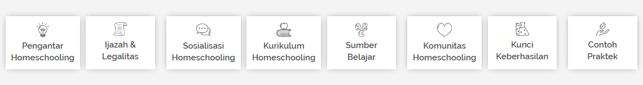

(Source: http // [www.RumahInspirasi.com](http://www.RumahInspirasi.com))

In addition there are various articles about the concepts and practices of homeschooling undertaken by Aar Sumardiono's family which can be an inspiration and a reference for homeschooling practitioners. On the topic of Parenting provides a variety of articles, ideas of activities, as well as a checklist of child development that can be used as a reference for the learning process of parenting. Entrepreneurship topics educate parents that learning Learning entrepreneurship is not just teaching children to learn business. Learning entrepreneurship means learning to create value, resilience and be oriented to opportunities and solutions.

Following are some of the interactions of Rumah Inspirasi visitors in the question and answer column in response directly to Aar Sumardiono founder as admin.

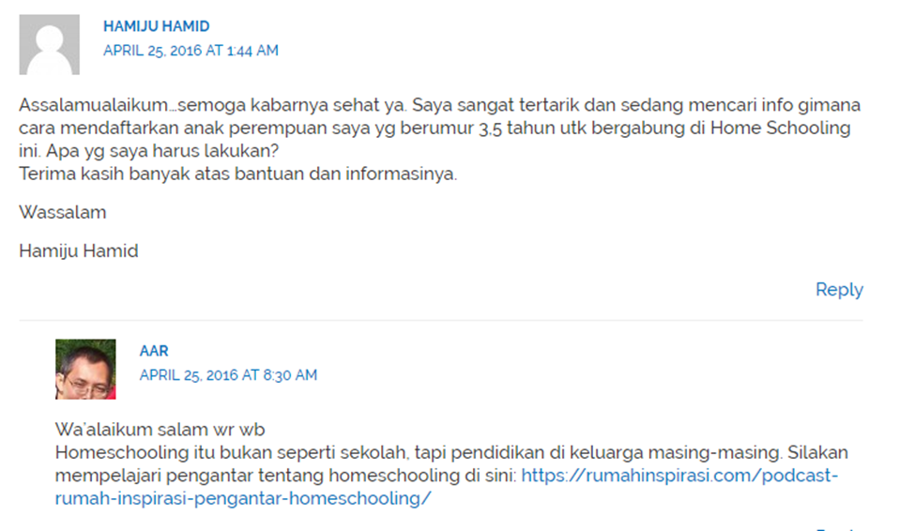

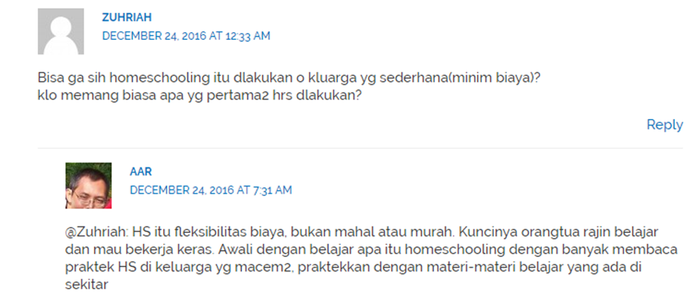

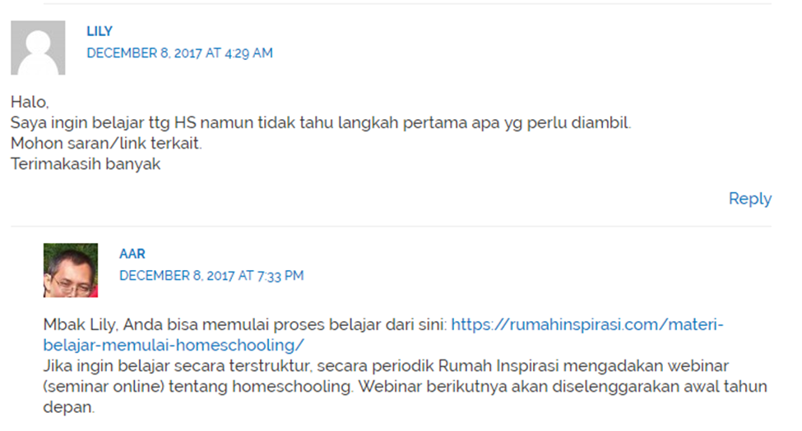

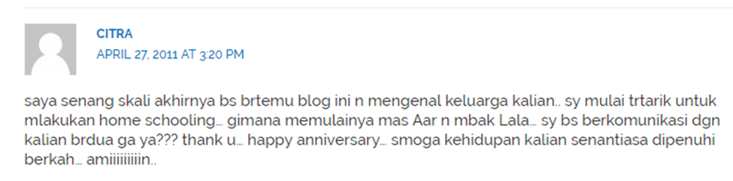

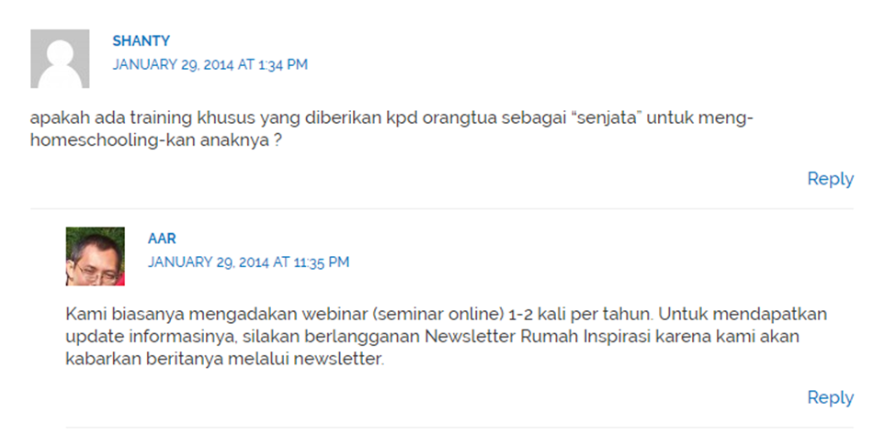

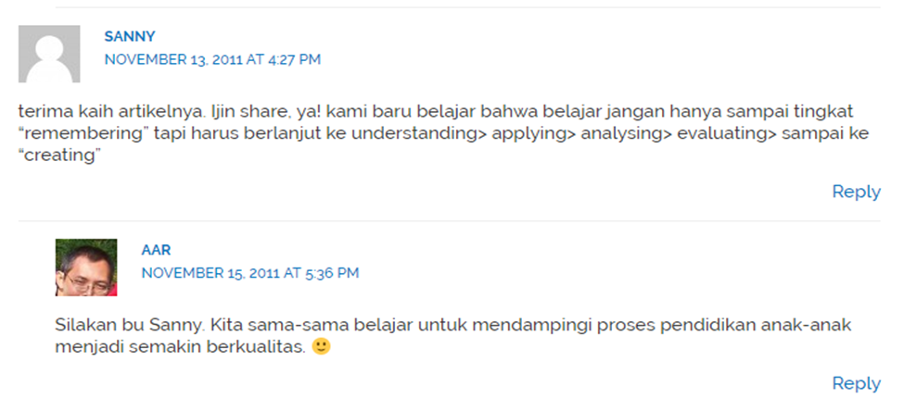

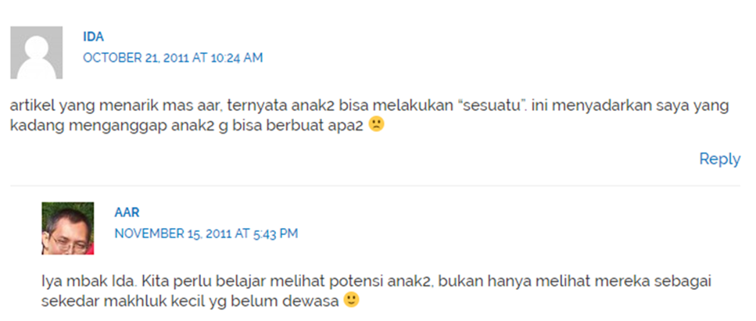

(Source http // [www.RumahInspirasi.com](http://www.RumahInspirasi.com))

In addition to interacting with the text with the founder, visitors can also meet face-to-face by joining the Web Seminar. The following is an example of Webinar information with the theme "21st Century Education" which is held periodically by Rumah Inspirasi. The information provided is more structured face-to-face through computer mediation that allows online seminar participants to interact directly with resource persons.

(Source : http//www.RumahInspirasi.com)

**Discussion**

Rumah Inspirasi Blogs is a virtual learning room initiated by homeschooling practitioners Aar Sumardiono and Mira Julia since 2007. Virtual learning rooms which were originally personal blogs, are now community media that have become a reference for homeschooling practitioners and parents who want to run homeschooling for his children.

According to Tonnies quoted by David Bell (2001: 94), virtual communities are new forms of social relations between individuals on the internet that are formed from a group of people who interact socially among group members based on the similarity of needs or goals within themselves or among members other group members and the existence of individual areas that are open to other group members. Explanation from Wood and Smith (2005: 233) about virtual communities is as entities that share and connect through a computer-mediated environment.

RumahInspirasi.com is a homeschool study room, parenting and family management. In addition to containing information, periodically holding a Webinar (Online Seminar) for parents who want to learn to start homeschooling and increase parenting capacity. Inspiring home content is articles and information, as well as homeschooling practice stories in Aar Sumardiono's family.

RumahInspirasi.com is one of the virtually active communities providing homeschooling guidance. Through this Rumah Inspirasi blog, the Aar family wants to share practical perspectives in implementing homeschooling. Rumah Inspirasi aims to provide inspiration, both for families who are interested in homeschooling and families who choose schools and want to enrichment the educational process in the family. RumahInspirasi.com blog is one of the virtual learning tools for the community as homeschooling practitioners.

Regarding Computer Mediated Communication Theory, Rumah Inspirasi uses the internet as a communication medium as a means of delivering messages and also allows for two-way communication. Griffin defines CMC as communication carried out by humans mediated by computers. CMC has made people do not need to face face to face to connect but face to face virtual through computer screens. Through Rumah Inspirasi, blog visitors seem to be in a virtual study room and can communicate directly with the founder of Rumah Inspirasi and admin.

CMC interactivity makes computers a responsive and reflective tool. Computer Mediated Communication has good syinchronicity, so communication is fast and feedback can also be obtained quickly. This is found in the comments column that displays a visitor's dialogue with Aar Sumardiono. Questions about homeschooling were responded to directly by Aar Sumardiono as the founder and admin. In addition to questions, it can also be seen an appreciation from blog visitors for articles that are considered useful as a guide to running homeschooling. From some comments, it can be seen that the benefits obtained from the information contained in Rumah Inspirasi.

Periodically Aar Sumardiono and Mira Julia held a Webinar (Web Seminar). The webinar allows visitors to interact face-to-face with the internet network facilities through an interconnected computer screen. Webinar participants are not only in the country but there are also those from other countries such as Malaysia and Japan. Like a face-to-face seminar. Webinars allow participants to interact directly with resource persons live. Computers are the mediation that connects Home Inspiration Webinar participants from various regions in Indonesia to penetrate national borders. Information about homeschooling from the founder of Rumah Inspirasi is a reference for homeschooling practitioners without distance.

Rumah Inspirasi Blogs education to the community uses the internet to form a virtual community that has the same interest in homeschooling and becomes a virtual learning room for homeschooling practitioners and the public who need referrals about parenting. Rumah Inspirasi Blogs fulfills information needs and insights about the practices of homeschooling applied to the community.

Virtual Learning Room Inspiration Houses generally consist of:

1. Understanding of Homeschooling

2. Homeschooling implementation guide

3. Parenting and Entrepreneurship Articles

4. Daily homeschooling practice

5. Homeschooling Community

6. Web Seminar

Some Rumah Inspirasi Blogs Virtual Study Room education about Homeschooling is:

1. Homeschooling has cost flexibility.

2. Parents must be diligent in learning and willing to work hard.

3. The first step to starting Homeschooling is learning about homeschooling by reading a lot of homeschooling practices from various families who have done it

4. The environment around us is one source of learning

5. Rumah Inspirasi provides information for parents who want to start homeschooling practices.

6. Rumah Inspirasi organizes periodic Web Seminars for parents who want to study structurally about homeschooling.

7. Homeschooling is not like school, but education in each family.

8. Rumah Inspirasi create newsletters that are sent regularly that want to subscribe and be sent via e-mail to get the latest information and articles about homeschooling.

9. Rumah Inspirasi invites parents to learn to see the potential of diverse children.

10. Response generally from the comments of visitors to the Rumah Inspirasi Blogs that they get clear directions for developing their children's potential.

11. Learning is not only up to the level of "remembering" but must continue to understanding, practice, analysis, evaluation to the creation.

12. Rumah Inspirasi invites parents to learn to accompany the process of children's education to become more qualified.

**Conclusion**

Rumah Inspirasi is a blog created in 2007 by Aar Suamadiono and his wife Mira Julia. Initially Rumah Inspirasi was a personal blog where Aar Sumardiono and Mira Julia noted the daily homeschooling activities of their children. Since 2014 Rumah Inspirasi has reached 400,000 page reviewers and there has been a shift from personal blogs to community media for homeschooling practitioners and parents who want to increase their parenting capacity. Rumah Inspirasi is a homeschool learning room that forms a virtual community.

Rumah Inspirasi Content is a virtual study room as a means of education for people who are unfamiliar with matters relating to homeschooling. Information presented in a systematic and structured manner makes it easier for blog visitors to get to know and understand the homeschool education system.

Incorrect understanding of the homeshooling education system can be easily understood from the articles presented in Rumah Inspirasi and interaction through question and answer in the comments column that is directly answered by the founder (Aar Sumardiono). In addition to interaction through text in the comments column, Rumah Inspirasi also holds periodic Web Seminars with themes related to homeschooling. Web seminars allow face to face meetings through computer mediation and are able to reach a wide audience to foreign countries.

**Reference**

Achmad Razi, 2016. *Homeschooling: an Alternative Education in Indonesia International Journal of Nusantara Islam.* Vol 4, No. 2

Asrori, 2014. *Homeschooling Dalam Perspektif Pendidikan Islam Dan Undang- Undang Sisdiknas*, Jurnal Edukasia Vol 9.

Bell, David. 2001. *Introduction of Cyberculture, London* : Routledge.

Creswell John.W. 2014. *Penelitian Kualitatif & Desain Riset.* Yogyakarta: Pustaka. Pelajar

Griffin, E. (2009). *A First Look At Communication Theory*. New York: McGraw-Hill

Mulyana, Deddy. 2006. *Metodologi Penelitian Kualitatif.*. Remaja Rosdakarya.

Salman. *Media Sosial Sebagai Ruang Publik*, (2017) Jurnal Kalbisocio Vol 4.

*Wright, Kevin. B & Lynne M. Webb. 2011. (Eds.) Computer-Mediated. New York: Peter Lang.*

Majalah Gatra no. 30 Tahun XVIII, 31 Mei-6 Juni 2012).

Tabloid Nova: “Nilai Lebih Belajar di Rumah”- September 17, 2013

Tabloid Nakita nomor 648, 29 Agustus 2011

<https://lifestyle.kompas.com/read/2018/03/16/120000920/minat-orangtua-pilih-homeschooling-meningkat>.

<https://rumahinspirasi.com>