**Learning Innovative Based on Multimedia Application for Civic Education in Senior High School**

Muhammad Japar1, Komarudin2, Ganang Lakshita Hadi Purnomo3, Dini Nur Fadhillah4

1,2,4 Fakultas Ilmu Sosial, Universitas Negeri Jakarta

3 Civic Education Teacher, Senior Intercultural School

[mjapar@unj.ac.id](mailto:mjapar@unj.ac.id)

**Abstract**

The development of information and communication technology encourages various educational institutions to utilize e-learning systems to improve the effectiveness and flexibility of learning. This study aims to describe student learning outcomes using innovative based on multimedia learning applications for civic education. This method used sequential explanatories mix method design is used in the 'face to face' survey. In-depth interviews were conducted by eight students in grade ten year 2018, two civic education teachers, and also 20 students who were running a practice program in teaching skills at Senior High School. Among 36 participants, 94% stated that the quality of learning was very good. The results showed that the average student score in civic education increased by 27.8%. Multimedia application is effective in increasing students' understanding regarding Pancasila values ​​within the framework of the practice of administering the State government. The implication of this research is that multimedia applications can be used as alternative learning media that are more complete, interesting and also facilitates the teacher i`n the learning process. Students are more motivated in learning and improve learning transformation.

**Keywords:** *Learning innovative, multimedia application, civic education*

**INTRODUCTION**

An important phenomenon in the process of globalization has given affected to a generation of gadgets; this term is used to mark the emergence of the millennial generation. All information is easy to get and there are no more limits or space and time to communicate. Along with the rapid development of information and communication technology, currently learning models can be done through the empowerment of computer technology (Priyo Darminto, 2015). For this reason, education that uses technology is needed to support interactive learning (Sandfort, 2018). Innovative approaches to learning refer to various teaching approaches called new learning, natural learning, active learning that allow students to play an active role in the learning process compared to traditional approaches (Hornstra, van der Veen, Peetsma, & Volman, 2015). In the last two decades Information and Communication Technology (ICT) has played an important role in everyday life and in the teaching and learning process (Girwidz et al., 2019). One of the technologies that can facilitate learning through interactive multimedia (Kumar, Muniandy, & Wan Yahaya, 2019). Interactive multimedia is an excellent tool in education. Multimedia applications can have a positive impact on the learning process for engineering design lessons (Höhne & Henkel, 2004). The use of multimedia tools in educational process has improved in the learning environment concepts that presented to students in various semantic formats integrated with each other (Antonietti, Colombo, & Di Nuzzo, 2015). The benefits of multimedia integration as a tool in learning and teaching processes are clearly demonstrated and confirmed in the study of Bruckermann, et. al.(2017) regarding metacognitive and multimedia support of experiments. Such as inquiry learning for science teacher preparation. Chiu and Churchill (2016) explained that the design of learning objects for concept learning using multimedia supports approaches to learning. According Debs, et.al. (2018) showed that students' have positive perspective on technology programs in learning. In the USA, Multimedia is a science ability (Dimitrov, McGee, & Howard, 2010). Based on Doolittle, Bryant and Chittum (2015) shows that the use of multimedia learning has a positive influence on students' memory. In Portugal, to prepare children for outpatient surgeries using an educational multimedia (Fernandes, Arriaga, & Esteves, 2015). The results show that information about children regarding medical procedures and hospital rules reduces their concerns before surgery.

Utilization of information and communication technology has a positive impact on the world of education (Anggraini, 2013). Students can learn and get the information needed from anywhere, anytime, and from anyone. Seeing the positive impact of ICT utilization, efforts need to be made to develop learning facilities for students Civic Education has a role for students as facilitators to remind about filtering Pancasila (Ideology in Indonesia) and moral values ​​to control the impact of gadgets, so that Civic Education course need innovation to increase students' interesting to study. Civic Educationis a compulsory subject in all elementary and secondary education units. The aspects that become the scope of this subject are knowledge of citizenship (cognitive), citizenship skills (psychomotor), and values ​​of citizenship (affective). These three knowledge are expected to be integrated, so that the learning objectives of Civic Education can be achieved, to make students as good and intelligent citizens. Based on Minister of Education Regulation No. 22 of 2006 normatively stated that Civic Education course is focus on the formation of citizens who understand and are able to exercise their rights and obligations to become an intelligent, skilled, and characteristic Indonesian citizens mandated by Pancasila and the 1945 Constitution. The teacher center learning model makes students passive. As an educational environment, multimedia is complex. Most educational multimedia is informed by a constructivist approach to learning where users on previous experience meaning constructing by drawing in active engagement with content. In doing this, educational multimedia incorporates numbers from instructional forms, for example, micro worlds, anchored instruction, problem-based learning and goal-based scenarios(Jonassen & Rohrer, 1999).

Pancasila and Civic Education is a compulsory subject in all elementary and secondary education units. The aspects that become the scope of this subject are knowledge of citizenship (cognitive), citizenship skills (psychomotor), and values ​​of citizenship (affective). These three knowledge are expected to be integrated, so that the learning objectives of Pancasila and Civic Education can be achieved, namely to make students as good and smart citizens. Knowledge of Pancasila and Civic Education is elaborated in subjects whose depth is adjusted to the level of development of students. Then to find out students have mastered an subject matter optimally is when students have achieved the set learning objectives. In the learning process, the media has a function as a carrier of information from the teacher's source to the recipient of students. The method is a procedure to help students receive and obtain information to achieve learning goals (Wina, 2010:204). Multimedia applications are applications that are designed and built by combining elements such as documents, sounds, images, animations and videos.

Based on the above background, Civic Education for high schools requires innovation using Multimedia Learning Application. Civic Education is a lesson that focuses on the formation of citizens who understand and are able to exercise their rights and obligations to become intelligent, skilled and characteristic Indonesian citizens (Japar, Fadhillah, & Purnomo, 2019). Civic Education is a study of citizenship which is supported by various relevant disciplines, namely political science, law, sociology, anthropology, psychology, and other scientific disciplines, which are used as the basis for conducting studies on the process of developing citizens' democratic concepts, values ​​and behavior country (Komarudin, 2004). According to Supriatoko, Civic Education will be able to give citizens who have insight into nation and state and high nationalism and can think critically about the problems facing their country (Supriatoko, 2008). In Japan, Civic Education can be expected to be wider as it is associated with new curricula and concern about the concept of citizenship (Japar & Fadhillah, 2018) . In Indonesia Civic Education, which is expected to help students to (a) know, understand and appreciate national ideals, (b) be able to make smart and responsible decisions in a variety of personal, community and state problems (Rahayu, 2007). According to Muhammad Japar (2018), education in Indonesia aims to develop knowledge and skills in the context of ideas, values, concepts, and morals. Therefore, the Indonesian civics education emphasizes civic knowledge, civic skills, and civic disposition by learning experiences in everyday life. There are alternative actions based on a scientific approach to improve the quality of learning, which can encourage the involvement of students in learning and improve teacher creativity. One alternative is to use Electronic Learning systems in the form of multimedia applications. Pujiastuti, Idrus, and Emosda (2014) develop interactive multimedia-based civic education learning media. Kuswanto and Ismawati (2018) developed a computer-based drill model of media learning on Civic Education course for senior high schools.

In this advanced era, developments in the education sector have been very advanced. This is indicated by the many methods in delivering in the field of education. In addition, the rapid development of information and communication technology has encouraged various educational institutions to utilize Electronic Learning systems to improve the effectiveness and flexibility of learning. Through Electronic Learning can be accessed anytime and anywhere, in addition, material that can be enriched with a variety of learning resources including multimedia can be quickly updated by educators. Development of Information Technology now educators are greatly facilitated in making IT-based learning media. With this tool, it is expected to be able to attract the interest of students in learning a material able to stimulate students, able to follow the progress of Information Technology, help understanding students learn a material that can contain text, images, sounds, videos or animations that can facilitate educators in doing classroom teaching and fostering innovative and creative learning.

**Method**

Mixing methods are carried out through qualitative and quantitative data that are truly merged into one end of continue, kept separate in the other end of continuum or combined in several other ways (Bian, 2007). This research strategy used sequential exploration involving the collection and analysis of quantitative data in the first stage which is then followed by the collection and data of quantitative analysis in the second stage based on the results of the first stage (Creswell, 2017:317).

KUAL

KUAN

Kuan

Pengumpulan Data

KUAL

Pengumpulan Data

Interprestasi Keseluruhan Analisis

Kuan

Analisis Data

KUAL

Analisis Data

Figure 1. Sequential Exploratory Strategy

Source : Creswell et al. (2003)

In the questionnaire for needs analysis, the scale used is the Gutman scale. This scale of measurement is obtained by a firm answer such as: yes-no; True False; often-sometimes, etc. (Abdi, 2010). The description of the results of the calculation is presented in the form of a frequency table whose percentage is based on the categories of answers from the data source. The percentage calculation formula is as follows

**Table1**

**Assessment Scale Questionnaire Evaluation**

|  |  |
| --- | --- |
| Scale | Interpretation |
| 1 | Very Less |
| 2 | Less |
| 3 | Enough |
| 4 | Good |
| 5 | Very Good |

The data source at the planning stage was in the form of needs analysis obtained from grade ten, Civic Education teachers at SMAN 78 West Jakarta, as well as an additional 20 students who had the opportunity to teach Civic Education while participating in the PKM program at Universitas Negeri Jakarta. This activity was carried out by conducting observations in grade ten of SMAN 78 West Jakarta in the study of Citizenship Education. Then conducted interviews with 20 students who taught Civic Education through the PKM program. Data collection and data analysis activities carried out with this qualitative method as a preliminary study to obtain information about learning civic education. Furthermore, data collection is taken through quantitative methods, such as providing a questionnaire regarding the learning model of citizenship education. In the evaluation phase of learning media the data source was obtained from material experts and learning Civic Education, learning media experts, Civic Education teachers, and students of grade ten SMAN 78 West Jakarta. Test material experts and learning is done with an expert, one of the lecturers of Civic Educationa Esa Unggul University. Then for the media expert test carried out by the Head of the LIPI Bandung Information and Technology Center Work Unit. After obtaining a percentage of the calculated data, then the percentage is interpreted as a qualitative sense, based on the interpretation criteria for the rating scale by (Thoifah, 2015).

**Results and Discussion**

PANDAWA LIMA

Multimedia-based interactive learning media or called PANDAWA LIMA (Application of Pancasila Education and State-Owned Education Through Multimedia Applications) was chosen with the assumption that this application is the solution for most problems in the Civic Education learning process, where in this application have a complete program starting from presentation material interesting and innovative learning, simulating questions and answers, collection of inspirational videos, and also accompanied by a game program with many choices which of course is in accordance with the learning material.

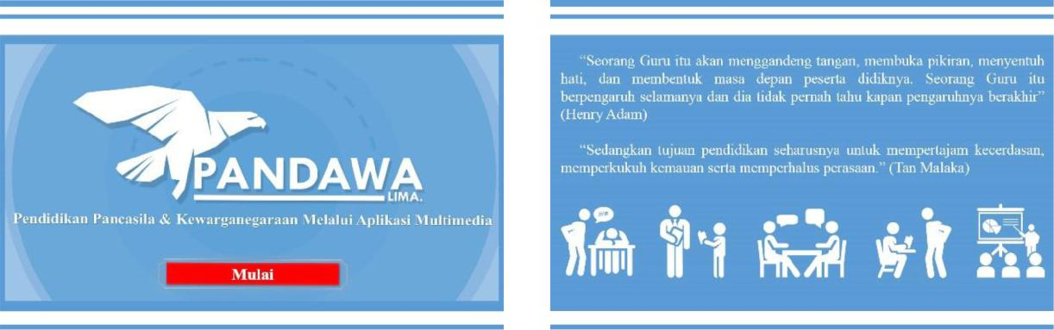**Figure 2. App Opening Display**

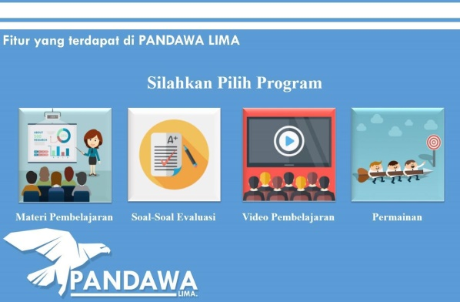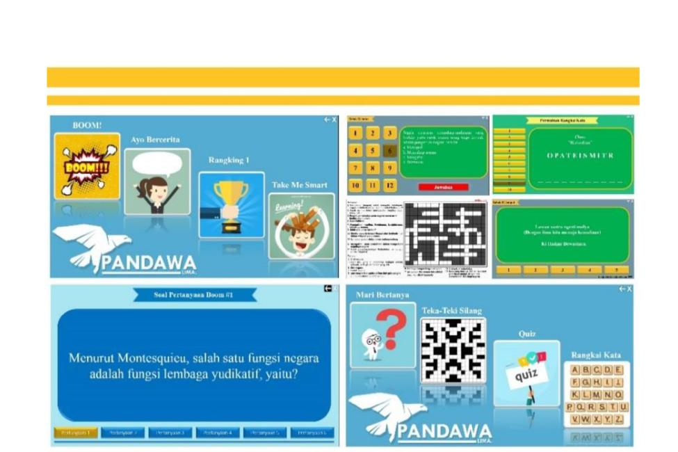 **Figure 3. Display of the Main Menu Figure 4. Display of Game Menu Programs**

Source: Private Document

**Figure 5. Product Finishing Display**

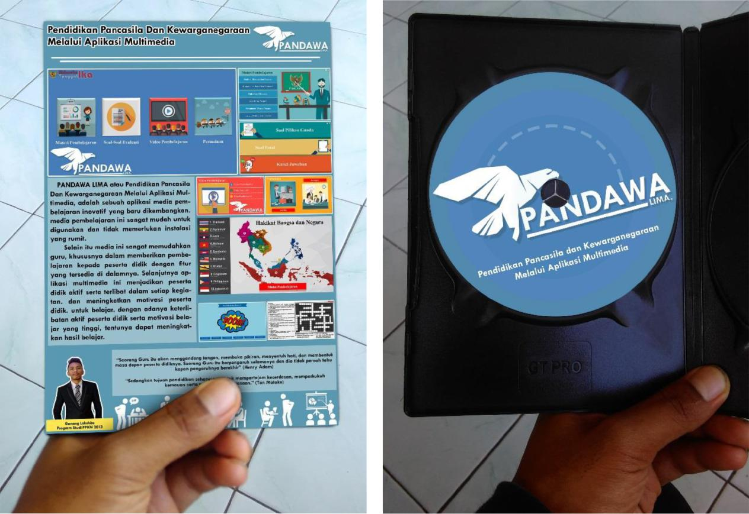

Media in the teaching and learning process tends to be interpreted as graphical, photographic, or electronic tools to capture, process, and rehearse visual and verbal information (Arsyad, 2005:3). The picture above shows that the learning process is done electronically, namely multimedia applications. According to Agus Hariyanto (2009), where general principles and tips for learning to read are the ability to read requires a process that takes place continuously and gradually. Use tools to give effect to happy students, so students do not feel bored when studying. Don't hesitate to explore in finding new breakthroughs or techniques that are easier and more fun to teach reading to students. Based on the general principles of teaching reading, the teacher needs to use tools / media to teach reading. Interview with the Civic Education teacher regarding the learning process of students, the obstacles faced by students when learning, student learning outcomes, efforts to improve learning, characteristics, to the learning facilities and infrastructure of students. Based on the results of the interview, information was obtained, among others, students of grade ten had difficulty in understanding the material on Civic Education course, which then had an impact on the learning outcomes of students.

The main obstacle in Civic Education learning which then impacts on low student learning outcomes is because students are not maximal in understanding learning material, this was revealed by teacher 1 for Civic Education course.

*"The difficulty that I have experienced is that there are still many students who are sometimes less serious in the Civic Education learning process, for example there are still people who like to joke when I explain material, chat, and also sleep. In addition, students are also lazy to read so this becomes a problem that has an impact on their learning outcomes later. I see the reasons that make them lazy to read and the lack of motivation during learning because Civic Education is a lesson that is considered a lot of memorization and also related to history, besides that with teaching materials that are full of writing makes them less interested plus Civic Education lessons are considered not lessons important because it's not on the national exam. "*

According to data obtained from Civic Education teachers, there are still some students whose learning outcomes are still below the KKM average, which is 75. In addition, students' learning motivation at the time of Civic Education learning is still not optimal, students often chat with other students, and students tend to get bored and often the teacher gives a warning to students who sleep when the learning process is in progress. The homeroom teacher also expressed concern that the Civic Education books available at the school as learning resources have not helped students to overcome difficulties in understanding learning materials, because they are still incomplete and at least examples and images. This interview was conducted for 20 students who had gained different teaching experiences in schools. This interview relates to how to teach teachers in schools, learners' interest in learning, ideal teaching methods according to personal opinions and suggestions for improving the learning process of Civic Education.

**"What do you think about Civic Education learning using the lecture method?"**

*"I think there are still some teachers who have not been maximal in providing learning. So they prefer the lecture method compared to other methods "* (interview, R1, 2018)

*"I feel boredom during the learning process. Because there are too many explanations. Whereas I find it easier to understand lessons through pictures ”* (interview, R2, 2018)

Based on the results of the interviews, information was obtained including in each school there were still Civic Education teachers who had not been optimal in providing learning, in some cases there were teachers who were not varied in using learning methods, not mastering IT skills, lack of use of interesting and interactive learning, and in some cases , more learning to the teacher center. In some of the narratives of the students who were made as speakers explained that this made the students experience burnout and would feel bored while studying Civic Education. Furthermore, in the interview process, most students gave the opinion that Civic Education learning should be presented in a more interesting format, using varied learning methods, and if needed could also be interspersed with several things that could increase students' learning interest again such as video playback, learning with simulation , games, quizzes and using interesting and interactive learning media.

**Discussion**

**Material results of PANDAWA LIMA**

Meanwhile, to be able to maximize learning, researchers recommend using learning media, namely the use of interactive learning media based on multimedia applications or called PANDAWA LIMA (Application of Pancasila Education and State-Owned Education through Multimedia Applications). This is based on the assumption that packaging learning by involving various media in it will give students a pleasant impression, reduce saturation, increase the concentration of learning and of course the learning atmosphere will be much more active. This is reinforced by the statement of the informant where the use or use of instructional media in the teaching and learning process can arouse new desires and interests, generate motivation and stimulation of learning activities, and even bring psychological influences on students.

**Tabel 2**

**Material Results**

|  |  |  |  |  |  |
| --- | --- | --- | --- | --- | --- |
| **No** | **Aspect** | **Score** | **Criteria** | **Percent** | **Interpretation** |
| 1 | Material and purpose quality | 43 | 55 | 78% | Good |
| 2 | Learning Quality | 49 | 55 | 89% | Very Good |

From the table the results of the assessment of material experts and learning on PANDAWA LIMA Learning Media as a Multimedia Application-Based developed, obtained product feasibility according to material experts and learning with categories Good for aspects of quality content and purpose and very good for learning quality aspects . The researcher uses an instrument in the form of a test to obtain data on student learning outcomes. The test given amounted to 20 MCQs. The technique used is using treatment techniques, namely by comparing student learning outcomes when not using the student learning outcomes when already using PANDAWA LIMA learning media as a Multimedia Application-Based in the same class, namely grade ten with the number 36 students. The results of the pretest and posttest grade ten students can be seen in the following table:

**Tabel 3**

**Learning Results**

|  |  |  |  |
| --- | --- | --- | --- |
| **No** | **Aspect** | **Pretest** | **Posttest** |
| 1 | Number of students who reach KKM (≥75) | 26 | 36 |
| 2 | Classical completeness (%) | 72% | 100% |
| 3 | Average | 76,11 | 81,94 |

In the table above, it is known that the average value of students when not using PANDAWA LIMA learning media as a Multimedia Application-Based is 76.11. While the average value of students after using PANDAWA LIMA learning media as a Multimedia Application-Based is 81.94. So, student learning outcomes have increased by 5.83. This shows that there is an influence from PANDAWA LIMA learning media as a Multimedia Application-Based which then facilitates students in understanding the material in the Civic Education learning process. Based on the data, in line with Sandfort statement about interative learning. PANDAWA LIMA is one of learning model affective to interactive learning students in the class.

**Conclusion**

PANDAWA LIMA learning media (Pancasila and Civic Education through Multimedia Applications) that have been declared feasible as learning media are then implemented on the results of student learning tests with the aim of seeing how far the learning media can facilitate students learning. Based on the test of learning outcomes between students when they have not used the learning media (pretest). with students when they have used learning media (posttest), the results obtained show an increase in the average learning value of students after using learning media to achieve the minimum completeness criteria (KKM) compared to before students use learning media. PANDAWA LIMA learning media Multimedia Applications is effective in improving students' understanding. This is reinforced by the results of the classical completeness of the first and second posttest trials experiencing very good changes from the good category to very good. The implication of this research and development of PANDAWA LIMA learning media as a Multimedia Application-Based is that can be used as an alternative learning media in a more complete and interesting form and can be used by both teachers and students, so that in the process learning can also facilitate the teacher, making students more enthusiastic in learning and improving learning outcomes of course

**References**

Anggraini, S. dan D. (2013). Pengembangan Bank Soal Dan Pembahasan Ujian Nasional Berbasis Multimedia Pembelajaran Interaktif Dengan Macromedia Authorware 7.0. *Jurnal Cakrawala Pendidikan*, (3), 394–408. https://doi.org/10.21831/cp.v0i3.1138

Antonietti, A., Colombo, B., & Di Nuzzo, C. (2015). Metacognition in self-regulated multimedia learning: integrating behavioural, psychophysiological and introspective measures. *Learning, Media and Technology*, *40*(2), 187–209. https://doi.org/10.1080/17439884.2014.933112

Arsyad, A. (2005). *Media Pembelajaran*. Jakarta: PT Raja Grafindo Persada.

Bian, H. (2007). *Designing and Conducting Mixed Methods Research*. *Australian and New Zealand Journal of Public Health* (Vol. 31). https://doi.org/10.1111/j.1753-6405.2007.00096.x

Bruckermann, T., Aschermann, E., Bresges, A., & Schlüter, K. (2017). Metacognitive and multimedia support of experiments in inquiry learning for science teacher preparation. *International Journal of Science Education*, *39*(6), 701–722. https://doi.org/10.1080/09500693.2017.1301691

Chiu, T. K. F., & Churchill, D. (2016). Design of learning objects for concept learning: effects of multimedia learning principles and an instructional approach. *Interactive Learning Environments*, *24*(6), 1355–1370. https://doi.org/10.1080/10494820.2015.1006237

Creswell, J. (2017). *Research Design, Qualitative, Quantitative and Mixed Methods Approaches* (Fourth). Sage Publication.

Debs, L., Miller, K. D., Ashby, I., & Exter, M. (2018). Students’ perspectives on different teaching methods: comparing innovative and traditional courses in a technology program. *Research in Science and Technological Education*, 1–27. https://doi.org/10.1080/02635143.2018.1551199

Dimitrov, D. M., McGee, S., & Howard, B. C. (2010). Changes in Students’ Science Ability Produced by Multimedia Learning Environments: Application of the Linear Logistic Model for Change. *School Science and Mathematics*, *102*(1), 15–24. https://doi.org/10.1111/j.1949-8594.2002.tb18192.x

Doolittle, P. E., Bryant, L. H., & Chittum, J. R. (2015). Effects of degree of segmentation and learner disposition on multimedia learning. *British Journal of Educational Technology*, *46*(6), 1333–1343. https://doi.org/10.1111/bjet.12203

Fernandes, S., Arriaga, P., & Esteves, F. (2015). Using an Educational Multimedia Application to Prepare Children for Outpatient Surgeries. *Health Communication*, *30*(12), 1190–1200. https://doi.org/10.1080/10410236.2014.896446

Girwidz, R., Thoms, L. J., Pol, H., López, V., Michelini, M., Stefanel, A., … Hömöstrei, M. (2019). Physics teaching and learning with multimedia applications: a review of teacher-oriented literature in 34 local language journals from 2006 to 2015. *International Journal of Science Education*, *41*(9), 1181–1206. https://doi.org/10.1080/09500693.2019.1597313

Hariyanto, A. (2009). *Making your students smarter in Reading*. Jogjakarta: Diva Press.

Höhne, G., & Henkel, V. (2004). Application of multimedia in engineering design education. *European Journal of Engineering Education*, *29*(1), 87–96. https://doi.org/10.1080/0304379032000129278

Hornstra, L., van der Veen, I., Peetsma, T., & Volman, M. (2015). Innovative learning and developments in motivation and achievement in upper primary school. *Educational Psychology*, *35*(5), 598–633. https://doi.org/10.1080/01443410.2014.922164

Japar, M. (2018). The Improvement of Indonesia Students “Engagement in Civic Education through Case-Based Learning” , v9 n3 p27-44 2018 No Title. *Journal of Social Studies Education Research*, *9*(3), 27–44.

Japar, M., Fadhiillah, Dini Nur, & Purnomo, G. L. (2019). *Media dan Teknologi Pendidikan*.

Japar, M., & Fadhiillah, D. N. (2018). Do We Need to Learn About Human Rights Values?: Jurisprudential Inquiry Model of Teaching in Senior High School. Atlantis Press. https://doi.org/10.2991/icli-17.2018.19

Jonassen, D. H., & Rohrer, M. L. (1999). Activity Theory as a Framework For Designing Constructivist Learning Environments. *Educational Technology Research and Development*, *47*(1), 61–79.

Kumar, J. A., Muniandy, B., & Wan Yahaya, W. A. J. (2019). Exploring the effects of emotional design and emotional intelligence in multimedia-based learning: an engineering educational perspective. *New Review of Hypermedia and Multimedia*, *0*(0), 1–30. https://doi.org/10.1080/13614568.2019.1596169

Kuswanto, J., & Ismawati. (2018). Pengembangan Media Pembelajaran Berbasis Komputer Model Drill pada Mata Pelajaran PKN Kelas X. *Teknomatika*, *08*(01), 61–68.

Priyo Darminto, B. (2015). Efektivitas Pembelajaran Model Allan G. Bluman Dalam Peningkatan Pemahaman Konsep Matematika Mahasiswa. *Jurnal Cakrawala Pendidikan*, (2), 326–340. https://doi.org/10.21831/cp.v0i2.4240

Pujiastuti, D., Idrus, A., & Emosda. (2014). Pengembangan Media Pembelajaran PKn Berbasis Multimedia Interaktif untuk SMP Kelas VIII. *Tekno-Pedagogi*, *4*(1), 1–6.

Sandfort, J. R. (2018). Using Technology to Support Interactive Learning. *Journal of Public Affairs Education*, *22*(3), 321–326. https://doi.org/10.1080/15236803.2016.12002250

Thoifah, I. (2015). *Statistika Pendidikan dan Metode Penelitian Kuantitatif*. Malang: Madani.

Wina, S. (2010). *Planning and Learning System Design*. Jakarta: Kencana Prenada Media Group.