Management Strategy for Sawarna Lebak Banten Beach Development Towards Sustainable Ecotourism  
  
Sucahyanto  
Department of Geography Education, State University of Jakarta, Jalan Rawamangun Muka, East Jakarta, 13220, Indonesia.

email: sucahyanto@unj.ac.id

**Abstract**. Sawarna Beach Lebak Banten has very different conditions with other coastal tourist attractions in Indonesia. The tourism object consists of seven beaches and one cave in the Sawarna Village area. Sawarna Beach itself is an area from the coast that extends from Pulo Manuk Beach to Karang Taraje Beach. Sawarna Village which was originally a plantation area was slowly known as a Tourism Village. This is indicated by the number of homestays or lodging that are rented out to tourists.

The purpose of this study is to create a strategy model for managing the development of Lebak Sawarna Beach in Banten towards sustainable ecotourism. The development of the region is environmentally sound, so that it can be sustainable. The method used in this study is qualitative descriptive, namely analyzing the initial data for the development of Sawarna towards sustainable ecotourism. The data needed is in the form of regional maps to determine the general picture of the physical, social and economic conditions. Primary and secondary data on the physical condition of the Sawarna area, to determine what natural tourism objects can be developed. Regional social and economic data, to determine the condition of the community, in order to develop their regional potential. To ensure the validity of the data, a Focus Group Discussion was conducted between a team of researchers, local government officials, and the local community.  
Based on data acquisition in the field, the current Sawarna area (2018) is being developed by the Regional Government of Banten Province. At the initial stage, a permanent Entertainment and Stall / Kiosk stage has been built on the beach. It is planned that the Banten regional government will provide 150 stalls. Currently 60 units are being built, which have become 30 units. The stalls are for local residents. The Banten regional government made a rule, a coastal area at a distance of 50 meters from sea water, there should be no buildings. In the satellite image, land use zoning is seen. The aim is to facilitate the future development of the Sawarna Coast area.  
In the area east of Sawarna Beach there is a Fish Auction Place (TPI), so that the lives of fishing communities in the area receive good attention by the Regional Government. The area towards the area, there are still many paddy fields, this shows that rice farming in Sawarna is still going well. Land use around the highway in the form of residential and lodging (home stay). Lodging facilities are adequate. Facilities and infrastructure at the complete accommodation.  
Based on the results of meetings with the community and village officials, the Sawarna Beach tourism area is currently being revamped by the Banten Provincial Government through the Tourism Office. The construction of facilities and infrastructure (Stage of Entertainment and Permanent Stalls) is a Regional Government Work Program. The community wants a "certified" training on knowledge of natural tourist objects, especially cave attractions, so they cannot compete with tour guides from outside the region.

1. **Introduction**  
   Pantai Sawarna Banten has conditions that are very different from other beach resorts in Indonesia. Especially when compared to beach tourism in West Java and Banten. The tourism object consists of seven beaches and one cave in the Sawarna Village area. Sawarna Beach itself is an area from the coast that extends from Pulo Manuk Beach to Karang Taraje Beach. Sawarna Village, which was originally a plantation area, is now known as a Tourism Village. This is indicated by the number of homestays or lodging that are rented out to tourists.

Ecotourism is one of the tourism activities that is environmentally sound by prioritizing aspects of nature conservation, aspects of socio-cultural empowerment of local communities and aspects of learning and education. Ecotourism starts when there is a negative impact on conventional tourism activities. This negative impact is not only expressed and proven by environmental experts but also cultural experts, community leaders and tourism business actors themselves. Impacts in the form of environmental damage, uncontrolled influence of local culture, reduced role of local communities and business competition that threatens the environment, culture and economy of local communities (Wikipedia, 2018).

The purpose of this study is to obtain a strategy for managing the development of Sawarna Beach Banten, West Java towards sustainable ecotourism. It is hoped that the preservation of nature will be well preserved. The development of the region is environmentally sound, so that it can be sustainable. The method used in this research is qualitative descriptive, namely analyzing the initial data for the development of Sawarna towards sustainable ecotourism. The data needed is in the form of regional maps to determine the general picture of the physical, social and economic conditions. Primary and secondary data on the physical condition of the Sawarna area, to determine what natural tourism objects can be developed. Regional social and economic data, to determine the condition of the community, in order to develop their regional potential. The next stage (second year), the results of data analysis are applied to local communities to be invited to develop their regions towards sustainable ecotourism. In the third year, it is expected that the community will be able to independently carry out the development of their region towards sustainable ecotourism.

1. **Method**  
   The method used is descriptive qualitative research, which analyzes data obtained from the field to develop a management strategy model for Sawarna Lebak Banten Beach towards sustainable ecotourism. The key informants in obtaining field data were sub-district, kelurahan, and local communities. Physical data is obtained from direct (primary), or secondary measurements from the local government. To ensure the validity of the data, a Focus Group Discussion was conducted between a team of researchers, local government officials, and the local community.
2. **Results**  
   Based on data acquisition in the field, the current Sawarna area (2018) is being developed by the Regional Government of Banten Province. At the initial stage, a permanent Entertainment and Stall/Kios stage has been built on the beach.

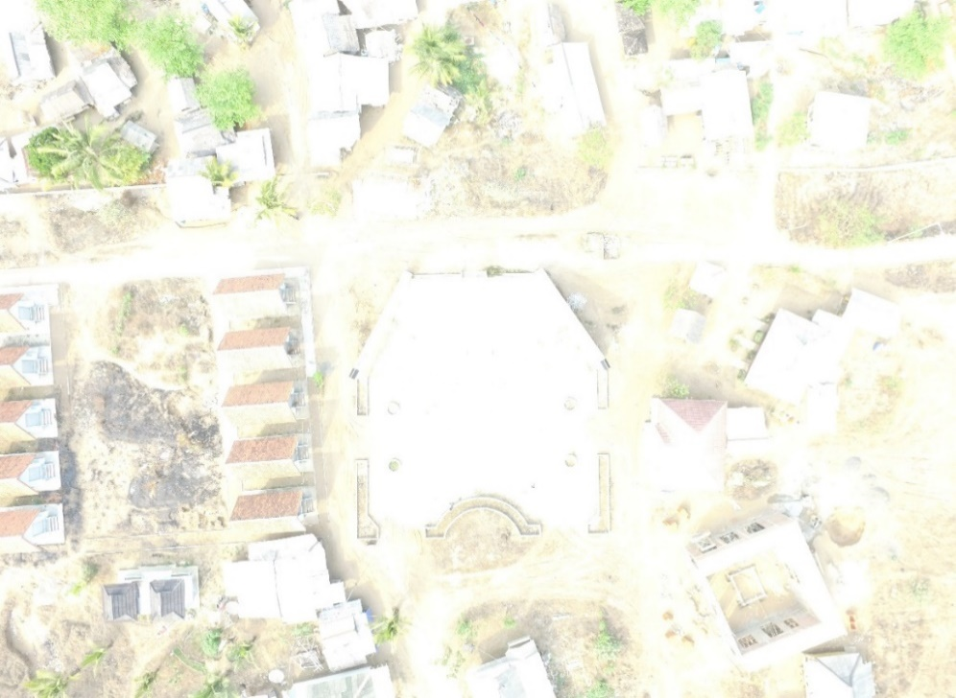

Photo 1. Entertainment Stage (in the middle) and Warung / Kiosk (left), vertical appearance (results of recording with drones, 14-9-2018).

It is planned that the Banten regional government will provide 150 stalls. Currently 60 units are being built, which have become 30 units. The stalls are for local residents.

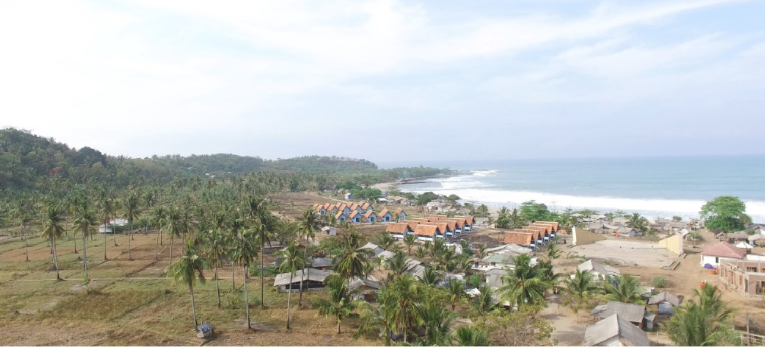

Foto .2. Panggung Hiburan (di tengah) dan Warung/Kios (sebelah kiri), kenampakan horisontal (hasil perekaman dengan drone, 14-9-2018).

The Banten regional government makes a rule, a coastal area at a distance of 50 meters from sea water, there should be no buildings (Map 2. Satellite imagery). In the satellite image, land use zoning is seen. The aim is to facilitate the future development of the Sawarna Coast area.

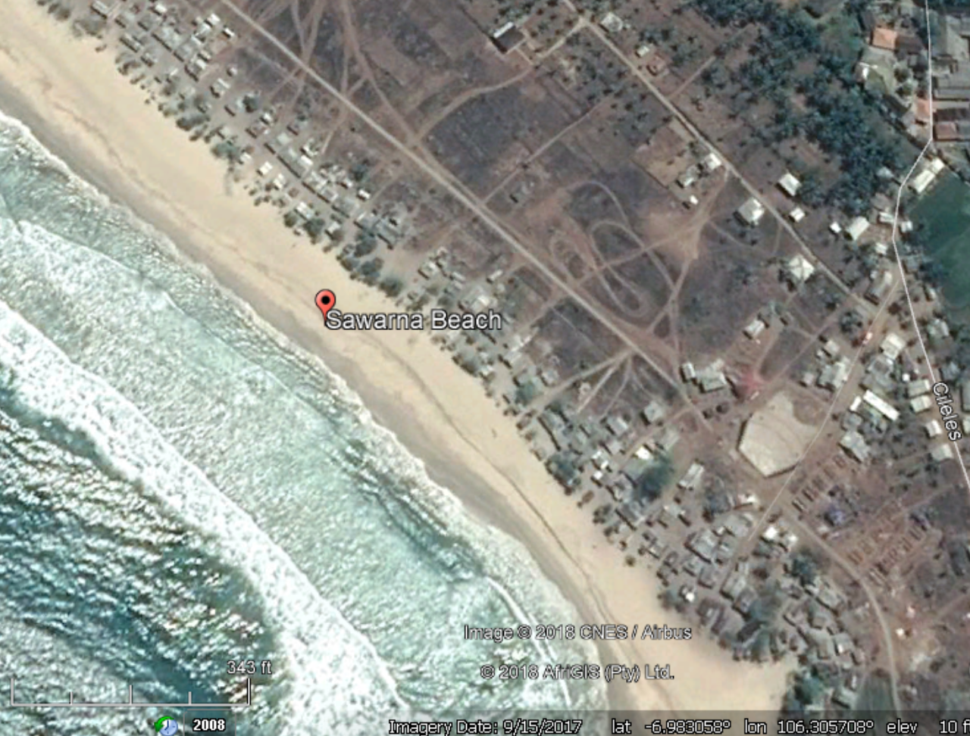

Map 2. Satellite image of the Sawarna area.

In the eastern region (Photo 3.) Sawarna Beach has a Fish Auction Place (TPI), so that the lives of fishing communities in the area receive good attention by the Regional Government.

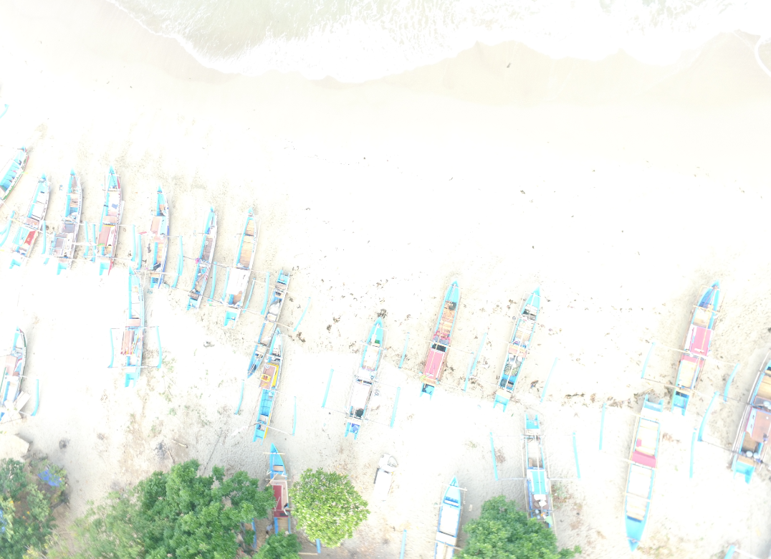

Photo 3. Ports and fish auction sites (results of recording with drones, 14-9-2018).

In this area there are still many paddy fields, this shows that rice farming in Sawarna is still going well (Photo 4).

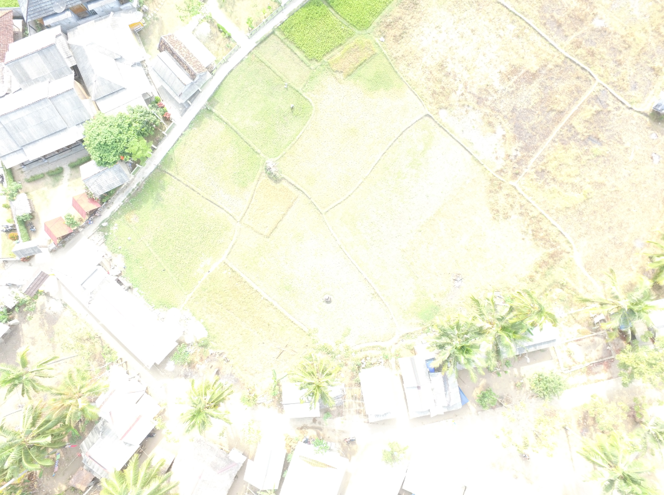

Photo 4. Rice field area (results of drone recording, 14-9-2018).

Land use around the highway in the form of residential and lodging (home stay) (Photo 5). Lodging facilities are adequate. Facilities and infrastructure at the complete accommodation.

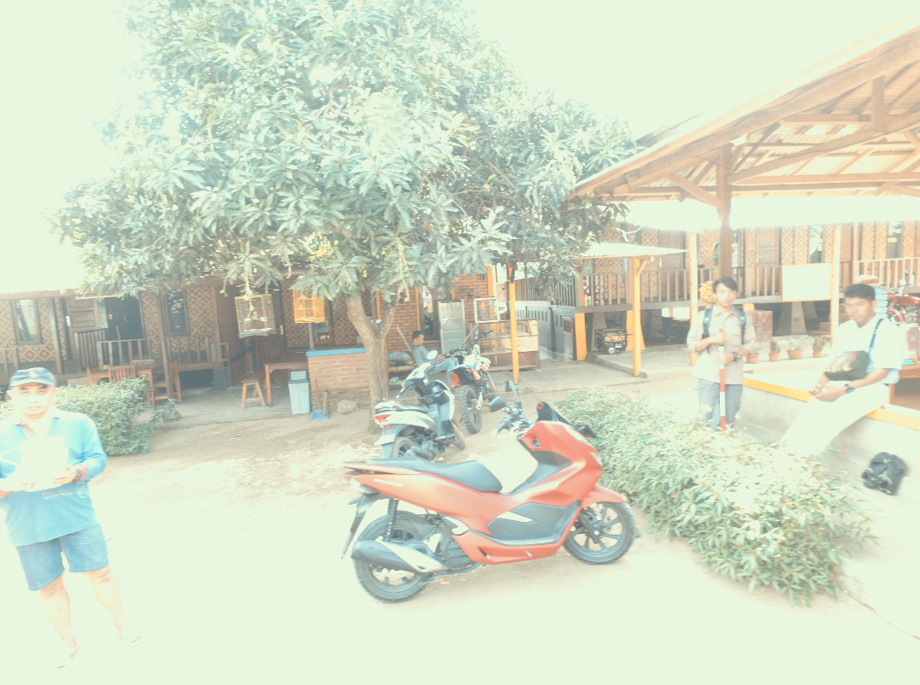

Photo 5. Research team prepares mapping with drones (results of drone recording, 14-9-2018).

Based on the results of meetings with the community and village officials, the Sawarna Beach tourism area is currently being revamped by the Banten Provincial Government through the Tourism Office. The construction of facilities and infrastructure (Stage of Entertainment and Permanent Stalls) is a Regional Government Work Program. The community wants a "certified" training on knowledge of natural tourist objects, especially cave attractions, so they cannot compete with tour guides from outside the region.

1. **Conclusion**  
   Based on the results of the study, it was concluded that the development of Sawarna Beach towards sustainable development was strongly supported by the local community and local government. The community wants certified learning in handling the development of Sawarna Beach in a sustainable manner.

**REFERENSI**

Ahman Sya dan Hamsu Hanafi, *Geologi Pariwisata (Promosi Studi Geologi: Objek dan Daya Tarik Wisata)*, Bandung: Paramedi Komunikatam, 2018.

Christian N. Madu, *Environmental Planning and Management,* New York: Imperial College Press. 2007.

Gordon Dickinson and Kevin Murphy, *Ecosystems*, New York: Routledge, 1998.

James P. Lester, *Environmental Politics and Policy*, London: Duke University Press, 1995.

Malcom Newson, *Land, Water and Development*, New York: Routledge, 1997.

Mark J. Smith, *Thinking through the Environment*, New York: Routledge, 1999.

Michael Pacione, *Applied Geography: Principles and Practice*, New York: Routledge, 1999.

Barrow, C.J. *Environmental Management for Sustainable Development (Second Edition)*, New York: Routledge: 2006.

Notohadiprawiro, Tejoyuwono. 2006. *Kemampuan dan Kesesuaian Lahan: Pengertian dan Penetapannya.* Yogyakarta: Ilmu Tanah Universitas Gadjah Mada.

Richard John Huggett, *Environmental Changes (The Evolving Ecosphere)*, New York: Routledge, 1997.

Robert J. Kodoatie, *Tata Ruang Ari Tanah*, Yogyakarta: Andi. 2012.