**The Communication Strategy of Female Candidates in Elections 2019 through Social Media**

**Vera Wijayanti Sutjipto, M.Si., Maulina Larasati Putri, M.I.Kom., Dr Kinkin Yuliaty Subarsa Putri., Aisya Tanzil**

**Fakultas Ilmu Sosial Prodi Ilmu Komunikasi Universitas Negeri Jakarta**

[**verawijayanti@unj.ac.id**](mailto:verawijayanti@unj.ac.id)**.,** [**maulinalarasati@unj.ac.id**](mailto:maulinalarasati@unj.ac.id)**.,** [**kinkinsubarsa@unj.ac.id**](mailto:kinkinsubarsa@unj.ac.id) **.,** [**aisyatanzil02@gmail.com**](mailto:aisyatanzil02@gmail.com)

**Abstract**

This research is about the strategy of political communication from national level women legislative candidates in the previous election 2019, especially political communication through social media. Starting with the rapid development of the internet, so many people take advantage of social media. Social media is used to facilitate individuals to connect with other individuals without being constrained by time and place. But now the use of social media is developing, one of which is used as a media campaign by politicians. In order to analyze the communication strategies of the female candidates, questions were asked regarding the management of women's social media during the campaign period. This research is qualitative research with in-depth interviews with two speakers who are female candidates from PKS and PKB parties. Data analysis is done by using data analyzed, then data reduction, then the data is presented and conclusions are drawn. The results of this study indicate that the two female politician candidates have social media, but for the purpose of their campaign, they did not use the social media maximum. This can be seen from their posting during the campaign, which was a few posts related to the election. The two women candidates considered the campaign through social media to be ineffective compared to going into the field and meeting with the community.

Key Words: Female Politicians, Social Media, Campaigns, Communication Strategies

**Introduction**

The reason why female candidate failed to Senayan (legislative candidates election), it could be because of the inability to do the effective campaigns (Suryati, 2018). One effective campaign is to carry out creative campaigns, where female candidates can convey their ideas in a non-boring way. Creative campaigns can be done by using media to communicate with their constituents, whether through conventional media such as print, radio, and television, or using new media.

The use of new media, due to the development of internet technology, has become one of the political channels, where people use it to read and express their political opinions (Heryanto, 1998). The first political campaign in the world that uses the internet, as a new media in the political campaign Bill Clinton and Al Gore, where the text of the speech from Clinton, was disseminated through the internet (Heryanto, 1998). Internet use in the campaign was also carried out by Barrack Obama, where through his campaign team called Triple O (Obama's Online Operation) conducted a campaign by utilizing social media, including Facebook, MySpace, and Twitter (Heryanto, 1998).

New media began to be used as campaign media in Indonesia since the 2014 election. KPU commissioner in 2014 election, Sigit Pamungkas stated that the use of social media as campaign media was not regulated by the General Election Commission Regulation (PKPU), it is allowed if election participants used social media for political campaign advertisements, deem not to violate the rules. (Harera, 2013). The use of new media can help legislative candidates to be closer to their constituents, without having to incur large costs, especially internet users in Indonesia are growing rapidly, as shown in the diagram below:

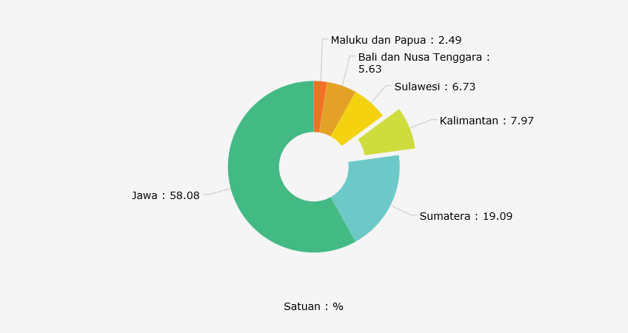Table I.2. The Composition of Internet Users in Indonesia by Island (2017)

(Source: https://databoks.katadata.co.id/datapublish/2018/02/22/pengguna-internet-indonesia-masih-terkons concentration-di-jawa, accessed on April 5, 2019, 13.01 WIB)

The people who use the internet in Indonesia, mostly are in Java, which is 58.08%, then the people in Sumatra are around 19.09%. Based on data, there are around 87.13% who access the internet, also accessing social media. In 1998, there were only around 500 thousand users using the internet in Indonesia, but in 2017, there was a rapid increase in internet users, reaching more than 100 million. The driving factors of internet users rose, among others, increasingly sophisticated and advanced technological developments, the breadth of internet service coverage and the more affordable smartphone prices.

Based on data from APJII, in 2017 there were 142 million people using the internet, meaning that there was a penetration of around 54.69 percent of the population. There was an increase of around 7.9% of internet users from 2016 to 2017, compared to the last 10 years, internet users rose by around 600%. People who use the internet from year to year will increase, this is affected by more and more Menara Base Transceiver Station (BTS) is built, new satellites have been launched by the Indonesian government so that East Indonesia is covered by internet services and fiber optic network expansion.

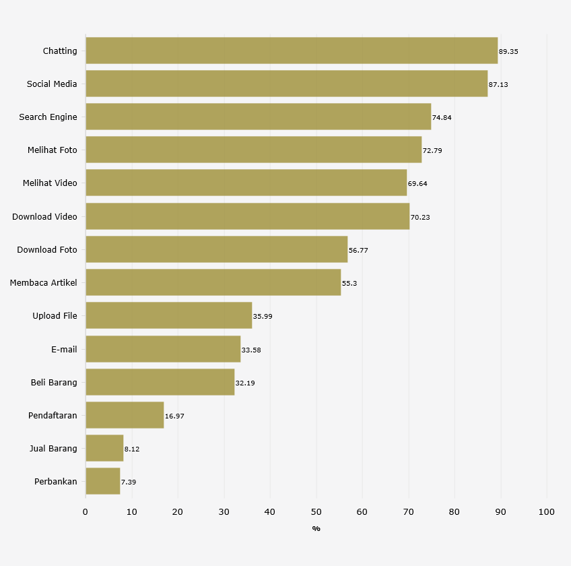Table I.3. Use of Internet Service Applications According to the 2017 APJII Survey

(Source: https://databoks.katadata.co.id/datapublish/2018/02/21/chatting-aplikasi-paling-digemari-masyarakat-indonesia, accessed on March 2, 2018, 13.01 WIB)

(Katadata.co.id, 2018)

Creative campaigns are needed by female candidates considering the number of millennial voters in the 2019 Election is around 45 percent of the total voters. CSIS (Center for Strategic and International Studies) classify the age of 17 years to 29 years as a millennial group. CSIS conducted a survey during the period of August 23-30 2017, the survey was conducted on 600 millennial people. Media that are considered relevant as sources of information for millennials include radio, television, newspapers and online media, of the four types of media, the highest penetration of online media, where 54.3% of millennials access social media every day, 8.3 % access online media 1-2 days, 6% access online media 3-4 days, 4.3% access online media 5-6 days, the remaining 27% never access online media.

Based on the reasons above, the researchers wanted to know how the strategy of campaigning for female politicians through the use of social media.

**Methods**

This study uses a qualitative approach, where data collection techniques with in-depth interviews and document analysis in the form of postings of social media candidates, which are used during the campaign. In-depth interviews were conducted with two female legislative candidates from different parties, assuming each party had a different campaign strategy so that it would also influence the campaign strategy used by female candidates.

Questions to be asked to female candidates include how to conceptually plan. There are 3 (three) phases that must be done in conceptual planning, namely situation analysis, strategy decision, and strategy implementation (Schroder, 2003). The next question is, who is the target group in their campaign. The target group is part of the general public, identifying the target group aims to determine the direction of communication so that communication objectives are achieved (Schroder, 2003). The next question is what is the target image desired by female candidates when conducting political communication through social media. The usefulness of the target image is to provide a picture that is in the shadow of the target community or group within a certain period, sometimes the picture of the candidate is not yet there or is still empty. That means the community or target groups do not know the legislative candidate (Schroder, 2003). One of the requirements to build an image is popularity, but it is popular in a positive sense, not a negative meaning, such as a popular legislative candidate because of corruption cases, certainly not beneficial for the legislative candidate (Schroder, 2003).

The first speaker was Anis Byarwati, the legislative candidate from the PKS in the 2019 Election for the Indonesian Parliament, Anis represented the electoral district (I) in Jakarta. In daily life, Anis works as a lecturer at the Yarsi University Postgraduate Program. Besides being a lecturer, Anis was also active in the PKS party. In 2012, she was the Chairperson of the PKS DPP in the field of women. Anis was born in Surabaya in 1967, married in 1989 with eight children. Anis studied Bachelor Degree in two places, first, the Financial Management Department at the Jakarta Corporate Leadership Academy, second at the Al-Hikmah Islamic College in Jakarta, Special Program in Arabic Language specializing in Hadith Interpretations and At-Taqwa Islamic College in Bekasi, Department of Da'wah and Islamic Broadcasting. Master Degree education is taken at the University of Indonesia, Department of Economics and Islamic finance with a choice of Banking concentration. Doctoral Degree in Airlangga University, Department of Islamic Economics.

Second speakers, Hj. Vera Susanti, S.AG., MPd, is a female legislative candidate from the PKB, the chosen region (electoral district) 7 with number 6 for the DPR RI. Vera works as an entrepreneur, studying a Master Degree at UNJ majoring in environmental. Vera was born in Bandung in 1973, married and blessed with three children.

**Findings and Discussion**

**A. Information on Social Media for Candidates**

The first speaker was Anis Byarwati, the legislative candidate from PKS had several social media such as Instagram, Facebook, and Twitter. The name of the Instagram account is @anis_byarwati. On Instagram, Anis has 143 followers and 23 accounts followed by Anis. On Anis’s Instagram, there have been 75 posts, with the first posting on September 30, 2018, and the last posting on June 29th, 2019. Anis has a tagline on his Instagram that is "Together to Realize a Qualified Indonesian Family".

Besides Instagram, Anis also has other social media, namely Facebook. Anis's Facebook account name is Anis Byarwati I and Anis Byarwati II, each of these accounts has approximately 2500 friends. Anis seems to be more active using Facebook than other social media. In Anis Byarwati I's account, the last post was on July 3rd, 2019, while the last post was in Anis Byarwati II's account on May 2nd, 2019. Based on his post, Anis Byarwati I contained more daily activities as an activist or lecturer, while Anis Byarwati II, the post is more dominant about family.

The next social media that is owned by Anis is Twitter with the account name @anisbyarwati. Anis has this account since April 2010. Anis has 283 accounts following her, while Anis only follows 2 accounts. Anis rarely uses Twitter, seen from the first post on April 10, 2010, while the last post was on November 3rd, 2011. The timeframe, Anis only posted 4 (four) times, the theme of her posting is about her family.

The second speaker, Vera Susanti, candidates from PKB have active social media, such as Facebook and Instagram. Vera's Facebook account name is Vera Susanti, this account has 865 friends. Vera's last posting was June 25th, 2019, the majority of posts on Vera's Facebook were Vera's activities in the women's organization Nahdatul Ulama (NU), where Vera was the Chairman of the NU Women's Association (GOW) in Bekasi with a term of 2019-2024. The second social media used by Vera is Instagram with the account name @verasusanti3. Vera has 204 followers, Vera itself follows 98 accounts with 83 posts.

**B. Campaign Strategy: Situation Analysis**

The first step in the political strategy in the campaign is to make conceptual planning, where female candidates must analyze the situation first, so as to facilitate candidates to determine the target audience. Anis, the legislative candidate from PKS also conducted a situation analysis first, as an active PKS cadre, Anis had identified the target. The focus of Anis's campaign is family-themed, so Anis identifies that the target audience is young mothers, so that in the selection of social media Anis is more focused on Facebook, assuming Facebook is used more by generations above 20-39 years (Katadata.co. id, 2019). Although using Facebook as a media campaign, Facebook is not the main media. Anis prefers to meet directly with the target audience, usually through seminars, counseling or recitation.

The same thing was done by Vera, candidates from PKB. Vera conducted a situation analysis first, this analysis was carried out by Vera herself based on her observations, Vera identified her imaginary targets as mothers who were actively involved in women's organizations and housewives, so Vera decided not to rely on social media. Vera considers social media to be ineffective compared to meeting directly with its target audience. According to Vera, when meeting with the audience it will be easier to remember by audiences than through social media, besides that most of the mothers who were targeted by Vera, do not have social media applications.

**C. Campaign Strategy: Target Image**

The next campaign strategy is to form the target image. The target image is what the legislative candidates want to be seen by the community and how the strategy is. Anis stated that the image target during the campaign was the same as before Anis became a legislative candidate. Anis does not want to change the existing image, as Anis is a PKS activist who fights for issues related to the family, such as Anis's statement below:

"... being a candidate does not mean we have to change who we are ..."

Anis also stated that:

"... personal branding does not mean that we juggle the public's will, no, that's how it is. That is not natural. ee ... so see how I and do not make the legislative candidate come out from the original so, later ee ... it's all troublesome, I'm bothered. it's not natural ... "

PKB Candidate, Vera, does not have an image target, according to Vera, the community can judge her as it is, so far Vera has been known as an entrepreneur, a female activist from Nahdhatul Ulama and one of the PKB party administrators in Bekasi district.

**D. Campaign Strategy: Management of Social Media**

Although social media is not the main media campaign of legislative candidates, however, during the social media management campaign carried out by special teams, such as Anis's revelation, below:

"... yes the team holds Twitter, they hold Instagram ..."

Even though there was a special team, Anis did not hand over all the management to the team, such as the contents of the media, it was the result of writing from Anis herself, the team’s task was editing. Especially for Facebook, Anis has managed it herself. The reason is Anis's message is intended to be conveyed to the public as Anis's idea, which is written using the language that is easily understood by the audience, so that it does not lose its meaning if written by the team, Anis feels the purpose of the writing is not conveyed. The Anis team consisted of 3 (three) women, like Anis, Vera’s team also consisted of 3 (three) women. Anis teams task is to be responsible for managing Twitter accounts and Instagram if it's an account. Team Anis, not only handles social media, they also handle conventional media, such as banners, leaflets, brochures, and souvenirs.

PKB candidates, Vera has social media namely Facebook and Instagram. Management of Facebook and Instagram is done alone. During the campaign, Vera had a campaign team that created content for social media, but Vera herself uploaded to Facebook and Instagram, before uploading, the content was checked by Vera first.

**E. Campaign Strategy: Financing**

The financing for the Anis campaign media is assisted by parties, donations, and personal funds. Anis does not use television and radio media, because it avoids even greater financing.

Vera is also not much different from Anis, but party assistance is not obtained. Funding in managing campaign media comes from the help of friends and from their own funds. The campaign media used by Vera is more in the form of brochures, banners, and brochures.

**Conclusion**

This study concludes that the communication strategies of female candidates in the previous 2019 election using social media are as follows:

A. Both female candidates have more than one type of social media. They have had social media for a long time, during the campaign they did not create a special account. Their campaign posts on social media, combined with personal posts or other activities.

B. Campaign strategy in the situation analysis. The two candidates first conducted a situation analysis before using social media on their campaign. But the analysis they do is not well structured. Anis was doing an analysis of the situation based on her experience among women, where Anis always cares about family problems. When Anis was appointed as a legislative candidate from PKS, Anis did not spend time specifically with her success team, to identify the strengths and weaknesses of the social media she used. The same thing was done by Vera legislative candidates, where Vera conducted a situation analysis based on her experience and observation as a PKB activist and chairman of the Bekasi branch of the Women's Association (GOW). Vera concluded that using social media in the 2019 Election campaign did not have a significant impact, compared to if Vera went directly to the field, Vera argued that the majority of the public were not exposed to social media because they were housewives living in the suburb of Bekasi.

C. Campaign strategy on the target image

The two candidates, do not have a target image strategy, like what they want. Anis stated that she did not want to pretend to be someone else, she still wanted to be herself. The same statement was delivered by Vera when Vera was appointed to be a candidate representing PKB, Vera did not make changes to her, Vera wanted her supporters to judge her for who she was.

D. Campaign strategies in managing social media

The two candidates in managing campaign media were assisted by the team. But not all media is handled by the team, especially messages posted on social media. Anis handles his Facebook content on his own, while Instagram and Twitter are handed over to her success team. Media campaigns outside online media are also handled by her success team. Vera is the same as Anis, Vera's Facebook is managed by herself, but Instagram is submitted to the success team.

E. Campaign strategy in financing

Financing in the management of media from two candidates from several sources, such as Anis, most of the funds come from personal sources, some of which are assisted by friends and parties. The same thing with Vera, most of the funds were from personal sources, but Vera was not assisted by party funds.

# References

CSIS. (n.d.). *Ada Apa dengan Milenial? Orientaso Sosial,Ekonomi dan Politik.* Retrieved from https://www.csis.or.id/uploaded_file/event/ada_apa_dengan_milenial____paparan_survei_nasional_csis_mengenai_orientasi_ekonomi__sosial_dan_politik_generasi_milenial_indonesia_notulen.pdf

Harera, M. M. (2013). *KPU Persilakan Parpol dan Caleg Kampaye Di Media Sosial*. Retrieved from www.merdeka.com: www.merdeka.com/politik/kpu-persilakan-parpol-dan-caleg-kampanye-di-media-sosial.html

Heryanto, G. G. (1998). *Media Komunikasi Politik, Relasi Kuasa Media di Panggung Politik.* Yogyakarta: IRCiSOD.

Ilham Rian Pratama. (2008). *KPU Tetapkan Jumlah Caleg DPR*. Retrieved from Tribunenesw.com: http://www.tribunnews.com/nasional/2018/09/20/kpu-tetapkan-jumlah-caleg-dpr-terdiri-dari-4774-caleg-laki-laki-3194-caleg-perempuan?page=3.

Katadata.co.id. (2019, Mei). *Usia 20-29 Tahun Domniasi Pengguna Faceboo di Indonesia*. Retrieved from https://databoks.katadata.co.id: https://databoks.katadata.co.id/datapublish/2016/11/03/usia-20-29-tahun-domniasi-pengguna-facebook-di-indonesia

Katadata.co.id, A. (2018). *Chatting Aplikasi Paling Digemari Masyarakat Indonesia*. Retrieved from www.katadata.co.id.

Rahkmatulloh. (2014). *KPU Nilai Caleg Perempuan Di Pemilu 2014 Meningkat*. Retrieved from https://nasional.sindonews.com: https://nasional.sindonews.com/read/839925/113/kpu-nilai-caleg-perempuan-di-pemilu-2014-meningkat-1393558129

Schroder, P. (2003). *Strategi Politik, Edisi Revisi Untuk Pemilu 2009.* (I. D. Denise Joyce Matindas, Trans.) Jakarta, Indonesia: Friedrich-Naumann-Stiftung Fur die Freiheit.

Suryati. (2018). *Kampanye Efektif Caleg Perempuan*. Retrieved from www.news.detik.com: https://news.detik.com/kolom/d-4240340/kampanye-efektif-caleg-perempuan