**A TASK FORCE FOR STRENGTHENING CHARACTER EDUCATION**

**(SATGAS PPK)**

**Vina Resa Fitri Rahayu1, Zainal Arifin2**

1,2Graduate School, Universitas Negeri Yogyakarta

1[vinaresa@gmail.com](mailto:vinaresa@gmail.com), 2zainal_arifin@uny.ac.id

**Abstrak**

Penelitian ini bertujuan untuk menganalisis pelaksanaan manajemen sumber daya manusia di SATGAS Penguatan Pendidikan Karakter Kabupaten Sukabumi. Penelitian ini merupakan penelitian kualitatif dengan menggunakan pendekatan studi kasus. Teknik pengumpulan data menggunakan observasi, wawancara dan dokumentasi. Subjek pada penelitian ini adalah ketua umum SATGAS, ketua harian SATGAS, perwakilan anggota SATGAS, dan lembaga mitra SATGAS. Hasil penelitian menunjukkan bahwa (1) penentuan anggota dilakukan melalui analisis kebutuhan, penentuan anggota secara umum, pembagian komisariat, penentuan kuantitas anggota, dan penentuan kualitas anggota, (2) rekrutmen dilakukan melalui penyebaran undangan khusus kepada wakasek kesiswaan SMP sekabupaten Sukabumi, (3) seleksi anggota dilakukan dengan menggunakan *voting,* (4) penempatan anggota dilakukan dengan pemberian tugas dan tanggungjawab sebagai koordinator komisariat, (5) pengembangan anggota dilakukan oleh lembaga mitra, (6) tidak ada pemberian kompensasi untuk anggota, (7) pengintegrasian dilakukan dengan pengambilan jalan tengah pada setiap perbedaan-perbedaan yang muncul kemudian disepakati bersama, (8) pemeliharaan anggota dilakukan dengan memberikan fasilitas pendukung, dan (9) pemutusan hubungan kerja belum pernah dilakukan.

***Kata Kunci: manajemen sumber daya manusia, SATGAS, penguatan pendidikan karakter.***

**Abstract**

This study aims to analyze the implementation of human resource management in SATGAS PPK (Task Force of Strengthening Character Education) in Sukabumi District. This research was qualitative study using case study approach. Data collection techniques used observation, interviews and documentation. The subject of this study were General and Daily Chair of SATGAS PPK, representatives of SATGAS PPK members, and partner institutions of SATGAS PPK. The results of the study showed that (1) the determination of members was carried out through needs analysis, determination of members in general, division of commissariat, determination of quantity of members, and determination of the quality of members, (2) The recruitment was done through the dissemination of special invitations to the Assistant Principal of Student Affairs of Junior High Schools level in Sukabumi District, (3) The selection of members were done by using voting, (4) The placement of members was carried out by giving assignments and responsibilities as the coordinator of commissariats, (5) The development of members was carried out by partner institutions, (6) The compensation for members was not provided, (7) The integration of members was carried out by taking a middle decision on any differences that arise then agreed upon, (8) The maintenance of members was carried out by providing supporting facilities, and (9) the termination of employment had never been done.

***Keywords: Human resource management, SATGAS, strengthening character education.***

1. **INTRODUCTION**

In the era of globalization and modernization, the development of science and technology is felt so rapidly by all countries including developing countries such as Indonesia. The development of science and technology is very positive for human life because people's activities will be much easier. However, globalization and modernization that have a positive impact also have a negative impact, especially in Indonesia, where most of people are not yet fully prepared.According to the results of a survey conducted by LIPI (2015) on the Community preparedness Index (Indeks Kesiapan Masyarakat/IKM) in the three provinces namely West Sumatra, Special Region of Yogyakarta, and South Sulawesi with a total number of respondents as many as 4561 showed that the three provinces were still relatively unprepared in facing the phenomenon of globalization.

One of the negative effects of globalization and modernization is that many people have known and even imitated the external values and culture that come to Indonesia which causes the fading of indigenous Indonesian culture itself. The negative impact caused by globalization and modernization is very clearly seen in all circles of Indonesian society, including student circles. One of the results of the negative impact is the decline in character of students shown by the rise of juvenile delinquency in student circles which happen in almost every region in Indonesia.

Delinquent behaviors committed by students in this modern era has exceeded the reasonable limits such as drugs, free sex, scribbling/graffiti on public facilities, and gang formation. As stated by Zuchdi et al., there are some worrying issues which describe the portrait of Indonesia. The first is about extramarital sex. Annisa Foundation (AF), in its research conducted in July to December 2006, which took 412 respondents from 13 public and private junior high schools (SMP) and senior high schools (SMA) stated that 42.3% of junior and senior high school students in Cianjur had having sex outside of marriage. The second is related to abortion cases. Based on data from the World Health Organization (WHO), it is estimated that 2 to 2.6 million cases of abortion are found or 43 abortions occur for every 100 pregnancies and 30% of them are estimated to be committed by occupation ages 15-24 year. And the third case is about gangs. The student gang in SMA Negeri 34 (one of exemplary and favorite high schools in Jakarta) committed torture to junior students. The seniors who are members of this gang also often committed bullying to their juniors by asking their belongings or money forcefully (Furkan, 2013).

Another character deterioration leads to criminal acts, for example acts of violence that occur among students, brawls. In Sukabumi, West Java, there was a brawl in November 2013 between students from two different schools. Quoted from ***kompasiana.com*** that the fight between students was known as hereditary brawls and often occurred. This brawl was an act of mutual revenge from the previous generation. They carried out the action armed with sharp weapons. From this incident four students were killed.

Based on data obtained from the Head of Sukabumi District Police Intelligence Unit from 2013 to 2017, student brawls often occurred in Sukabumi District and always caused casualties or damaged to facilities. In 2013 there were two incidents of brawls among students on November 9, 2013 which caused 4 students died. Then on November 16, 2013 was an act of revenge from the victimized school. As a result of this incident the school buildings where the students became suspects were damaged. On October 2015, a brawl occurred between Technical High School (STM) students and Vocational High School (SMK) students which caused 1 student dead. On February 2017 there was a brawl between junior high school students causing 1 victim to die from drowning in the river. In addition to the real world, junior high school students in Sukabumi District also often committed delinquent behaviors in cyberspace. Quoted from ***Radarsukabumi.com***, stated that based on the results of its monitoring to a junior high school group in Sukabumi on Facebook social media, whose members has reached 19,495 people, the majority of whom are junior and senior high school students in Sukabumi District and from outside of Sukabumi district. In this social media group there were many statuses that led to mutual ridicule, mutually challenging status and even contain solicitation of buying and selling weapons that were used for brawls. In addition to brawl cases, other data released by the Chief of Sukabumi District Police Narcotics Investigation Unit showed that the cases of narcotics abuse crimes from 2013 to 2017 indicated that there had been 6 incidents of drug abuse that the perpetrators were students.

Willis (2005) said that there are no specific solution that can be used as a cure for juvenile delinquency problems, because the factors of those problems are different. This caused a lot of different efforts and a variety of measures to overcome these problems. Overcoming student delinquency problems is a joint task and responsibility. Not only schools as individuals but also the government, officials and special institutions have the same responsibility in overcoming these problems. Therefore, there is a need for unity between all schools in an area assisted by the government, officials and special institutions in preventing and overcoming delinquent behaviors and providing character education for students.

Education Office of Sukabumi District formed a Task Force with the name SATGAS PPK (Task Force for Strengthening Character Education) in 2017. This task force was formed on the basis of concerns and anxiety regarding students' delinquent behaviors and student moral crisis, especially in Sukabumi District. Through this SATGAS PPK organization, the Education Office of Sukabumi District together with all parties involved to carry out the same tasks and functions in strengthening character values to students by reducing the number of students’ delinquent behaviors, especially in Sukabumi District. So that in the future there will be a reduction in the number of delinquency committed by students, especially in Sukabumi District and also as the result, all students in Sukabumi District have noble character. Later on, students are expected to no longer do delinquent behaviors or do negative things but things that are more positive.

In some books, the task force is the same as the team. A team is a number of people who come from different backgrounds, skills and knowledge. However, they work together in a particular task (Drucker, 1986). Likewise with this SATGAS PPK, the people involved in this force are varied including *internal stakeholders* consisting of the Head of Sukabumi District Education Office, Secretary of the Sukabumi District Education Office, Middle School Principals, Middle School Assistant Principal of Student Affairs; *external stakeholders* consisted of the Sukabumi District National Narcotics Agency, Sukabumi District AIDS Commission, Sukabumi District Police and City Police, City Military Command (KODIM) and Sukabumi District Military Command (KODIM), and Sukabumi Women and Children Forum (FORWA); and also this force involved all of junior high school in Sukabumi District consist of 324 schools (119 public schools, 162 private schools and 43 one roof (Satu Atap) schools). (Kusumah, 2017).

Thus, the purpose of this research is to analyze the implimentation of human resource management in in SATGAS PPK (Task Force of Strengthening Character Education) formed by Sukabumi District Education Office. Through this research, it is expected to know more about determination, recruitment, selection, placement, development, compensation, integration, maintenance to termination of employment in SATGAS PPK.

1. **METHOD**

This research is a qualitative research using a case study approach. The researcher used this type of research to analyze how the implementation of human resource management in SATGAS PPK in Sukabumi District intensively, in detail and in depth. This research was conducted in SATGAS PPK located at Pelabuhan II Street KM. 22, Cikembang, Cimanggu Village, Cikembar, Sukabumi District, West Java, in August 2018 until May 2019. Meanwhile, the subject resources in this study consisted of the General and Daily Chair of SATGAS PPK, representatives of SATGAS PPK members, representatives of partner institutions consisting of City police and Sukabumi District police, Sukabumi Women and Children Forum (FORWA), Sukabumi District National Narcotics Agency, Sukabumi District Military Command (KODIM), and Sukabumi District AIDS Commission (KPA).

The procedures of this study was carried out by the researcher through several steps including: (1) the *pre-field* step by looking for data and information on the research background. The design of the study was outlined in this step. The pre-field step was done from August to September 2018. (2) The *field work* step by conducting data collection. This step took place from October to December 2018. Then (3) the *data analysis* step by analyzing the data that had been collected previously. Data analysis was carried out by *member check*, then the results were compared with the theory of literature. This step took place in January 2019 until March 2019. And the last (4) *reporting* step by consulting the research to the experts till the final conclusion of the study. This step was performed in April 2019 until May 2019.

Data collection techniques in this study were through observation, interviews and documentation. In this study, the researcher used *overt observation*. Through this type of observation the researcher said frankly to the data resource that she was conducting a research. So the resources knew from the beginning till the end about the activities of the researcher. Whereas for interviews, the researcher used a structured interview type whose questions were prepared in advance by the researcher with an open type of question so the interviewees can freely answer. And to make it easier, the researcher also prepared a checklist sheet for the documents needed as a complement to the research data.

The validity of the data in this study included: (1) *credibility* or internal validity, (2) *transferability* or external validity, (3) *dependability* or reliability, and (4) *confirmability* or objectivity. While data analysis used a model developed by Miles & Huberman, namely *Interactive Model Analysis* which explains that the analysis is divided into four stages: (1) data collection, (2) data reduction, (3) data presentation, (3) conclusion/verification.

1. **RESULTS AND DISCUSSION**
2. **Results**

In this study, the researcher found several results which described how human resource management in SATGAS PPK in Sukabumi District was run. Based on the data obtained from observations, interviews and document analysis, it was known that the process of determining human resources in SATGAS PPK was done in several steps: (1) needs analysis, (2) determination of human resources to be involved in general, (3) commissariat division, (4) determination of human resources quantity to be involved, and (5) determination of human resources quality to be involved. While the recruitment process was carried out through the dissemination of invitations "The dissemination of overcoming for students delinquency in Junior High School level in 2017" which was only specifically sent to the Assistant Principal of students affairs of junior high school in Sukabumi District. Then, for the selection process in SATGAS PPK, voting was done to get the members. SATGAS PPK did not have specific standards or criteria for prospective members but only based on estimates (consideration) and experience. The next process of placement in SATGAS PPK was done by giving assignments and responsibilities to its members who were elected as coordinators of commissariats. Then for the process of developing human resources in SATGAS PPK, it was done by involving partner institutions as the main source in developing abilities and knowledge. The development activities were more in the form of discussions and lectures presented directly by partner institutions that were expert in their fields. The compensation process in SATGAS PPK was not done especially for financial compensation because the Sukabumi District Education Office as a policyholder did not provide a budget to pay the members of SATGAS PPK. Furthermore, the process of integration in SATGAS PPK was performed by taking a middle decision on any differences that arise which were then mutually agreed to avoid conflicts. Next, the process of maintaining human resources was done by providing supporting facilities for members in performing their duties and responsibilities in SATGAS PPK. And the last process of termination of employment in SATGAS PPK had never been done. Even if there was no longer joining SATGAS PPK, it was because of retirement as the teacher not due to the termination of employment.

1. **Discussion**
2. **Determination of Human Resources in SATGAS PPK**

Determination of human resource is same as human resource planning. Where it is a process of comparing human resource needs with their availability and determining whether the company has a lack or excess of personnel (Mondy & Noe, 2005). HRP is a process for knowing the needs and availability of human resources in an organization through analysis and identification so that later the organization can carry out its objectives (Mathis & Jackson, 2010). Employee planning estimates the demand for future employees, both in quantity and quality, comparing the expected demand with the current workforce, and determining the lack and excess numbers of employees based on the strategy and objectives of the institution (Riani, 2013). HRP is an organizational work in determinating workforce requirements that can help organization’s objectives for now and in the future (Samwel, 2018).

The determination of human resources in SATGAS PPK is firstly by considering the results of needs analysis by identifying internal organizational conditions using the approach of *man, money, minute, machine, method* and *material*. The results of the identification show that the *man* or human resources in Sukabumi District Education Office, especially student affair section of Junior High School, is only 6 people. If viewed from the number of people, it can be said to be sufficient, but in terms of understanding the students delinquency at SMP level, this is still very lacking. So it is decided that there will be additional personnel or human resources who will be directly involved in the implementation of SATGAS PPK by involving 324 Junior High Schools in Sukabumi District. Due to the large number of schools, those SMP schools are structured to be divided into 8 commissariats (sub-districts).

After the commissariat is divided, then it determines 5 people from each commissariat who will represent to become members of SATGAS PPK in District level. These pointed people to be the members of SATGAS PPK in District level became the coordinators of the commissariats. After the number of human resources has been determined, 5 people from 8 commissariats (40 people), then the determination of the quality of human resources will be involved in SATGAS PPK. There are no specific indicators in determining the human resources involved in SATGAS PPK, only the priority is indeed to the School Assistant Principals of Students Affairs. This is because Assistant Principal of student affairs is a person who is concerned directly with students every day.

Torrtington, Hall, & Taylor (2008:76) show a model of traditional manpower planning. It consist of:

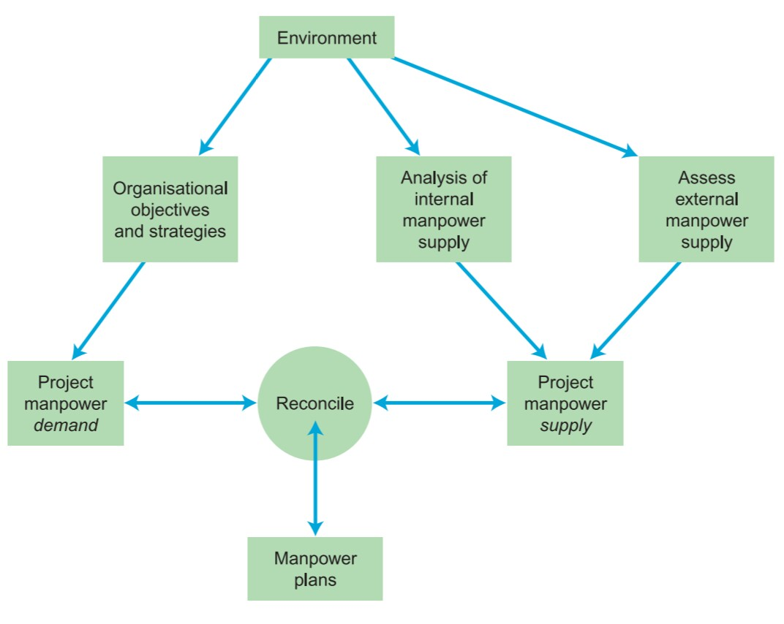

Human resource planning in SATGAS PPK also showed the same process, where:

* environment: Education Office of Sukabumi District/Assistant Principal of Student Affairs of Junior High School
* Organisational objective: to overcome delinquency in junior high school students
* Organizational strategies: (1) conducting programs to foster students in school environment in strengthening Character education using the form of KIE (Communication, Information, and Education), (2) monitoring all region of Sukabumi District, especially in vulnerable areas where student delinquency always occurs, in the form of patrol with SATGAS PPK members in each commisariat and related institution, (3) conducting communication and coordination with related institution
* Analysis of internal manpower supply: The Head of Sukabumi District Education Office, Secretary of the Sukabumi District Education Office, Middle School Principals, Middle School Assistant Principal of Student Affairs; the human resources in Sukabumi District Education Office, especially student affair section of Junior High School, is only 6 people.
* Assess of external manpower supply: partner institutions consisting of City police and Sukabumi District police, Sukabumi Women and Children Forum (FORWA), Sukabumi District National Narcotics Agency, Sukabumi District Military Command (KODIM), and Sukabumi District AIDS Commission (KPA).
* Project manpower demand: All of junior high school in Sukabumi District.
* Project manpower supply: Stakeholder internal *(*The Head of Sukabumi District Education Office, Secretary of the Sukabumi District Education Office, Middle School Principals, Middle School Assistant Principal of Student Affairs) and partner institutions.
* Reconcile: SATGAS PPK (Satuan Tugas Penguatan Pendidikan Karakter/(Task Force of Strengthening Character Education)
* Manpower plans: Involving all of junior high school in Sukabumi District (324 schools; deviding those junior high schools into 8 commissariats (sub-districts); determining 5 people from each commissariat; giving the priority to the School Assistant as members.

1. **Recruitment of Human Resources in SATGAS PPK**

Recruitment is the process of finding and attracting the capable applicants to be employed in and by an organization (Siagian, 2008). Recruiting is a process of finding the candidates who have the capabilities expected by the organization. Through this process there will be a union between people who have jobs and people who are looking for work (Decenzo & Robbins, 2005).

SATGAS PPK is not a "formal organization" which usually recruits employees with special standards. In SATGAS PPK, recruitment is done to get members only by giving invitations to all Junior High Schools (SMP) throughout Sukabumi District addressed to their principals so that they can assign their assistant of student affairs to attend the " The dissemination of overcoming for students delinquency in Junior High School level in 2017" in each commissariat.

Based on the existing documents, it was noted that the dissemination of overcoming for juvenile delinquency in SMP level in 2017 was scheduled to start from July 13 to July 20, 2017 at 8 commissariats with the following details:

1. Thursday, July 13, 2017; Located in SMPN 2 Cibitung was attended by the commissariat of Jampang Kulon.
2. Tuesday, July 18, 2017; Located in SMPN 1 Cikidang was attended by the commissariat of Cibadak and Cicurug.
3. Wednesday, July 19, 2017; Located in SMPN 1 Sukaraja was attended by the commissariat of Cisaat, Sagaranten, and Sukaraja.
4. Thursday, July 20, 2017; Located in SMPN 1 Cisolok was attended by the commissariat of Cikembar and Pelabuhan Ratu.

There are several steps in the recruitment process. One of them is choosing the right recruitment method. The recruitment method consists of two, a closed method and an open method. The closed method is the recruitment that is only informed to prospective employees or certain people, while the open method is recruitment that is widely informed such as by using advertisements (Setiani, 2013). If it is seen from the process in accordance with the results of interviews from several sources and data, SATGAS PPK uses a closed method in recruiting its members because the recruitment was only informed to prospective members through the invitation of "The dissemination of overcoming for students delinquency in Junior High School level" addressed directly to school assistant principals of students affairs.

1. **Selection of Human Resources in SATGAS PPK**

Selection is the process of selecting individuals who have relevant qualifications to fill jobs in an organization. Selection is far more than just choosing the best candidate. This is an effort to achieve a balance between what the applicant can and wants to do and what is demanded by the organization (Kumari, 2012).

The selection process in SATGAS PPK is only conducted through voting by the school assistant principals of student affair who attended each event of the dissemination of overcoming for student delinquency in SMP level in each commissariat to choose the representatives that they trusted from their commissariat to join as the member of SATGAS PPK in District level.

There are two methods that can be used in the selection process. The first is non-scientific method. Through this method, the selection process is not based on criteria, standards or specifications of the real needs of a job, but only based on consideration and experience. The second is scientific method. Through this method, the selection process is carried out by conducting a careful analysis of the elements to be selected such as the existence of tests for prospective employees (Pusparini, 2012).

Based on the existing data, SATGAS PPK tends to use non-scientific methods. That is because there are no specific criteria or standards set out as considerations for being selected as members of SATGAS PPK, especially at the District level. However, the chosen members are mostly the people who have more leadership spirit.

1. **Placement of Human Resources in SATGAS PPK**

Placement process is the main goal of selection that is placing someone in the right job position. Most importantly, the placement of human resources must be seen as a matching process. How well an employee fits into the job will affect the number and quality of his work (Mathis & Jackson, 2006). Placement is a process of placing someone who has been chosen at a certain position in a job (Daniel, Sanda, & Midala, 2014).

The placement process in SATGAS PPK is carried out by giving assignments and the responsibilities to members based on their leadership skills as coordinators in overcoming student delinquency. The people selected as members of SATGAS PPK have the duty and responsibility to coordinate their commissariat. Those duties and responsibilities are given directly by the Head of Sukabumi District Education Office through the Decree of the Head of Sukabumi District Education Office number 800/kep-1557/Bid SMP on Determining the Team for Forming SATGAS PPK, Overcoming Students Delinquency of SMP which includes 40 names of members (5 from each commissariat). The decree was signed by the Head of Sukabumi District Education Office on 29 September 2017.

The important thing in placement process is the matching process. It means that how suitable the employee (knowledge, skill and ability) with job position. The right employee placement will increase the employee morale (Martini, 2017). According to the representative of SATGAS PPK members, the duties and responsibilities given to him as the member and coordinator in SATGAS PPK organization match with his experience and activities in various organizations and institutions. Therefore, he is very happy to do his duties and responsibilities and consider them as an appreciation not a burden.

1. **Development of Human Resource in SATGAS PPK**

The development of human resources in an institution or organization is also very important in managing human resources. Development which includes training is an activity that aims to improve and develop attitudes, behavior, skills, and knowledge of the workforce that are matched to the needs of the company (Tulus, 1994). Alhalboosi (2018) shows the process of human resource development, such as:

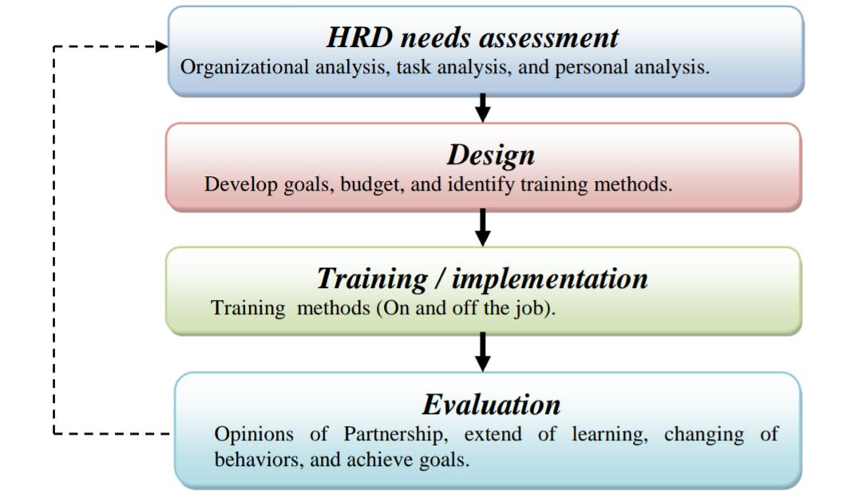

Based on the human resource development process above, SATGAS PPK only does a few of them. HRD need assessment is only done through task analysis, where the task of SATGAS PPK members is to overcome juvenile delinquency at the level of high school students, so they must have the knowledge and ability about juvenile delinquency and how to overcome it. While in the design phase, SATGAS PPK does not specify a special program. Development design submitted to partner institutions. Then for its implementation, partner institutions are more likely to develop members of the SATGAS PPK with lectures. And until now there have been no evaluations made regarding the development of human resources that have been implemented in SATGAS PPK.

1. **Provision of Human Resource Compensation in SATGAS PPK**

Compensation is a reward given to every employee or person who has performed his work or provided services for his workplace. Compensation is the same as providing rewards to employees in exchange for work performed and contributions to achieve organizational goals (Suwatno & Priansa, 2011). Tulus (1994) describes the form of compensation including money in the form of salaries and wages; allowances in the form of money; bonus. Natura in the form of rice, sugar, etc.; clothes; medicines; etc. And enjoyment in the form of house facilities for free or rent; vehicle facilities; medical checkup; etc.

There was no compensation for all SATGAS members especially for financial compensation. SATGAS members work voluntarily without reward. Sukabumi District Education Office did prepare a budget for the implementation of SATGAS PPK, but the budget was not provided to pay salaries for its members. The budget is only used for guidance (dissemination and socialization) in 8 commissariats, providing facilities such as HT (Handy Talky), uniforms and vests for 40 members of SATGAS PPK in District level.

1. **Integration of Human Resources in SATGAS PPK**

Integration is the union of desires between employees and organizations that tend to find differences. Integration is an important operational function of human resource management, but complex in realizing it. This is due to the fact that employees are dynamic living beings, have thoughts, feelings, traits, self-esteem, and have different backgrounds, behaviors, desires and needs (Sofyandi, 2008). Likewise with the SATGAS PPK, different desires always arise especially the differences that come from each member. This is because members of SATGAS PPK come from different educational backgrounds, regions, teaching places with the different characteristics of their students.

The Daily Chair of SATGAS PPK said that SATGAS PPK did not use a special method in terms of integration. If there are differences found, the method chosen is to take a middle decision and then form a collective agreement.

1. **Maintenance of Human Resources in SATGAS PPK**

According to Tulus (1994), maintenance is one of the important things in human resources management. Maintenance means keeping employees or workforce who are already in an organization or institution to remain willing to be together, maintain the attitude of cooperation and work ability of the employees and workforce. There are several programs that can be done in terms of employee maintenance including occupational safety and health programs and employee welfare programs such as recreational programs, cafes, housing, educational scholarships, financial and legal counseling and various other services.

SATGAS PPK does not provide special programs for its members in the context of maintenance. There is no occupational safety and health program, nor welfare programs for its members. The maintenance carried out by SATGAS PPK for its members is only in the form of providing facilities to facilitate their duties. Facilities provided for 40 members of SATGAS PPK in District level are Handy Talky (HT) with the status of "loaned". In addition, members are also given uniforms and vests labelled SATGAS PPK.

The absence of a special program provided by SATGAS PPK for the maintenance of its members is caused by a lack of budget. Inadequate budget has an impact on the absence of RPU (Re-Radiating Radio) so that the Handy Talky held by the members cannot yet be used to communicate in long distance place. Moreover, with the lack of a budget, SATGAS PPK has not been able to provide welfare programs for its members such as recreational programs. However, the provided solution to reduce these constraints is to continue to submit budget proposal and to communicate through *WhatsApp* group as a solution.

1. **Termination of Employment of Human Resources in SATGAS PPK**

According to Raharjo (2013), the function of the relationship termination or often called *separation* is the last function in human resource management which includes the termination, separation or termination of employment. This function occurs because of several reasons including the existence of legislation, company wishes, employee desires, retirement, the expiry of employment contracts, employee health, death, and the liquidation of company.

During the establishment of SATGAS PPK from 2017 until now there is no termination of employment. If there are members who leave or no longer work with SATGAS PPK, this is because they are already retired from their jobs as teachers not because they quit or are dismissed as members of SATGAS PPK.

1. **CONCLUSSION**

Human resource management is one of the important things for organizational success. Because through human resource management, problems related to recruiting and applying workforce for an organization to achieve predetermined goals will be more effective and efficient. This is also done by the Task Force of Strengthening Character Education (SATGAS PPK). SATGAS PPK have performed the human resource management well starting from:

1. The process of determining human resources is carried out through:

* Analyzing the needs using 6M approach (which shows whether the personnel / human resources to carry out the duties of SATGAS PPK is lack or not),
* Determining human resources to be involved in general by involving 324 schools throughout Sukabumi District,
* Dividing those 324 schools into 8 commissariats: Sukaraja, Cisaat, Cibadak, Cicurug, Pelabuhan Ratu, Sagaranten and Jampang Kulon,
* Determining the quantity of human resources from each commissariat, namely 5 people from each, so the number of human resources to be involved are 40 people,
* And determining the quality of human resources, namely school assistant principals of student affairs.

1. The recruitment process is performed through the dissemination of invitations addressed specifically to the assistant principals of student affairs of SMP throughout Sukabumi District.
2. The selection process is done by *voting* method
3. The placement process is carried out by giving assignments and responsibilities as coordinators of commissariats.
4. The development process is carried out by involving institutions that have already partnered
5. The integration process is done by taking a middle decision from any differences then agreed upon
6. The termination of employment process has never been done

But the compensation and maintenance of human resources are not maximally provided by SATGAS PPK due to the insufficient budget. Therefore, compensation is not provided while the maintenance process is provided through giving clothes, hats, vests and loaned HT (Handy Talky). In the future, it is expected that Education Office of Sukabumi District can provide a budget for compensation and manintance for members of SATGAS PPK.

With the results of this study, it is expected to be used as a reference for further researchers and also references for other regions with similar problems related to strengthening character education for students by forming Task Force (SATGAS) which has been done by the Education Office in Sukabumi District for the realization of students with positive character. And also it is expected to be used as an evalution material for Education Office of Sukabumi District.

**ACKNOWLEDGEMENT.** The researcher would like to express her special gratitude to Universitas Negeri Yogyakarta, Dr. Zainal Arifin as the consultant, Education Office of Sukabumi District, General and Daily Chair of SATGAS PPK, representatives of SATGAS PPK members, City police and Sukabumi District police, Sukabumi Women and Children Forum (FORWA), Sukabumi District National Narcotics Agency, Sukabumi District Military Command (KODIM), Sukabumi District AIDS Commission (KPA), her beloved parents (Irta and Iis Aisyah), brothers, her fiancee (Rusliana), and also Wilis Witasari as a partner.

**REFERENCES**

Alhalboosi, F.H.A.M. (2018). Human Resource and Development. DOI: 10.13140/RG.2.2.34328.65285 from <http://www.researchgate.net/publication/327546162>

Dacenzo, D.A., Robbins, S.P. (2005). *Fundamentals of Human Resource Management Eight Edition.* USA: John Wiley & Sons, Inc.

Daniel, A., Sanda, A.B., & Midala, A.S. (2014). Recruitment, Selection, and Placement of Human Resource in Adult Education Organization: Implication for the Management of Adult Education Borno State Nigeria. *IISTE.* 5(31), 64-69 from <https://iiste.org/Journals/index.php/JEP/article/view/16689>

Drucker, P.F. (1986). *Management Tasks, Responsibilities, Practice.* USA: Truman Talley Books.

Furkan, Nuril. (2013). *Pendidikan Karakter Melalui Budaya Sekolah.* Yogyakarta: Magnum Pustaka Utama.

Kepolisian Negara Republik Indonesia Daerah Jawa Barat Resor Sukabumi. (2017). *Data Kejadian Tawuran Pelajar Di Wilayah Hukum POLRES Sukabumi Selama Tahun 2013 s/d 2017*. Pelabuhanratu: Kepala Satuan Intelkam POLRES Kabupaten Sukabumi.

Kepolisian Negara Republik Indonesia Daerah Jawa Barat Resor Sukabumi. (2017). *Data Penyalahgunaan Tindak Pidana Narkotika (Pelaku Pelajar) Satuan Reserse Narkoba POLRES Sukabumi Selama Tahun 2013 s/d 2017*. Pelabuhanratu: Kepala Reserse Narkoba POLRES Kabupaten Sukabumi.

Kumari, Neeraj. (2012). A Study of the Recruitment and Selection Process: SMC Global. *IISTE* 2(1), 34-44 from http://www.iiste.org/Journals/index.php.IEL/article/view/1079/999

Kusumah, D. I. (2017). *Laporan Kegiatan Laboratorium Kepemimpinan (Leadership Laboratory-Breakthrought II) Diklat Kepemimpinan Tingkat IV Angkatan IX Tahun 2017.* Sukabumi: Pemerintah Kabupaten Sukabumi, Badan Kepegawaian dan Pengembangan Sumber Daya Manusia Kabupaten Sukabumi.

LIPI. (2015). *Masyarakat Indonesia Belum Siap Hadapi Globalisasi.* Humas LIPI, Tim Global Village, lyr: Penulis. Retrieved from http://lipi.go.id/siaranpress/masyarakat-indonesia-belum-siap-hadapi-fenomena-globalisasi/13701.

Martini, N.P.R. (2017). Pengaruh Penempatan Sumber Daya Manusia pada Kinerja Karyawan di Pemerintah Kabupaten Bandung. *Jurnal KRISNA*. DOI: 10.22225. KR.9.1.330.70-79.

Mathis, R.L., Jackson, J.H. (2010). *Human Resource Management Thirteenth Edition.* South-Westren: Cengage Learning.

Mondy, R.W., & Noe, R.M. (2005). *Human Resource Management.*  New Jersy: Pearson Education, Inc.

Pusparani, D. (2018). Analisis Proses Pelaksanaan Rekrutmen, Seleksi dan Penempatan Kerja Karyawan (Studi pada Hotel dan Restoran Mahkota Plengkung Banyuwangi). *Jurnal Administrasi Bisnis (JAB)*. 58(2), 101-109 from administrasibisnis.studentjournal.ub.ac.id

Raharjo, Joko. (2013). *Paradigma Baru Manajemen Sumber Daya Manusia.* Jakarta: Platinum.

Riani, A.L. (2013). *Manajemen Sumber Daya Manusia Masa Kini.* Yogyakarta: Graha Ilmu.

Rustandi, Rendi. (27 November 2017). *Melihat Kenakalan Pelajar SMP Sukabumi di Dunia Maya Mulai dari Saling Ejek, Sampai Tawaran Transaksi Jual Beli Sajam.* *Radarsukabumi.com*, hlm 1. Retrieved from <https://radarsukabumi.com/2017/11/27/melihat-kenakalan-pelajar-smp-sukabumi-di-dunia-maya-mulai-dari-saling-ejek-sampai-tawaran-transaksi-jual-beli-sajam/>

Samwel, J.O. (2018). Human Resource Planning as an Important Prcatice to Anticipate Future Human Resource Requirements of the Organization-Literature Review*. SRYAHWA Publications*. 5(3), 24-30, from <https://www.ijrbsm.org/papers/v5-i3/4.pdf>

Setiani, Baiq. (2013). Kajian Sumber Daya Manusia Dalam Proses Rekrutmen Tenaga Kerja di Perusahaan. *Jurnal Ilmiah WIDYA.* 1(1), 38-44.

Siagian, S.P. (2008). *Manajemen Sumber Daya Manusia.* Jakarta: Bumi Aksara.

Sofyandi, H. (2008). *Manajemen Sumber Daya Manusia.* Yogyakarta: Graha Ilmu.

Suryanegara, Herawati. (19 November 2013). *Tawuran Pelajar di Sukabumi Kembali Memakan Korban.* *Kompasiana.com*, hlm 1. Retrieved from <https://www.kompasiana.com/gadis/552a81a4f17e615c16d62423/tawuran-pelajar-di-sukabumi-kembali-memakan-korban>.

Suwatno., & Priansa, D.J. (2011). *Manajemen SDM dalam Organisasi Publik dan Bisnis.* Bandung: Alfabeta.

Torrington, D., Hall, L., & Taylor, S. (2008). *Human Resource Management Seventh Edition.* England: Pearson Education Limited.

Tulus, M.A. (1994). *Manajemen Sumber Daya Manusia.* Jakarta: PT Gramedia Pustaka Utama.

Willis, S.S. (2005). *Remaja & Masalahnya Mengupas Berbagai Bentuk Kenakalan Remaja Seperti Narkoba, Free Sex dan Pencegahannya.* Bandung: CV Alfabeta.