RECONSTRUCTION THE LEGEND OF PRIGEN
TO IMPROVE REFLECTIVE THINKING OF STUDENTS
INTEGRATED ISLAMIC PRIMARY SCHOOL AL-USWAH PRIGEN
Wiedy Putri Fauziah
Technology Education Department in Sebelas Maret University, Indonesia, wiedyputrif@student.uns.ac.id
Hermanu Joebagio
History Education Department,Sebelas Maret University, Indonesia, hermanu.joebagio@gmail.com
Asrowi
Technology Education Department in Sebelas Maret University, Indonesia, aasrowi10@gmail.com

Abstract :
This study aims to increase the love of local culture by getting to know local wisdom education from an early age so that it can foster character education and prevent the moral crisis of primary school students. Qualitative research methods were descriptive of phenomenological research designs. Data sources are legends in Prigen sub-district. This research data in the form of speech descriptions from several informants who tell the legend of Prigen. The subject of this study is Integrated Islamic Primary School Al-Uswah Prigen with objects, namely 30 students and 4 classroom teachers. The results of the study show that: 1) The continuity of the legend by increasing reflective thinking of primary school students, 2) The continuity of the legend with learning media. Creating a new paradigm of preserving the culture and tradition that has existed for a long time and is still preserved by society. The function of the legend is applied in customs to anticipate and be aware of the moral crisis to students at Integrated Islamic Primary School Al-Uswah Prigen.
Keywords : the legend, reflective thinking, primary school
Abstrak :
Penelitian ini bertujuan untuk meningkatkan cinta budaya lokal dengan mengenal pendidikan kearifan lokal sejak dini sehingga dapat menumbuhkan pendidikan karakter dan mencegah krisis moral siswa sekolah dasar. Metode penelitian kualitatif deskriptif desain penelitian fenomenologis. Sumber data adalah legenda di kecamatan Prigen. Data penelitian ini berupa deskripsi ucapan dari beberapa informan yang menceritakan legenda Prigen. Subjek penelitian ini adalah SDIT Al-Uswah Prigen dengan objek, yaitu 30 siswa dan 4 guru kelas. Hasil penelitian menunjukkan bahwa: 1) Kesinambungan legenda untuk meningkatkan reflective thinking siswa sekolah dasar, 2)Kesinambungan legenda dengan media pembelajaran.Sehingga,menciptakan paradigma baru pelestarian budaya dan tradisi yang telah ada sejak lama dan masih dilestarikan oleh masyarakat.Fungsi legenda diterapkan dalam kebiasaan untuk mengantisipasi dan menanggulangi krisis moral kepada siswa di SDIT Al-Uswah Prigen.
Kata kunci: legenda, reflective thinking, sekolah dasar

INTRODUCTION
Digitalization has now entered the world of education, while its presence has changed and attracted the sympathy of millennial generations to work. The development of technology is increasingly rapid so that the positive consequences that have been experienced by society as a whole also have negative consequences, such as weakening inter-individual relations and loss of local cultural traditions. Legend is secular (worldly), occurring in the past, and located as we live now (Danandjaja 1984: 66). Legend is also seen as a "historical" collective (folk history), even though the history is not written, it has been distorted, so that it can often be very different from the original story, the legend is usually migratory, which can move around, so it is widely known in different areas. In addition, legends are often scattered in groups called cycles, namely a group of stories that revolve around a character or a particular event. The legend of Prigen in the Prigen sub-district is interesting to study to recognize, understand, and appreciate the results of reflection, philosophical thinking, historical and socio-cultural background, community psychology, hopes, ideals, and values ​​that people want and are proud of. The unique local culture that was used as the frame of reference for supporting community life activities was downward and downward from the assumptions put forward by Griffith (1982: 78). The results of research from Wiedy Putri Fauziah and Soedjijono in 2018 entitled Nilai Kearifan Lokal dan Budaya dalam Legenda Prigen published in the proceedings Seminar Nasional Kajian Bahasa, Sastra, dan Pengajarannya V Pembelajaran Bahasa dan Sastra untuk Generasi Milenial, explained that the Prigen legend has a representation of the importance of the values ​​of a culture that must be preserved from a legend. So that the people's desire to develop this collective is ideal and rational and can be understood by the community. The community takes life lessons from a legend that keeps the message implied so that local wisdom is preserved and preserved. Not consumed by technological advances in the current era of disruption.
Azhar's assumptions (2013: 29) Indonesian language teaching uses listening learning strategies still struggling with old patterns, namely students listen and try to answer what is explained by the teacher. As for the exposure from Tarigan (2008: 2) listening and speaking were learned before entering school, while reading and writing were studied at school. The four skills are basically a unit called chess.
Smaldino's assumption states (2008: 310), video is a suitable medium for various learning, such as classes, small groups, even one student alone. That, can not be separated from the conditions of the students at this time who are growing in the culture of television, where at least every 30 minutes show different programs. From that, videos with a duration of only a few minutes can provide more flexibility for the teacher and can direct learning directly to the needs of students. The results of the research conducted by Andrew Burn in 2016 entitled Making machinima: animation, games, and multimodal, published in the journal Learning, Media and Technology, explained that the use of animation is very interesting to use to help the learning process. The goal is to stimulate the five senses possessed by humans that is why in choosing images and sounds in animation is very important. With the multimedia, the learning process can be made more interesting and interactive, this is because the object to be learned can be felt by the human senses both through vision and hearing. Still in line with the above research regarding the latest interactive media research, the results of research from Esther Leslie and Joel McKim in 2017 entitled Life Remade: Critical Animation in the Digital Age, published in the journal Interdisciplinary, explained that the terms of the project curriculum show the importance of connecting students' understanding of their representation processes and creative practices in various school curricula as different disciplines: in this case, literacy, media education, music, art, and ICT.
The teacher must be able to master suitable tools to be used in the learning process so that through the use of learning media the learning objectives can be achieved effectively and efficiently. According to Arsyad (2013: 4) that the media carries messages or information aimed at instructional or contains the purpose of teaching, the media is called learning media. As for the harmonious exposure of Denis McQuail (1987: 16-17) new media as telematic media which are different electronic technology devices with different uses. Meanwhile, Martin Lister at.all (2009: 13) states that new media terminology refers to large-scale changes in media production, media distribution and media use that are technological, textual, conventional and cultural. Has several characteristics, namely digital, interactive, hypertextual, virtual, network, and simulation.
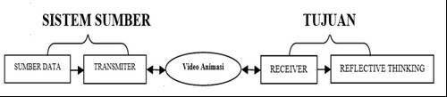
As for Ibiz's assumptions (2002), animation is a process of recording and playing back a series of static images to get an illusion of movement that moves something that cannot move on its own. Galih Pranowo (2011: 1), Adobe Flash CS5 is one of the software that is enjoyed by many people because its reliability is able to do everything related to multimedia.performance Flash can also be combined with other programs, Flash can be applied to making cartoon applications, interactive animations, animation effects. So the problem of this research, namely: 1) How is the continuity of the legend to improve reflective thinking in elementary school students?, 2) How is the continuity of the legend with learning media?.
METHOD
The method used in research qualitative phenomenology approach. Phenomenology studies explain or reveal the meaning of a concept or phenomenon of experience based on awareness that occurs in some individuals. Researchers in this case can develop meaning from individuals and also ask individuals to describe their daily life experiences. The data collected is closely related to the research that takes place and in the researcher trying to approach the object of study critically and careful observation, without prejudice to any previous conceptions (Cresswell, 2015: 125).
The place of this research was carried out at SDIT Al - Uswah Prigen, which is in the area of ​​East Java Province. Determining this location is due to female and male students as students. The time of research is conducted from January to May 2019 within a period of 5 months. Whereas the work of the research report begins in June 2019. The subject of this research data is SDIT Al-Uswah Prigen. The object of this research data is a total record of 30 students and 4 class teachers obtained from the record. Based on the events experienced, this shows reconstruction of the legend by increasing reflective thinking of elementary school students.
The technique this research is researchers begin to organize all data a comprehensive picture of the phenomenon of experience that has been collected through the student portfolio. Read the data as a whole and make marginal notes about the data that is considered important and then encode the data. Find and classify the meaning of statements felt by respondents by doing horizonaliting, ie each statement initially treated has the same value. Next the researcher develops the overall description of the phenomenon so that it finds the essence of the phenomenon. Then develop a textural description (regarding the phenomenon that occurs in the respondent) and a structural description (which explains how the phenomenon occurs). The researcher then provides a narrative explanation of the essence of the phenomenon under study and obtains the meaning of the respondent's experience regarding the phenomenon.
RESULT AND DISCUSSION
Result
The results of this study explain the advantages possessed by animated videos, so far people only think that legend is a matter of superstition. The legend is not just a thing of the past that does not know the truth through animated video (digital video) turning legend into reality and its existence is real by stimulating reflective thinking in elementary school students so that they can solve problems and implement knowledge gained from learning the legend. Digitizing the legend will be designed with an attractive design so that students are encouraged to read and learn. Besides getting new knowledge, students also get new science uses the latest educational technology and is closer to ICT.
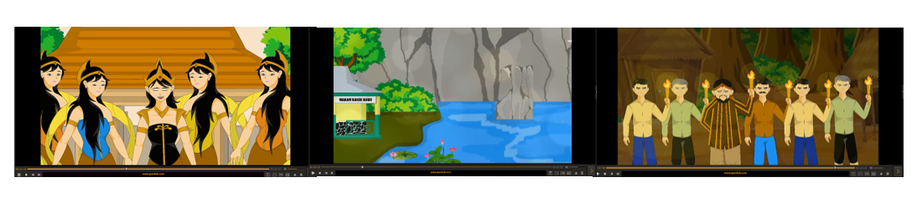
Discussion
The Continuity of The Legend by Increasing Reflective Thinking of Primary School Students
Confusion is uncertainty about something that is difficult to understand, then challenges the mind and signals changes in thoughts and beliefs. Investigation is looking for information that leads to directed thoughts. By allowing confusion and investigation to occur at the same time, changes in a person's behavior can be seen, and vice versa. Reflective thinking greatly influences good or bad behavior, whether or not someone is confident. Thus the teacher must know reflective thinking to be adapted to learning. suggests that reflective thinking is a way of changing one's behavior, and is a way to overcome practical problems.
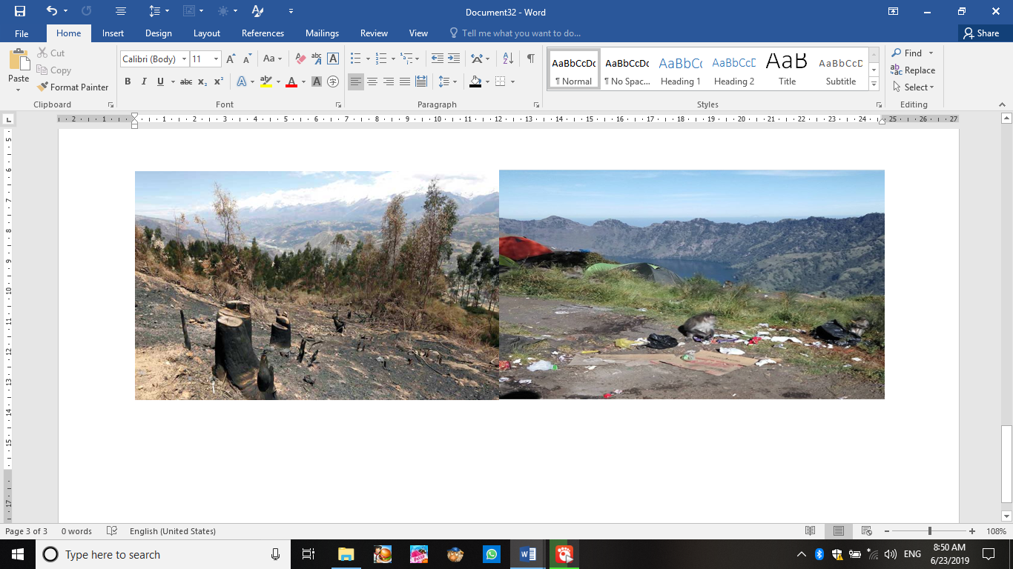

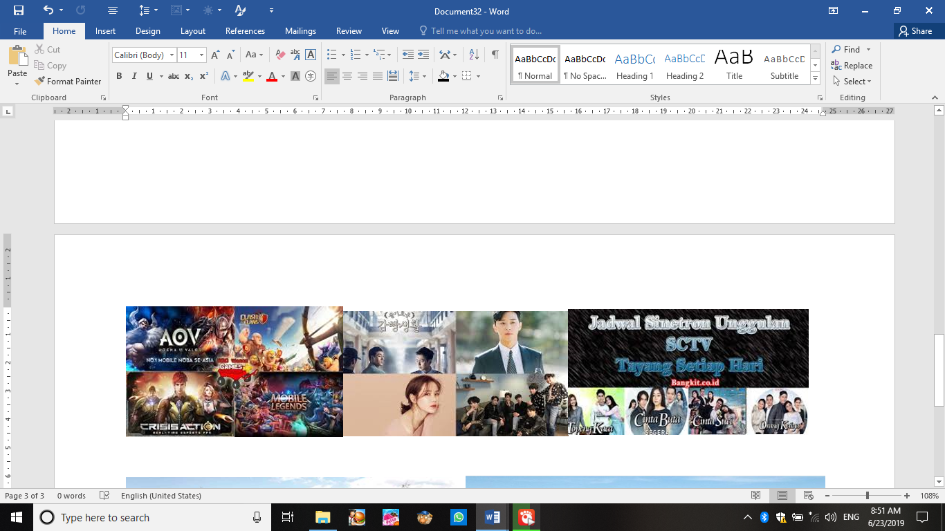

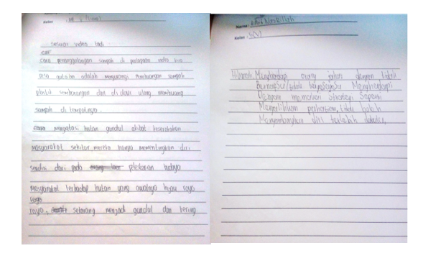
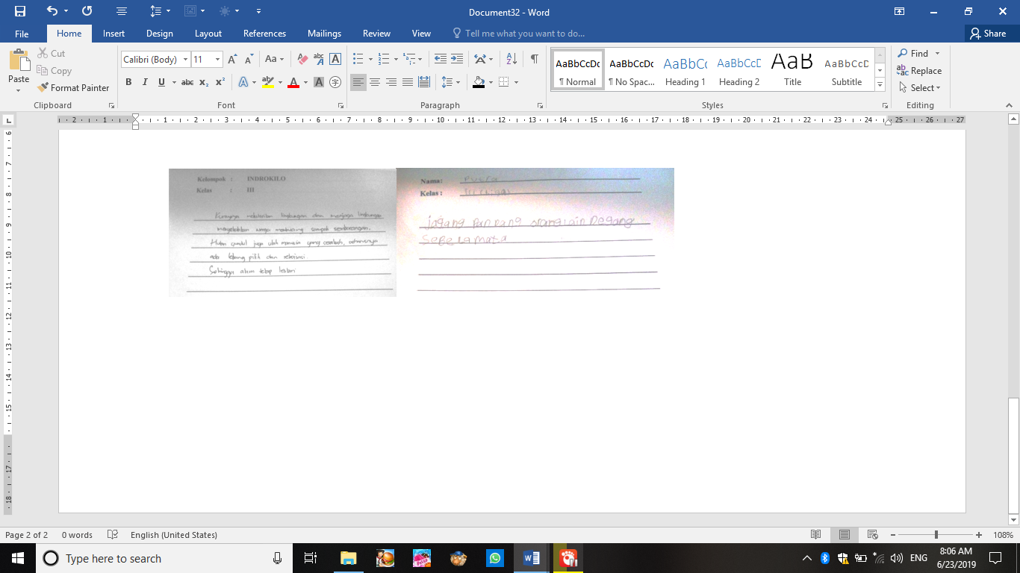

According to Dewey's assumption (2008: 310), students who have a reflective style tend to use more time to respond and reflect on the accuracy of answers. From the portfolio assessment through the results of discussion of solutions to the problems of grade 3rd and 5th students of SDIT Al-Uswah, thinking reflective is very slow and careful in responding, but tends to give correct answers. Reflective students are more likely to perform tasks such as remembering structured information, reading by understanding and interpreting text. With the explanation of the results of the study grade 3rd and 5th students at SDIT Al-Uswah Prigen had solved the problem through moral messages from the legend of Prigen, so that they learned the culture and learning Indonesian legendary material from animated videos. However, students still need the teacher as a facilitator who can later improve the solution to the problem. At the very least, local culture has been introduced through animated videos and students can take moral messages to be used as life guidelines and applied in daily life including resolving a problem related to the environment and culture. Azhar (2013: 29) listening learning strategies are still used and teacher-centered. It can be seen from the results of research that students have become centers of learning, with the material of the legend of animated videos. So, the teacher no longer uses listening in learning. The exposure from Tarigan (2008: 2) is the basis of language learning is singular. Where elementary school students must have singles, so that learning will be centered on students and teachers only as facilitators. Not only is legend learning more developed by using speaking and writing skills, but students will also be more interested and more fond of reading and writing.
The Continuity of The Legend with Learning Media
Video is one of the learning media that serves to help students in independent learning or groups, so that the subject matter taught can be understood so that the exchange of information between the sender to the recipient so that the achievement of learning objectives is achieved. Align with assumptions Arsyad (2013: 4) that the media carries an instructional purpose message. As for the harmonized exposure also from Denis McQuail (1987: 16-17) new media as telematic media. Meanwhile, Martin Lister at. all (2009: 13) states that new media terminology refers to large-scale changes in media production.
So that it can be seen from this research that video images in a frame where frame by frame is projected through a projector mechanically so that the screen shows that the image is alive. Video can describe an object that moves together with a natural sound or an appropriate sound. The video capability of portraying live images and sound provides its own charm. Videos can present information, explain processes, explain complex concepts, teach skills, abbreviate or extend time, and influence attitudes. In the cognitive domain, videos can strengthen students in implementing new knowledge and knowledge from effective learning. In the affective domain, videos can strengthen students in feeling emotional elements and attitudes from effective learning. In the psychomotor realm, the video has the advantage of showing how things work.
As for Ibiz's assumptions (2002), animation has an effect on the image to run. In line with the assumption of Galih Pranowo (2011: 1), Adobe Flash CS5 is one of the software that is enjoyed by many people because it is able to provide an interesting effect on animation. As with the legend of Prigen, using animated videos to clarify the legendary material presented to students in grade 3rd and 5th SDIT Al-Uswah. It can be concluded that legendary material of Prigen using animated videos is very significant and provides learning media innovations previously through books. With the video animation media students are more aroused to sharpen singles in learning Indonesian, especially legendary material.
FINDINGS
Most school institutions have used the media to support learning carried out with the aim of improving the quality of high-quality human resources and being skilled in utilizing existing technology. The teacher utilizes multimedia as a supporting facility in learning activities. It's just that the teacher hasn't fully been able to create or create his own media used for teaching (media by design). The teacher gets learning media from internet downloads or assistance from the local service (media by utilization). So that sometimes the media used is not fully in accordance with the material taught when the learning process occurs, then the media used must be innovative and can attract students' interest in learning at school or at home. The learning process using media makes it easier for teachers to convey and give understanding to students on the material being taught, besides that it can provide new experiences for students who are too saturated with conventional learning models conducted by teachers in this case the lecture method.

REFERENCE
Arsyad, Azhar. 2013. Media Pembelajaran. Jakarta : Rajawali Pers.
Burn,Andrew. 2016. Making machinima: animation, games, and multimodal participation in the media arts. Learning, Media and Technology Journal. (1) 1,pp. 1-20.
Creswell, John W. 2015. Penelitian Kualitatif & Desain Riset. Yogyakarta : Pustaka Belajar.
Danandjaja, James. 1984. Foklor Indonesia: ilmu Gosip Dongeng, dan lain-lain. Jakarta: Pustaka Utama Grafiti.
Dewey,John. 1992. Human Nature and Conduct. New York : Paulist Press.
_______, 2005. Democracy and Education. New York : Macmillan.
Fauziah, Wiedy Putri , Soedjijono.2018. Nilai Kearifan Lokal dan Budaya dalam Legenda Prigen. Prosiding Seminar Nasional Kajian Bahasa, Sastra, dan Pengajarannya (SEMNAS KBSP) V Pembelajaran Bahasa dan Sastra untuk Generasi Milenial. pp. 238-244. E-ISSN: 2621-1661.
Fernandes, Ibiz. 2002. Macromedia Flash Animation and Cartooning : A Creatif Guide. California: Ibiz Fernandez McGraw- Hill/.
Fwu, Bih-Jen. et. al. 2018. I believe; therefore, I work harder: The signiﬁcance of reﬂective thinking on eﬀort-making in academic failure in a Confucian heritage cultural context. Thinking Skills and Creativity.(5) 1,pp.1-12. https://doi.org/10.1016/j.tsc.2018.01.004.
Griffith, J. r. Kelley. 1982. Writing Essays About Literature. New York: Hartcourt Brece Javanovich. Inch
Hasyim ,Noor, Ali Muqoddas.2017.Inventarisasi Cerita Rakyat dari kabupaten
Demak melalui Aplikasi Buku Digital (E-Book) Interaktif. Jurnal Desain Komunikasi Visual & Multimedia. 1 (2) pp. 17-24.
Khasanah ,Sofia Nur.2017. Digitalisasi Buku Dongeng Anak : Strategi Mempertahankan Warisan Budaya Sastra Lisan Di Era Disrupsi Landasan Keilmuan Kearifan Lokal. Jurnal Studi Islam dan Budaya, 5 (1) pp.1-8.
Leslie, Esther & Joel McKim.2017. Life Remade: Critical Animation in the Digital Age, Interdisciplinary Journal, 12(3) 207 –213.
Lister Martin. 2009. New Media: a critical introduction. Newyork: Routledge.
McQuail, Denis. 1987. Mass Communication Theory (Teori Komunikasi Massa). Jakarta: Erlangga.
Morris, Neil P. & James Lambe.2017. Multimedia Interactive Ebooks in Laboratory Bioscience Education. Higher Education Pedagogies Journal, (2) 1, pp 28–42.
Smaldino, E Sharon, dkk, 2012. Teknologi Pembelajaran dan Media untuk Belajar, diterjemahkan oleh Arif Rahman dari Istrukturional Technology And Media For Learning, Jakarta: Kencana Prenada Media Grup
Tarigan, Henry Guntur. 2008. Berbicara Sebagai Suatu Keterampilan Berbahasa.
Jakarta : Angkasa.
_____. 2008. Membaca Sebagai Suatu Keterampilan Berbahasa . Jakarta :
Angkasa.

