DEVELOPMENT OF CHEMISTRY MODULE BASED ON CHARACTER EDUCATION FOR SENIOR HIGH SCHOOL STUDENTS

Putri Dwi Humaerah and Mukminan
Prodi Teknologi Pembelajaran Program Pascasarjana, Universitas Negeri Yogyakarta
e-mail: putrihumaerah@gmail.com

Abstract
The limitation of learning resources that contains character values ​​is one of the obstacles encountered in the implementation of character education based on Kurikulum 2013 in SMAN 7 Bombana. This research aims to develop chemistry module that contains character education for the 2nd grade students of senior high school. This study used research & development methods that adapt the steps of modified Borg & Gall development model, such as requirement analysis, planning, module development, expert validation, small group testing, revisions, and final products. After the final product is declared feasible to use, the effectiveness of the module will be measured using the N-gain test. The research findings show the following results. First, the validation value for media is 95.71% (very feasible) and the material is 75.82% (feasible) which means that the developed module has been considered feasible to be used by media and material experts because it has met the eligibility criteria for aspects of graphics, grammar, content presentation and character education. Second, the results of the small group testing is 90.40% (very interesting) which means that students and teachers assess that the module has a very good appearance, presentation and usefulness so that it makes the module interesting for use in chemistry learning. Third, the value of the N-gain test is 0.69 (moderate), which means that the module developed is effective to improve student learning achievement in affective, cognitive, and psychomotor aspects.
Keywords: character education, chemistry module, module development

Abstrak
Keterbatasan sumber belajar bermuatan nilai karakter adalah salah satu kendala yang dijumpai di SMAN 7 Bombana dalam pelaksanaan pendidikan karakter sesuai kurikulum 2013. Penelitian ini bertujuan untuk mengembangkan produk berupa modul kimia yang bermuatan pendidikan karakter untuk siswa kelas XI SMA. Penelitian ini menggunakan metode penelitian & pengembangan yang mengadaptasi langkah-langkah pengembangan model Borg & Gall yang telah dimodifikasi, yaitu analisis kebutuhan, perencanaan, pengembangan modul, validasi ahli, uji coba kelompok kecil, revisi, dan produk akhir. Setelah produk akhir telah dinyatakan layak untuk digunakan, maka modul akan diukur efektifitasnya menggunakan uji N-gain. Temuan penelitian menunjukkan hasil sebagai berikut. Pertama, nilai validasi media 95,71% (sangat layak) dan materi 75,82% (layak) yang berarti modul yang dikembangkan telah dinilai layak untuk digunakan oleh ahli media dan materi karena telah memenuhi kriteria kelayakan pada aspek kegrafikan, tata Bahasa, isi penyajian dan pendidikan karakter. Kedua, nilai hasil uji coba kelompok kecil yaitu 90,40% (sangat menarik) yang berarti siswa dan guru menilai bahwa modul memiliki tampilan, penyajian dan nilai kebermanfaatan yang sangat baik sehingga membuat modul menarik untuk digunakan dalam pembelajaran kimia. Ketiga, nilai dari uji N-gain sebesar 0,69 (sedang) yang berarti modul yang dikembangkan efektif untuk meningkatkan prestasi belajar siswa dalam aspek afektif, kognitif, dan psikomotorik.
Kata Kunci: modul kimia, pendidikan karakter, pengembangan modul

INTRODUCTION
Character education is not a new thing in the world of education, but in recent years it has become more attention as the growth and advancement of science and technology are increasingly rapid. The cultivation of character values in the current generation is considered to be able to overcome the many problems and irregularities concerning moral, ethical, cultural and religious values ​​(Afandi, 2011:86). Important character values ​​are realized in education because it will be the output of all the implementation of learning and school culture. Amrullah et al (2017:1873) stated that character education has a very important role in achieving academic achievement and social life of students, so it is important to carry out character education in academic activities in schools.
Schools in this case play an important role because they have long been regarded as the most strategic formal education institutions and conducive to learning activities by the Indonesian people. The Ministry of Education as the party responsible for issuing policies of education in Indonesia also began to consider the need for the implementation of character education in schools. This is realized by designing the Kurikulum 2013 which can accommodate the implementation of character education in schools. In contrast to curricula before further highlight the cognitive aspects in the teaching process, learning targets in Kurikulum 2013 accordance Permendikbud No. 54 of 2013 which includes the development of the realm of spiritual and social attitudes, knowledge, and skills that are optimized and elaborated for each educational unit (Kemendikbud, 2013).
The Kurikulum 2013 for schools in Indonesia has been implemented in stages since mid-2013 and simultaneously in 2018. However, studies and evaluations relating to the implementation of character education in accordance with the 2013 curriculum are still ongoing today. This is inseparable from the many obstacles and problems found in the implementation of character education in accordance with the Kurikulum 2013 in schools.
Even though it has implemented the Kurikulum 2013, learning in schools is still overly emphasizing the cognitive aspects, while the attitude aspect is still not getting enough attention (Wuryandani et al, 2016:209). Cultivation of character values is always a separate part of the learning process in the classroom and is only available in certain subjects, even after the Kurikulum 2013 was implemented. Barus (2015: 223) revealed that, character education has always been associated with Kewarganegaraan, Agama and Budi Pekerti subject in the form of learning programs only in introducing cognitive character values in these subjects. However, in accordance with the objectives of the Kurikulum 2013 above, character education should be able to introduce character values in cognitive knowledge, appreciate affectively and actualize through learning activities. Thus, character education should always be present in all subjects in school learning.
SMAN 7 Bombana is one of the schools in Southeast Sulawesi Province which in 2018 began to implement the Kurikulum 2013 for all grade levels. Based on interviews, teachers at SMAN 7 Bombana stated that the lack of learning resources was the main obstacle for teachers in implementing character education according to the Kurikulum 2013. Facilities and infrastructure that were not sufficient to be able to access information more widely resulted in teachers and textbooks being the main learning resources for students SMAN 7 Bombana. Government-sourced textbooks are very limited in number, so they can only be lent to students during school hours. Even for chemistry book for 2nd and 3rd grade, the books available are BSE (Electronic School Books) that still use KTSP (Kurikulum Tingkat Satuan Pendidikan). The same thing was expressed by Krissandi & Rusmawan (2015:460-461), that the biggest obstacle in the implementation of the Kurikulum 2013 came from the government in terms of the distribution of books and from the teacher's side in making learning media. The teacher also admitted that he had difficulty making teaching materials or learning media on his own because of limited time, facilities and infrastructure. The overloaded teacher workload is one of the reasons why teachers can not make their own teaching material and only use existing ones (Werang, 2018: 458). Thus, teachers continue to use the BSE even though they have implemented the Kurikulum 2013.
The application of character education that is integrated in academic learning requires teaching materials in which in addition to containing cognitive knowledge also contains character values. Thus, the need for appropriate teaching materials in order to carry out character education in this Kurikulum 2013. Modules are one of the teaching materials that are often used by teachers in the learning process. Modules are printed teaching materials that are systematically designed and packaged in small learning units so that they can be used independently without the need for intermediaries so that students can manage their own learning speed (Martiningsih, 2018; Wulandari, Budiyono & Slamet, 2016). The characteristics of the module that distinguishes it from other printed teaching materials according to Daryanto (2013: 9-11), namely Self-instructional, Self contained, Stand-alone, Adaptive, and User friendly. The modules that are widely used in learning today are still rare, which contain character values ​​in the presentation of the material.
Based on the explanation above, author conduct research module development of chemical laden character values for high school students. This is in line with one of the objects of educational technology studies that is to facilitate learning in this research in the form of developing learning resources using appropriate technology. As explained in the 2008 definition by AECT (Januszewski and Molenda, 2008: 280), educational technology is the study and ethical practice to facilitate learning and improve performance by creating, using, and managing appropriate technological processes and resources. With this development research, it is expected to produce a product in the form of a chemistry module as an alternative source of learning for students, so that character education in chemistry learning at SMAN 7 BOMBANA can work well.

METHOD
This study uses a research and development method that adapts the steps in modified Borg & Gall model (Sukmadinata, 2013:169-170), with the aim of producing a product in the form of a chemical module containing character values ​​in buffer solution material for class XI students. This research was conducted at SMAN 7 Bombana, Kabupaten Bombana, Southeast Sulawesi in January to April 2019. The object of this study was a product in the form of a chemistry module with character values for senior high school students, while as a respondent and the test subject is students of class XI MIA 1, XI MIA 2 and XI MIA 3 at SMAN 7 Bombana. Data collection techniques in this study were the observation method using instruments in the form of expert validation questionnaire sheets and student responses, affective and psychomotor aspects of observation sheets, and test methods using pretest and posttest instruments.
Research procedure this study is divided into 3 stages. The first stage is pre-research which aims to analyze needs, formulate learning objectives and design the initial product in the form of a draft module. The second stage is the stages of product development, module validation, small group trials, and revisions so as to produce the final product in the form of a feasible and interesting module to use. The third stage is the module effectiveness test in improving student learning achievement. A brief description of the stages of research on the development of chemical modules based on character education for high school students is presented in Figure 1.

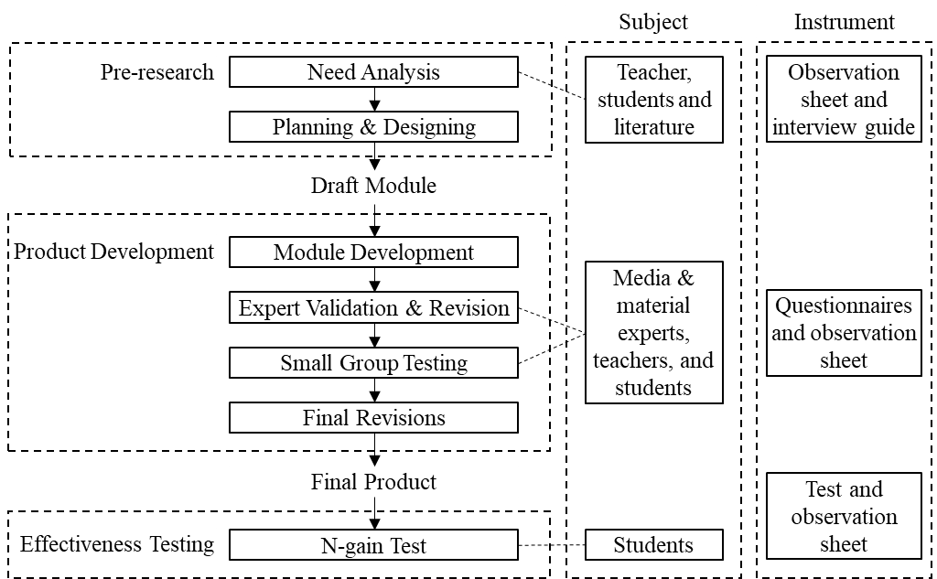

Figure 1. chemistry module development procedures

Every aspect in the questionnaire validation sheet, student responses and observations were assessed with a range of values from 1 to 5 based on a Likert scale. The assessment results are summed, the average score is searched, and the percentage of the assessment questionnaire is determined. The percentage is then the basis for assessing product quality based on the criteria in Table 1.
Table 1 Interpretation of Product Quality Criteria
Value | Percentage (%) | Interpretation
5 | 81% - 100% | Very good
4 | 61% - 80% | Good
3 | 41% - 60% | Enough
2 | 21% - 40% | Bad
1 | ≤ 20% | Very bad

Module effectiveness testing with N-gain test based on the results of the pretest and posttest using the following formula:
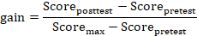
Criteria for N-gain levels are determined based on Table 2 and will show how effective the module is in improving student learning achievement.

Table 2 Criteria for N-gain Levels
Range | Criteria
g ≥ 0,7 | High
0,3 ≤ g < 0,7 | Medium
g < 0,3 | Low

RESULTS AND DISCUSSION
Results
The following are data from the results of the research & development of chemistry module based on character education for senior high school students which are presented based on the stages in the modified Borg & Gall model, namely needs analysis & planning, module development, expert validation, small group testing, final revisions, final products and effectiveness testing of the module.

Module Development
The module in the form of B5 (ISO) color print teaching with competency and module learning objectives is the development of core competencies and basic competencies of buffer solution material in 2nd grade on second Semester according to the Kurikulum 2013 that contains character values. Module is compiled following the indicators of presentation of teaching materials by BSNP (in Muslich, 2010) and based on the Textbook Writing Technique by Daryanto (2013:9-11).
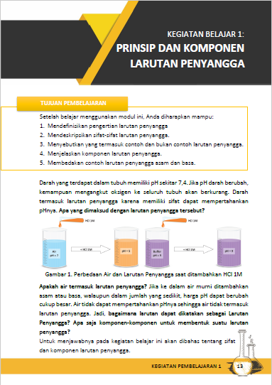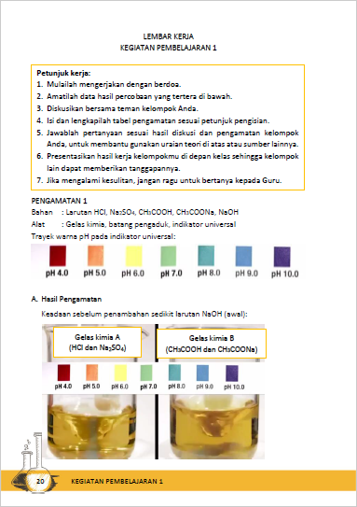
Figure 2. Display cover and contents of the module

Expert Validations Product
Product validation is done through 2 parts, namely validation by media experts and material experts. Media expert namely Mr. Dr. Ali Muhtadi, M.Pd., TP UNY lecturer who has an educational background and experience in the field of learning media. While the material experts, namely Dr. Eli Rohaeti, M.Sc., Pend lecturer. UNY Chemistry has an educational background and experience in the field of chemical education. The results of the module feasibility assessment can be seen in Table 3.

Table 3 Results of Assessment Feasibility of Modules by Media and Materials Experts
Aspect | Score Average | Percentage (%) | Criteria
Feasibility of Graphics | 4,79 | 95,88 | Very decent
Feasibility of Language | 4,78 | 95,55 | Very decent
Content Feasibility | 3,70 | 74,17 | Decent
Feasibility of Presentation | 3,95 | 79,13 | Decent
Character Education | 3,70 | 74,00 | Decent

The results of media validation show that the average value for aspects of graphics and language is 95.71% with a very decent category. Whereas the results of material validation show that the average value for the aspect of content, presentation and character education is 75.82% with a decent category.

Small Group Testing
Modules that have been said to be feasible by expert validators were then tested on 3 high school chemistry teachers and 9 students of XI MIA 3 class at SMAN 7 Bombana. In this trial, teachers and students were asked to fill out a product attractiveness questionnaire and provide feedback and suggestions for improvement after using the chemical module. The teacher and students assess the attractiveness of the module based on aspects of the display, presentation of material and usefulness of the module. The results of the module assessment in a small group trial are presented in Table 4.

Table 4 Rating result for module attraction by Teachers and Students
Aspect | Score Average | Percentage (%) | Criteria
Display | 4,83 | 96,60 | Very good
Presentation of Material | 4,25 | 84,90 | Very good
Usefulness | 4,48 | 89,60 | Very good
Average Total Score | 4,52 | 90,40 | Very good

The results of the appraisal of the attractiveness of the high school chemistry module charged with character values obtained a score of 4.52 or 90.40% with very good criteria.

Product Revision
Suggestions and critics provided by media experts, material experts, as well as teachers and students as input for product revisions so that module quality can be better presented in Table 5.

Table 5 Recommendations for Module Revision
Aspect | Recommendation | Improvememt
Media | More reproduced images/illustrations so users don't get bored reading the module | Interesting images and illustrations of more material added
 | Add "highlight" as a sign for messages that are considered important in the material description | Important terms and parts of the material that need to be considered are given different colors with other material descriptions. Important things like definitions and mathematical equations are written in the box
 | The language used is not too formal | Submission of material is made more communicative
Material | There needs to be a sign on each character value contained in the learning activities | Learning activities that contain certain character values ​​are given special marks
 | Evaluation on modules is not only for cognitive aspects, but also other aspects so that students can measure learning outcomes in all aspects | Evaluation of affective and psychomotor aspects was added along with indicators of achievement

Module Effectiveness Test
The effectiveness of the module in improving student learning achievement in affective, cognitive, and psychomotor aspects was tested using N-gain analysis on the value of the pretest and posttest students. In Table 4, the following N-gain values will be presented for each aspect of the assessment.

Table 4 N-gain values for affective, cognitive and psychomotor aspects
Aspect | N-gain value | Criteria
Affective | 0,64 | Medium
Cognitive | 0,72 | High
Psychomotor | 0,51 | Medium
Average | 0,62 | Medium

The results of the analysis above indicated that the average of N-gain value is 0.62 which is included in the medium category.

Discussion
Module Development
The product developed is in the form of a chemical module in the buffer solution material intended for high school students of class XI. Modules as alternative teaching materials have many advantages including easy to obtain, easy to use by students independently, and can provide learning experiences through illustrations and learning activities (Amrullah et al, 2017: 1873). Modules are in the form of color print and B5 (ISO) teaching materials so students are not easily saturated and can be used anytime and anywhere without the need for other media. The learning objectives in the module are developed according to the curriculum that is nationally applicable even though it still adapts to the conditions of the school environment.
This module is developed by considering aspects of character education that are in accordance with the conditions of the school environment in the presentation of buffer solution material. This is based on the results of the initial needs analysis that the textbooks that have been used are still more emphasis on mastery of cognitive and not yet charged character values ​​desired by the Kurikulum 2013. Based on the results of observations and interviews with teachers and students at SMAN 7 Bombana, characters like values divinity, independence, cooperation, and love of the environment, its application in the daily lives of students is still very low. Therefore, as an effort to realize character education into learning, the chemistry module developed contains the above character values ​​in the presentation of material and learning activities.

Expert Validations Product
Module validation by media experts was carried out by evaluating the feasibility aspects of graphics and language adapted from BSNP (Fitri et al., 2013:21). The aspects of graphic feasibility are said to be very feasible by obtaining a value of 95.88%, which means that the typography of the module is appropriate and the parts in the module are well organized. Whereas the language feasibility aspect is said to be very feasible by obtaining a value of 95.55% which means that the language used in the module is in accordance with EBI, student characteristics and communicative. The results of media validation show that the average value for aspects of graphics and language is 95.71% with a very decent category.
Whereas module validation by material experts was carried out by assessing aspects of content feasibility, feasibility of presentation and aspects of character education adapted from BSNP (Hasanah & Lazulva, 2017:143). The aspect of content eligibility is said to be feasible by obtaining a value of 74.17%, which means that the scope of the material, the accuracy of the material and the supporting material in the module have been considered appropriate and in accordance with the Kurikulum 2013 and character education. Whereas for the feasibility aspect of presentation, the score is 79.13%, which means that the presentation of the material parts in the module has been arranged in a coherent and systematic manner. As for the aspect of character education, the score is 74%, which means that the module has integrated character education in the presentation of material and learning activities. Result of material validation shows that the average value for the feasibility aspect of the content, presentation and character education is equal to 75.82% with a decent category. Based on the results of the media and material validation, it can be concluded that the module is feasible to be used by students.

Small Group Testing
Small group trials are conducted on teachers and students to get responses regarding the attractiveness of the module to use. Aspects that get the highest value are in the module display. The very attractive display of modules makes students more motivated to learn to use the module. Students are also very eager in working on worksheets because there are activities that involve knowledge and group collaboration. In addition, there are presentation activities of their work so that they can get feedback, so students can find out how far they have mastered the material. These learning activities are a form of character education contained in the module. Students indirectly practice character values ​​when they use the module (Rahayu, 2016:229). The results of the module attractiveness assessment are based on aspects of the display, presentation of material and usefulness of the module obtain an average score of 4.52 or 90.40% with very interesting criteria. These results indicate that, teachers and students are very interested in using high school chemistry modules with these character values. Students assume that many illustrations that can explain chemical concepts more clearly make this chemical module interesting to use. Examples of questions given with the help of work steps are very helpful for students to be more understanding in working on mathematical equation questions. Feedback after working on the questions also helps students to measure how far students understand the material. Some of the reasons above are what make this module considered interesting for use in learning.

Product Revision
Some recommendations are given by material experts, media experts and students and teachers as material for module revision so that the quality can be improved, among others, so that the material presentation in the module is more communicative. Because the nature of the module can be used independently without the need for the presence of the teacher as an intermediary for delivering the contents of the material, therefore the delivery of material in the module must be directly understood by students who use it. So that communicative sentences can help students to better understand the material in the module (Rahayu, 2016:226). Other recommendations are, the content of character values ​​to be more emphasized. This is realized by learning activities in modules based on desired character values ​​(Amrullah et al., 2017: 1875). So that students in conducting learning activities by themselves will also learn about the values ​​of these characters.

Module Effectiveness Test
The effectiveness of the module is measured using a written test and the results of direct observation. The results of the tests and observations were analyzed using N-gain to see how the influence of the use of modules on improving student learning outcomes. Student learning outcomes on the cognitive aspects obtain the highest N-gain value of 0.72. This value indicates that this chemical module managed to convey cognitive material to students. One reason is because the presentation of modules is divided into several small parts in the form of learning activities so that students are not overloaded with cognitive and easier to process the information provided (Afidah, 2015:74).
Student learning outcomes in the affective aspects obtain N-gain of 0.64 in the medium category, which means that effective modules can improve students' understanding of character values. Every learning activity in the module always begins with prayer is an embodiment of religious values. The module contains the value of independence in the form of independent training and competency testing in each learning activity. Modules designed to be used directly by students without the need for media or other intermediaries, making students more independent in learning. This is in line with the results of research by Swandhana et al (2016:166) which states that the use of modules in learning can improve students' independence in terms of doing and seeking information. In addition, the feedback provided at each evaluation in the module can increase student confidence. Students think that they can be more confident after knowing how many levels of achievement they have and what still needs to be improved after using the module. By knowing the level of achievement, students can determine and make an effort in order to improve these achievements. The accuracy of giving feedback can increase motivation and self-confidence because students know what they have and have not yet mastered (Seruni & Hikmah, 2014:234).
The results of the above analysis show that the N-gain value on average for all aspects is 0.62 which is included in the medium category. So that it can be said that the module is effective in improving student learning outcomes. Based on the results of interviews with students and teachers, improvement in learning outcomes is caused by several things. First, the material is presented in sections of learning activities so that students have no difficulty in accepting material and the presence of markers or "highlights" allows students to focus on more important parts of the material. Second, the availability of sample questions with the help of workmanship allows students to practice working on the questions independently. Third, communicative language style makes it easier for students to understand the meaning of the material. Fourth, with the availability of the answer key for each competency test, it helps students to know the success of their learning and explain what part the students have not understood. Fifth, group learning activities enable students to interact and exchange understanding.

CONCLUSION
Chemistry modules based on character education are considered feasible and interesting to be used as teaching materials in buffer solution materials for high school students. This module is not only effective in improving student learning outcomes in cognitive aspects, but also in affective and psychomotor aspects. Learning activities in the module make students gain an optimal learning experience and can instill character values ​​in students.
Increased learning outcomes in cognitive aspects are still higher than the affective aspects, this may occur because verbal and visual media are still more suitable to use in cognitive aspects, while for affective aspects more visualization and exemplary aspects are needed so that students are able to practice character values ​​contained in learning. So that further research is expected to be able to design and use more appropriate methods so that the application of character education in learning can be carried out better.
Based on the results previously explained, it can be seen that teaching materials designed and developed with due regard to feasibility aspects can make character education in accordance with the 2013 curriculum in schools run more optimally. Not only that, the module also succeeded in increasing the success of students in achieving the expected competencies. Therefore, the provision of appropriate teaching materials must be considered so that the learning process in the school can done better.

ACKNOWLEDGMENT
Thank you to the headmaster of SMAN 7 Bombana, Southeast Sulawesi for permission as a place to conduct research, to Prof. Dr. Mukminan for the guidance, as well as to the teachers and students of SMAN 7 Bombana for their cooperation in carrying out this research .

REFERENCES
Afandi, R. (2011). Integrasi Pendidikan Karakter dalam Pembelajaran IPS di Sekolah Dasar. Pedagogia, 1 (1), 85-98.
Afidah, V. N. (2015). Prinsip-pinsip Teori Beban Kognitif dalam Merancang Media Pembelajaran Matematika. Jurnal Pendidikan dan Pembelajaran Matematika, 1 (1), 72-79, from http://dx.doi.org/10.29100/jp2m.v1i2.195.
Amrullah, A., Hadisaputo, S., & Supardi, K. I. (2017). Pengembangan Modul Chemireligiousa Terintegrasi Pendidikan Karakter Bervisi SETS. Jurnal Inovasi Pendidikan Kimia, 11 (1), 1872-1883.
Barus, G. (2015). Menakar Hasil Pendidikan Karakter Terintegrasi di SMP. Cakrawala Pendidikan, 34 (2), 222-233, from https://doi.org/10.21831/cp.v2i2.4827.
Daryanto. (2013). Menyusun Modul: Bahan Ajar untuk Persiapan Guru dalam Mengajar. Yogyakarta: Gava Media.
Fitri, L. A., Kurniawan, E. S., & Ngazizah, N. (2013), Pengembangan Modul Fisika pada Pokok Bahasan Listrik Dinamis Berbasis Domain Pengetahuan Sains untuk Mengoptimalkan Minds-On Siswa SMA Negeri 2 Purworejo Kelas X Tahun Pelajaran 2012/2013. Jurnal Radiasi. 3, 19-23.
Hasanah, U., & Lazulva. (2017). Desain Modul Kimia Berbasis Karakter untuk Siswa SMK dan MA Materi Struktur Atom dan Sistem Periodik Unsur. Jurnal Pendidikan Kimia dan Terapan, 1 (1), 138-145, from http://dx.doi.org/10.24014/konfigurasi.v1i1.4067.
Martiningsih, I., Lisdiana, & Susilowati, S.M.E. (2018). Development of Module Based on Scientific Contextual Additives Material to Increase Learning Outcomes and Science Process Skills in Junior High School. Journal of Innovative Science Education, 7 (2), 372-381.
Januszewski, A., & Molenda, M. (2008). Educational Technology, a Definition with Commentary. New York: Lawrence Erlbaum Associates.
Krissandi, A. D. S., & Rusmawan. (2015). Kendala Guru Sekolah Dasar dalam Implementasi Kurikulum 2013. Cakrawala Pendidikan, 34 (3), 457-467, from https://doi.org/10.21831/cp.v3i3.7409.
Muslich, M. (2010). Text Book Writing. Jakarta: Ar-Ruzz Media.
Kemendikbud. (2013). Peraturan Menteri Pendidikan dan Kebudayaan R.I. Nomor 54 tahun 2013 tentang Standar Kompetensi Lulusan. Jakarta: Kemendikbud.
Rahayu, D., Pratikto, H., & Rahayu, W. P. (2016). Pengembangan Modul Pembelajaran Kontekstual Bermuatan Karakter Pada Mata Pelajaran Kewirausahaan di SMK Cendika Bangsa Kepanjen. Jurnal Pendidikan Bisnis dan Manajemen, 2 (3), 225-232.
Seruni & Hikmah, N. (2014). Pemberian Umpan Balik dalam Meningkatkan Hasil Belajar dan Minat Belajar Mahasiswa. Jurnal Formatif, 4 (3), 227-236.
Sukmadinata, N. S. (2013). Metode Penelitian Pendidikan. Bandung: PT Remaja Rosdakarya.
Swandhana, K., Churiyah, M., & Juariyah, L. (2016). Meningkatkan Kemandirian Belajar dan Hasil Belajar Siswa melalui Pengembangan Modul Administrasi Kepegawaian Berbasis Strategi Pembelajaran Inkuiri Terbimbing. Jurnal Pendidikan Bisnis dan Manajemen, 2 (3), 161 -169.
Werang, B.R. (2018). The Effect of Workload, Individual Characteristics, and School Climate on Teachers’ Emotional Exhaustion in Elementary Schools of Papua. Cakrawala Pendidikan, 37 (3), 457-469, from https://doi.org/10.21831/cp.v38i3.20635.
Wulandari, S.P., Budiyono, & Slamet, I. (2016, 3-4 September). The Development of Learning Module with Discovery Learning Approach in Material of Limit Algebra Functions. Paper presented at the The 3rd International Conference of Mathematics, Science, and Education (ICMSE). Retrieved from https://journal.unnes.ac.id/sju/index.php/icmse/article/view/13407/7392.
Wuryandani, W., Fathurrohman, & Ambarwati, U. (2016). Implementasi Pendidikan Karakter Kemandirian di Muhammadiyah Boarding School. Cakrawala Pendidikan, 35 (2), 208-216, from https://doi.org/10.21831/cp.v15i2.9882.

