**Communication Strategies for Women Legislative Candidates in 2019 Elections**

**Through Social Media**

VERA WIJAYANTI SUTJIPTO, M.Si

*Universitas Negeri Jakarta, Indonesia*

[*verawijayanti@unj.ac.id*](mailto:verawijayanti@unj.ac.id)

MAULINA LARASATI PUTRI, M.I.Kom

*Universitas Negeri Jakarta, Indonesia*

[*maulinalarasati@unj.ac.id*](mailto:maulinalarasati@unj.ac.id)

Dr. KINKIN YULIATY SUBARSA PUTRI

*Universitas Negeri Jakarta, Indonesia*

[*kinkinsubarsa@unj.ac.id*](mailto:kinkinsubarsa@unj.ac.id)

AISYA TANZIL

*Universitas Negeri Jakarta, Indonesia*

[*aisyatanzil02@gmail.com*](mailto:aisyatanzil02@gmail.com)

**ABSTRACT**

This research is about political communication strategies through social media from national women's legislative candidates in the last 2019 elections. Starting with the rapid development of the internet, so many people use social media. Currently, the use of social media is growing, one of which is used as a media campaign by politicians. In order to analyze the communication strategies of the Indonesian women legislative candidates, questions were raised related to the social media management of women legislative candidates during the campaign period. This research is qualitative research with in-depth interviews with informants. The guest speaker is a woman legislative candidate from PKS and PKB parties. The results of this study show the difference from the results of previous studies conducted by Susan Fountain, where campaigns carried out through social media provide benefits for women politicians, but the results of this study show the opposite results, where Indonesian women legislative candidates did not benefit from social media during they are a campaign. Both of these women legislative candidates consider the campaign through social media to be ineffective compared to going directly into the field and meeting the people face to face, so that the two legislative candidates during their campaign did not utilize social media to the fullest, this can be seen from their social media posts, as long as the campaign is not much, besides that the content on their social media is very little related to the election topic.

**Key Words:** *Politicians, Women, Social Media, Strategy, Political Communication, Indonesia*

**INTRODUCTION**

The reason why female candidate failed to Senayan (legislative candidates election), it could be because of the inability to do the effective campaigns (Suryati, 2018). One effective campaign is to carry out creative campaigns, where female candidates can convey their ideas in a non-boring way. Creative campaigns can be done by using media to communicate with their constituents, whether through conventional media such as print, radio, and television, or using new media.

In the current era of digital technology, where the interrelation between individuals is very high, it is an appropriate means for women politicians to carry out their political communication through new media such as social media. The use of new media, due to the development of digitalization technology that resulted in the emergence of the internet. Today the internet is a political channel, people use it to read and express their political opinions (Heryanto, 1998).

The internet is believed to bring new hope for the creation of democracy, especially in countries whose sources of information are controlled by the government. The internet is a connector for opposition groups and minority groups whose voice is often not heard by the authorities in speaking up their rights and desires because in the real world conventional media such as print and television are controlled by the authorities (Efriza, 2018).

Since the development of digital technology, the internet has become an important and prior information media in the process of political communication, the internet is used for political party campaigns for legislative candidates, through the political internet obtaining information quickly. The internet also makes it easy for politicians to access the latest and fastest domestic political information (Efriza, 2018).

The first political campaign in the world that uses the internet, by utilizing new media, is the political campaign of Bill Clinton and Al Gore, where the text of a speech from Clinton, distributed via the internet (Heryanto, 1998). The use of the internet in the campaign was also carried out by Barrack Obama, through his campaign team called Triple O (Obama’s Online Operation) conducting campaigns using social media, including Facebook, MySpace, and Twitter (Heryanto, 1998).

The internet brings a new way of communicating and obtaining information, new media can quench the thirst of modern humans who need information, as a result the exposure to information in this age of digital technology is overwhelming and unrelenting, making it confusing for users of new media technology itself, thousands of information hit them in a day, that makes it very difficult to identify which information is right and true, the information they read is not guaranteed to be true, often the information that reaches is information whose contents are lies or hoaxes. This has a negative and detrimental impact on politicians and their parties.

But on the other hand, the internet through social media has a positive side for politicians that is, becoming one of the mainstay communication channels for parties and politicians, because by using social media the costs incurred by politicians are much lower than conventional media, such as television or newspapers. Access and content from social media can be controlled by these politicians. The politicians believe that using social media can reach all people and across regions and even countries, and the feedback is obtained very quickly as if they were doing face-to-face communication.

The discovery of the internet as a new channel of communication also brought about a change in the way politics was involved. According to Efriza and Jerry Indrawan in their book entitled Theoretical and Empirical Political Understanding Communication, states that the way people express their aspirations in a democratic political system no longer recognizes time limits, spaces, and other physical obstacles. This democracy is known as digital democracy because it connects democracy and the internet. This digital democracy brings significant changes to political actors in determining political mobilization, campaign strategies and strategies for forming public opinion.

There are four types of linkages between the internet and democracy according to Anttiroiko, namely (Efriza, 2018), firstly with the existence of the internet, public involvement in politics is increasing, where politicians can solicit public opinion through social media such as Twitter, and even in developed countries elections are conducted using electronics, Also known as e-voting. Second, is cyber democracy, wherewith the internet, space and time limitations are no longer available, people are more actively involved in the democratic process, internet users can interact with each other without knowing demographic and time limitations, they can respond to good issues that domestic issues or foreign issues. Third, with the existence of electronic democracy, the public and politicians of internet users can directly copy interact, feedback can also be given at that time without any delay. This interaction generally uses social media applications such as Facebook, Twitter, Instagram, and others. Fourth, with the invention of the internet, the executive body utilizes this development by forming e-government. E-government is one of the technologies utilized by the government with several objectives, including facilitating their work, providing the best service to the community and in the context of information disclosure, so that data manipulation and corruption can be reduced because the public can supervise directly through the internet.

New media began to be used as a campaign media in Indonesia since the 2014 election. KPU commissioner in the 2014 election, Sigit Pamungkas stated that the use of social media as a campaign media is not regulated by the Election Commission Regulation (PKPU), if election participants use social media for political campaign advertisements allowed, is considered not to violate the rules. (Harera, 2013). The use of new media, especially social media, can help legislative candidates to get closer to their constituents, without having to incur large costs, moreover, internet users in Indonesia are developing rapidly, as shown in the diagram below:

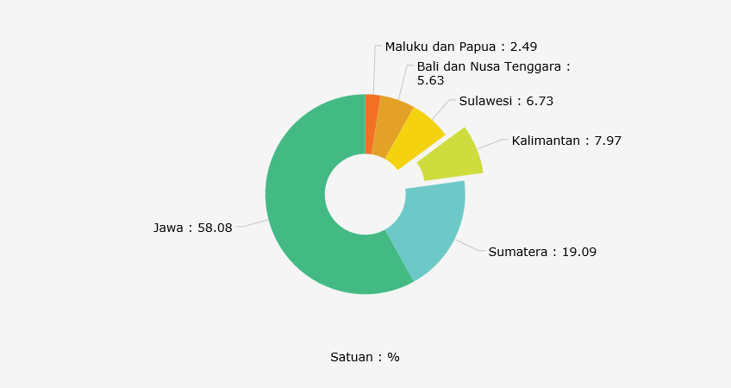

Graph 1. Composition of Internet Users in Indonesia by Island (2017)

Graph 1. Composition of Internet Users in Indonesia by Island (2017)

(Katadata.co.id, Pengguna Internet Indonesia Masih Terkonsetrasi di Jawa, 2018)

The people who use the internet the most in Indonesia are in Java, which is 58.08%, then the people in Sumatra around 19.09%. Based on data, there are around 87.13% accessing the internet, also accessing social media. In 1998, there were around 500 thousand users who used the internet in Indonesia, but in 2017, there was a rapid increase in internet users, reaching more than 100 million. Factors driving the rise of internet users include the development of increasingly sophisticated and advanced technology, the wide reach of internet services and the more affordable price of a smartphone.

Based on data from APJII, in 2017 there were 142 million people who use the internet, meaning there is penetration of around 54.69 percent of the entire population. An increase of around 7.9% internet users from 2016 to 2017, when compared to the last 10 years, internet users rose by around 600%. People who use the internet from year to year will increase, this is influenced by the increasing number of Menara Base Transceiver Station (BTS), the launching of new satellites by the Indonesian government so that Eastern Indonesia is covered by internet services and the expansion of fiber optic networks.

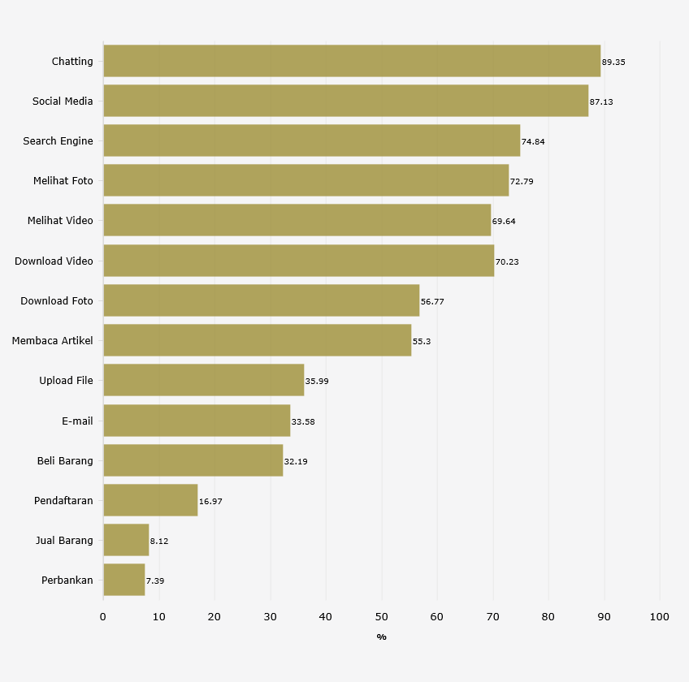

Graph 2. Use of Internet Service Applications According to the 2017 APJII

(Katadata.co.id, 2018)

Creative campaigns are needed by female legislative candidates, given the number of millennial voters in the 2019 elections was around 45 percent of the total voters. CSIS (Center for Strategic and International Studies) classifies ages 17 years to 29 years as millennial groups. CSIS conducted a survey during the period of 23-30 August 2017, the survey was conducted on 600 millennials. Media that are considered relevant as a source of information for millennial generation include radio, television, newspapers and online media, of the four types of media, millennial penetration of online media is highest, where 54.3% of millennials access social media every day, 8.3 % accessing online media 1-2 days, 6% accessing online media 3-4 days, 4.3% accessing online media 5-6 days, the remaining 27% have never accessed online media. Based on the above reasons, the researcher wanted to find out how the campaign strategy of Indonesian women legislative candidates was through the use of social media.

**LITERATURE REVIEW**

Previous research on women politicians and how they used social media while campaigning included research conducted by Moran Yarchi and Tal Samuel-Azran with the title Women politicians being more engaging: male versus female politicians 'ability to generate users' engagement on social media during an election (Moran Yarchi, 2018). This study wants to prove whether social media provides equal opportunities for women politicians to be exposed during the 2015 campaign in Israel, given that up to now the traditional media has given more news to male politicians than women politicians. Social media is the focus of research is Facebook, with the reason Facebook is the most popular social media in Israel. The results of this study indicate that women politicians see social media as an environment that provides the same opportunities as male politicians. Women politicians on social media get more responses when viewed from their posts, such as getting more likes and shares compared to male politicians. But women politicians and men politicians get the same response from the number of comments and discussions. Based on the results of research by Moran Yarchi and Tal Samuel-Azran, it shows that social media provides a better and fair opportunity for female police to be known by their names on social media, even using social media is more beneficial for female politicians than male politicians. This is not because of the ability of women politicians to raise the issue or intelligence of women politicians to make speeches, but the ability of women politicians to form a bond with their followers compared to male politicians, whereby using social media women politicians are seen to have more abilities and appear to have charismatics.

Other research that discusses women politicians and social media is research conducted by Susan Fountain with the title What is not to Like ?: A Qualitative Study of Young Women Politicians' Self-Framing on Twitter (Fountain, 2017). The focus of this research is how women politicians in New Zealand practice Public Relations through politics using social media, namely Twitter, how young women politicians use Twitter to shape their framing during the campaign period. This study focuses on tweets sent by two New Zealand women politicians namely Nikki Kaye and Jacinda Ardern during the 2014 election campaign in New Zealand. In order to form a self frame, tweets often appear on both job-themed candidates, in addition as additional frames, tweets themed about busy and rational politicians. Although the message they convey through Twitter is effective in framing the female politician, there are long-term consequences, where the community will demand more of their roles, especially in independence and competence.

The two literature reviews above are research with a qualitative methodology. Research conducted by Eun-Ju Lee with the title Effectiveness of Politicians' Soft Campaign on Twitter Versus TV: Cognitive and Experiential (Lee, 2013), is quantitative methodology research. Eun-Ju Lee conducted an experiment by collecting 183 respondents. Eun-Ju Lee wants to find out how people respond to women's politicians 'messages via Twitter with women's politicians' messages through television interviews, then Eun-Ju Lee wants to know the differences in each cognitive experience of respondents when watching women politicians talk to television presenters about their personal lives the politician, are there messages delivered by the female politician on television the same as the messages conveyed on twitter. Does the appearance of women politicians on TV vs Twitter interviews will increase social interaction higher than women politicians with their costs and whether women politicians are preferred to appear on television compared to using Twitter. The results of this study indicate that respondents have different responses to the same message conveyed by politicians when using different media. Respondents feel the difference when women politicians appear on TV, respondents feel the presence of women politicians is closer than when women politicians use Twitter.

**METHODOLOGY**

This study uses a qualitative approach, in which data collection techniques with in-depth interviews and document analysis take the form of legislative candidates' social media posts, which are used during the campaign. In-depth interviews were conducted with two women legislative candidates from different parties, assuming each party has a different campaign strategy so that it will also influence the campaign strategy used by women legislative candidates.

Questions to be asked of women legislative candidates include how to plan conceptually. There are 3 (three) phases that must be carried out in conceptual planning, namely situation analysis, strategic decision and strategy implementation (Schroder, 2003). A woman politician before conducting a campaign, should make a conceptual campaign planning in advance, the goal is that the campaign that will be carried out will focus on the desired campaign concept, in order to reduce failure in the campaign, in order to reduce conflicts of interest, facilitate cooperation with related parties, and sources the power users such as time, cost, and energy is not wasted. The first step in planning a campaign is to formulate five questions, namely, what do women politicians want to achieve? Who is the target? What message will be delivered? How can they be conveyed? and how to evaluate it? (Venus, 2007).

In planning a campaign, the five questions above are applied in the form of the first stages of analysis, the analysis is carried out using the SWOT analysis guide (Strength, Weakness, Opportunity, and Threats), then compiling the objectives of the campaign, so that during the campaign the politician does not give false promises or promises that are beyond the capabilities of these politicians. The third stage must identify the audience, the goal being that politicians know the characteristics of the target group, so they can choose a program that suits the characteristics of the target group (Venus, 2007).

The target group is part of the general public, identifying the target group aims to determine the direction of communication so that the communication objectives are achieved (Schroder, 2003). The target group can be identified into several types of voters (Firmanzah, 2007), the first is rational voters. This type of rational voter prioritizes the ability of political parties or politicians by looking at work programs and track records before, rational voters do not choose based on their liking or because of one group with them, rational voters tend not to give priority to the ideology carried by the party or political. The next type of voter is the critical voter. This voter is a combination of seeing the ability and track record of the party and its politicians and also seeing the ideology carried by the party and the politician, critical voters will study the party's system and values ​​(Firmanzah, 2007).

Next is traditional voters. Voters of this type see from the ideological side of the party or politician, do not really matter about the track record, do not see the policies or work programs of the party or politician. These traditional voters prioritize socio-cultural closeness, values, origins, ideology and religion as a measure of choice. The last type of voter is a type of skeptical voter. These voters are voters who are not too concerned with politics, voters of this type have low ideological ties and are less concerned with track records or policies or work programs of parties or politicians, generally skeptical voters have the potential to not exercise their voting rights (Firmanzah, 2007).

The next stage is determining the message. What is the theme of the campaign desired by politicians, this theme is related to what is the target image desired by women legislative candidates when conducting their political communication through social media. The purpose of the target image is to provide a picture that is in the shadow of the community or target group within a certain period, sometimes the picture of the legislative candidate does not yet exist or is still empty. That means the community or the target group does not yet know the legislative candidate (Schroder, 2003). One of the requirements to build an image is popular, but popular in a positive meaning, not a negative meaning, like a popular legislative candidate because of a corruption case, certainly not beneficial for the legislative candidate (Schroder, 2003).

In carrying out a campaign that requires no small cost, budget planning must be done from the beginning, wherewith the existing budget, the campaign can run smoothly. Campaign budget planning must be prepared realistically according to the ability of politicians to source funds. Sources of campaign funds can come from various parties, can be from personal funds, parties or third parties, known as contributors (Venus, 2007). A contributor generally has the motivation to provide assistance. This motivation could be due to the close relationship between the constituent and the politician, another motivation, could be because the contributor felt to fight for the same program or issue with the politician, the possibility of the next motivation was that the contributor was asked by a third party to make a financial contribution to the politician (Venus, 2007).

**RESULT AND DISCUSSION**

1. **Candidates for Legislative Candidates**

The first speaker was Anis Byarwati, a legislative candidate from PKS in the 2019 Election for the Republic of Indonesia DPR, Anis represented the electoral district (electoral district) I in DKI Jakarta. In her daily life, Anis works as a lecturer at Yarsi University Postgraduate, besides being a lecturer, Anis was also active in the PKS party, in 2012, having served as Chairperson of the PKS DPP in the women's field. Anis was born in Surabaya in 1967, married in 1989 and was blessed with eight children. Anis took S1 education in two places, firstly, the Department of Financial Management at the Jakarta Company Management Academy, secondly at the Al-Hikmah Islamic College of Jakarta, Special Arabic Language Program specializing in Hadith Interpretation and the At-Taqwa Islamic College of Bekasi, Department of Da'wah and Islamic broadcasting. He graduated from the University of Indonesia, majoring in Islamic Economics and Finance with a choice of Banking concentrations. S3 Education Airlangga University, Jurursan Sharia Economics.

The second guest speaker, Hj. Vera Susanti, S.AG., MPd, is a woman legislative candidate from PKB, 7 (electoral districts) with number 6 for DPR RI. Vera works as a businessman, pursuing her S2 education at UNJ majoring in environment. Vera was born in Bandung in 1973, is married and has three children.

1. **Social Media Information Legislative candidates**

The first guest speaker was Anis Byarwati, the legislative candidate from PKS had several social media namely Instagram, Facebook, and Twitter. The Instagram account name is @anis_byarwati. On Instagram, Anis has 143 followers and 23 accounts followed by Anis. On Instagram Anis already has 75 posts, with the first posting on 30 September 2018 and the last posting on 29 June 2019. Anis has a tagline on Instagram that is "Together Create Quality Indonesian Families Together".

Besides Instagram, Anis also has another social media, Facebook. Anis Facebook account names are Anis Byarwati I and Anis Byarwati II, each of these accounts has approximately 2500 friends. Anis seems to be more active using Facebook than other social media. On the Anis Byarwati I account, the last posting was on July 3, 2019, while the last posting was on the Anis Byarwati II account on May 2, 2019. Based on her posting, Anis Byarwati I contained more daily activities as an activist or lecturer, while Anis Byarwati II, the posting is more dominant about the family.

The next social media owned by Anis is Twitter with the account name @anisbyarwati. Anis has this account since April 2010. There are 283 followers of Anis, while Anis only follows 2 accounts. Anis is seen rarely using Twitter, seen from the first posting on April 10, 2010, while the last posting was on November 3, 2011. During that time, Anis only posted 4 (four) times, the theme of the posting was about family.

The second speaker, Vera Susanti, the legislative candidate from PKB has active social media, namely Facebook and Instagram. Vera's Facebook account name is Vera Susanti, this account has 865 friends. The last Vera post on 25 June 2019, the majority of Vera's Facebook posts were Vera's activities in the women's organization Nahdatul Ulama (NU), where Vera became the Chairperson of the NU Women's Organization Association (GOW), Bekasi Regency with a term of 2019-2024. The second social media used by Vera is Instagram with the account name @verasusanti3. Vera followers there are 204 accounts, Vera itself follows 98 accounts with 83 posts.

1. **Campaign Strategy: Situation Analysis**

The first step of a political strategy in a campaign is to make conceptual planning, where women legislative candidates must analyze the situation first, in order to make it easier for legislative candidates to determine their target audience. Anis, the legislative candidate from PKS also conducted a situation analysis first. Campaign planning can use a SWOT analysis (Strength, Weakness, Opportunity, and Threats). Anis and the team identified a number of strengths from Anis, including Anis's political experience of more than 20 years, starting with Anis as a student, Anis activist at a campus preaching institution which would later be the forerunner of the Justice Party (PK), then turned into PKS. Anis was once the head of the women's field at the PKP DPP (Central Board) level, then after the position ended Anis was asked to oversee the regeneration field at the PKS DPP level.

Anis' experience of 20 years and holding several positions in the DPP has made Anis well known in the community, especially among PKS cadres, Anis's network is extensive, not only from party members. Anis's many networks can be seen from the number of followers on its Facebook, so Anis has to create two Facebook accounts. Another strength of Anis is that Anis consistently socializes about family, where the family problem has been Anis' concern since 2012, at which time Anis assumed the position of chairperson of the PKS DPP women's field. The focus of Anis's family-themed campaign, Anis identified that the target audience was young mothers. Anis's writings on social media are always family-themed. so that even in the selection of social media Anis is more focused on Facebook, assuming Facebook is more widely used by generations over the age of 20-39 years (Katadata.co.id, 2019). Although using Facebook as its campaign media, Facebook is not the main media. Anis prefers to meet directly with the target audience, usually through seminars, counseling or recitation.

A Weakness from Anis is as an activist and lecturer, so Anis has a high level of activity, Anis has to divide her time by only being assisted by three people in her team, where they used to be Anis students. The team members have other activities, they are not bound by contracts as Anis's campaign team, they work voluntarily. Anis Opportunities is a track record as a PKS cadre that is consistent and has a permanent audience, so it is an advantage for Anis, coupled with Anis consistency on themes or issues related to the family. The Threats faced by Anis certainly were other competitors who both wanted to advance as legislators at the central level, both from the PKS itself or from other parties.

The same thing was done by Vera the legislative candidate from PKB. Vera does the SWOT analysis first, this analysis is done Vera based on observations. Vera also has a team like Anis, who helped her during the campaign. The Vera team consists of two women who are active in the Bekasi Regency GOW (Women's Organizations Organization). GOW is a collection of various women's organizations in Bekasi. This GOW is under the auspices of the Bekasi City Women's Empowerment and Child Protection (DPPPA) Office.

Among others, the strengthens of Vera include Vera is one of the core administrators of PKB, Vera is also known as the head of the Bekasi Regency GOW, and as a successful businessman in Bekasi. Vera Strengthens, among others, Vera has a wide relationship, as chairman of the GOW, Vera has an audience that has been fostered for years, especially from the group of mothers who are actively involved in women's organizations and housewives, so Vera considers social media does not bring a significant influence in winning votes, Vera considers social media to be ineffective compared to meeting directly with the target audience. According to Vera, when meeting with the audience, it will be more easily remembered by the public than through social media, besides that most of the mothers who are targeted by Vera, not many have social media applications.

Another of Vera's strengthens is that as a successful businesswoman, Vera is backed up with a strong source of funding. Weakness Vera, even though as a core administrator of the PKB party in Bekasi, the PKB regeneration was not organized like PKS, so Vera was quite overwhelmed looking for people in the party to help her, the Vera team members were not from the party, but from GOW members. Vera's Opportunities to become a member of the legislature at the central level is very large, Vera has been known by the people in her constituency, it is not difficult for Vera to interact with them. Threatens Vera, is the same as Anis, where legislative candidates try to advance to the central level, not only from fellow parties but from other parties in the same election area.

1. **Campaign Strategy: Target Image**

The next campaign strategy is to form a target image. The function of the target image so that the community or target group easily remembers this female legislative candidate, where the target image gives a special characteristic (Schroder, 2003), but the formation of the target image is considered not important by these two women politicians. Anis considers designing a strategy to form a target image that must change itself as desired by the community, the consequence will be a negative impact on themselves. This was revealed by Anis in his statement below:

“*.... You don't need to, I say. This ordinary person is simple then he has to be polished thereby poles here, that is how it is. So what is called personal branding does not mean that we juggle the public's will, no, that is. That's not natural. ee ..”*

What kind of target image does the legislative candidate want in society and how is the strategy Anis stated that the target image during the campaign was the same as before Anis became a legislative candidate. Anis does not want to change the existing image, as Anis is a PKS activist who fights for issues related to the family, as Anis stated below:

*"... being a legislative candidate does not mean we have to change who we are ..."*

Anis also stated that:

*"... so look at how I am and do not make the legislative candidate come out of the original so, later ee .. bother everything, I bother. it's not natural ... "*

The PKB legislative candidate, Vera, did not have a target image, according to Vera, the community was to evaluate it as it was, so far Vera was known as a businessman, Nahdhatul Ulama women's activist and one of the PKB party administrators in Bekasi district.

1. **Campaign Strategy: Social Media Management**

Both politicians, during the 2019 election campaign period, did not make the most of social media. They consider social media can not be a medium of communication with the voting community. Anis and Vera, argue that an effective way to communicate with the community is to go directly to the field. People will remember them if they are dealing directly, rather than only through social media. According to Vera, community constituents in the constituency, namely in Bekasi District, influenced Vera's decision not to use social media as one of the communication channels during the campaign, such as the people in Bekasi regency did not have internet access, due to several things, such as not having an internet-based mobile phone, internet signals that are difficult and unable to keep up with technological developments.

These two women politicians did not create new social media accounts during the campaign, they used existing social media accounts, so that content on social media was not only related to political activities, but personal activities such as family events also existed.

Although social media is not the main campaign media of legislative candidates, Ani's media management is handled by a special team, such as Anis's statement, below:

*"... yes, the team holds Twitter, they hold Instagram ..."*

Although there is a special team, Anis does not leave all management to the team, such as the contents of the media, is the result of writing by Anis, the task of the team is to edit it. Especially for Facebook, Anis himself manages it. The reason for the contents of the message that Anis wants to convey to the audience is Anis's ideas, which are written using the language that is easily understood by the audience, so that they do not lose their meaning, if written by the team, Anis feels the purpose of the writing is not delivered. The Anis team consists of 3 (three) women, the same as Anis, the Vera team also consists of 3 (three) women. The duties of the Anis team include being responsible for managing Twitter and Instagram accounts. The Anis Team, not only handles social media, but they also handle conventional media, such as banners, leaflets, brochures, and souvenirs.

Unlike the PKB legislative candidates, Vera has social media, namely Facebook and Instagram. Management of Facebook and Instagram is done alone. During the campaign, Vera has a campaign team that creates content for its social media, but Vera itself uploads it to Facebook and Instagram, before uploading, the content is checked by Vera first. But during the last 2019 election campaign, it was seen on Vera's Instagram and Facebook, only a few posts, and even then the content was not related to the campaign, but the documentation of Vera's activities in the GOW organization.

1. **Campaign Strategy: Funding**

Campaign funds can come from various sources, including personal, community and party sources. Funds originating from the community or party can be said to be a contributor fund (Venus, 2007). The campaign funds of the two women politicians come from various sources, such as Anis, the source of funds is mostly from personal sources, the party helps not in the form of money, but the party helps in the form of providing campaign aids such as banners and stickers, so that costs do not swell, Anis avoids using paid television and radio media. Vera, also not much different from Anis, but Vera did not get help from the party. Funding in the management of campaign media comes from the help of friends and from their own funds. The campaign media used by Vera are mostly brochures, banners, and brochures.

**CONCLUSION**

This study concludes that the communication strategies of women legislative candidates in the last 2019 election using social media are as follows:

1. Both women legislative candidates have more than one type of social media. The social media they have had for a long time, during the campaign period they did not create a special account. Their campaign posts on social media, combined with personal posts or other activities.
2. Campaign strategy on situation analysis. The two legislative candidates first conduct a situation analysis before using social media in their campaigns. But the analysis they did was not well structured. Anis legislative candidates, conduct a situation analysis because based on the track record of Anis who is active among mothers, where Anis cares about family matters. When Anis was appointed as a PKS legislative candidate, Anis did not spend special time with his success team, to identify the strengths and weaknesses of the social media he used. The same thing was done by the legislative candidate Vera, where Vera conducted a situation analysis based on her experience and observations as a PKB activist and chairman of the Bekasi branch of the Women's Association (GOW). Vera concluded that using social media in the last 2019 Election campaign did not have a significant impact, compared to if Vera went directly to the field, Vera thought the majority of the audience were not exposed to social media because they were housewives living in suburban Bekasi.
3. Campaign strategy on the target image

Both legislative candidates, do not have a target image strategy, like what they want. Anis stated that he did not want to pretend to be someone else, he still wanted to be yourself without any other makeup. The same statement was delivered by Vera when appointed to be a legislative candidate to represent the PKB, Vera did not make changes to her, Vera wanted her supporters to assess her as she was.

1. Campaign strategies for managing social media

Both politicians do not make social media the primary means of communication in campaigning so that social media management is not carried out maximally. Both of these politicians tend to use face-to-face communication by going to the field. But that does not mean social media is not used, the management of social media is still done with the assistance of the team. Although there are teams that help, there is still involvement from both politicians, especially in determining the content of social media. Anis handled the Facebook content himself, while Instagram and Twitter were left to the success team. Media campaigns outside of online media are also handled by the success team. Vera is the same as Anis, Vera's Facebook is managed by herself, but her Instagram is left to her success team.

1. Campaign strategy in financing

Funding in media management from two legislative candidates from several sources, such as Anis, most of the funds come from private sources, a small portion is assisted by friends and parties. The same thing with Vera, most of the funds came from private sources, but Vera was not helped by funds from the party.

**ACKNOWLEDGMENT**

Researchers would like to thank the leadership of FIS UNJ, especially to Dr. Muhammad Zid, M.Sc and Dr. Umasih, M.Hum, who gave researchers the opportunity to complete this research by allocating the FIS research funding budget for this research. The researcher also thanked Aisya Tanzil for helping to collect this research data.

# References

CSIS. (n.d.). *Ada Apa dengan Milenial? Orientaso Sosial,Ekonomi dan Politik.* Retrieved from https://www.csis.or.id/uploaded_file/event/ada_apa_dengan_milenial____paparan_survei_nasional_csis_mengenai_orientasi_ekonomi__sosial_dan_politik_generasi_milenial_indonesia_notulen.pdf

Efriza, J. I. (2018). *Komunikasi Politik : Pemahaman Secara Teoritis da Empiris.* Malang: Malang Intan Publishing.

Firmanzah. (2007). *Marketing Politik Antara Pemahaman dan Realitias.* Jakarta: Yayasan Obor Indonesia.

Fountain, S. (2017). What’s not to Like?: A Qualitative Study of Young Women Politicians’ Self-Framing on Twitter. *Journal Of Public Relations Research* , 219-237. doi:https://doi.org/10.1080/1062726X.2017.1388239

Harera, M. M. (2013). *KPU Persilakan Parpol dan Caleg Kampaye Di Media Sosial*. Retrieved from www.merdeka.com: www.merdeka.com/politik/kpu-persilakan-parpol-dan-caleg-kampanye-di-media-sosial.html

Heryanto, G. G. (1998). *Media Komunikasi Politik, Relasi Kuasa Media di Panggung Politik.* Yogyakarta: IRCiSOD.

Ilham Rian Pratama. (2008). *KPU Tetapkan Jumlah Caleg DPR*. Retrieved from Tribunenesw.com: http://www.tribunnews.com/nasional/2018/09/20/kpu-tetapkan-jumlah-caleg-dpr-terdiri-dari-4774-caleg-laki-laki-3194-caleg-perempuan?page=3.

Katadata.co.id. (2018, Febuari 22). *Pengguna Internet Indonesia Masih Terkonsetrasi di Jawa*. Retrieved April 2019, from Databoks.Katadata.co.id: https://databoks.katadata.co.id/datapublish/2018/02/22/pengguna-internet-indonesia-masih-terkonsetrasi-di-jawa

Katadata.co.id. (2019, Mei). *Usia 20-29 Tahun Dominasi Pengguna Facebook di Indonesia*. Retrieved from https://databoks.katadata.co.id: https://databoks.katadata.co.id/datapublish/2016/11/03/usia-20-29-tahun-domniasi-pengguna-facebook-di-indonesia

Katadata.co.id, A. (2018). *Chatting Aplikasi Paling Digemari Masyarakat Indonesia*. Retrieved from www.katadata.co.id.

Lee, E.-J. (2013). Effectiveness of Politicians’ Soft Campaign on Twitter Versus TV: Cognitive and Experiential Routes. *Journal of Communication*, 953–974. doi:10.1111/jcom.12049

Moran Yarchi, T. S.-A. (2018). Women politicians are more engaging: male versus female politicians’ ability to generate users’ engagement on social media during an election campaign. *Information, Communication & Society*, 978-995. doi:https://doi.org/10.1080/1369118X.2018.1439985

Rahkmatulloh. (2014). *KPU Nilai Caleg Perempuan Di Pemilu 2014 Meningkat*. Retrieved from https://nasional.sindonews.com: https://nasional.sindonews.com/read/839925/113/kpu-nilai-caleg-perempuan-di-pemilu-2014-meningkat-1393558129

Schroder, P. (2003). *Strategi Politik, Edisi Revisi Untuk Pemilu 2009.* (I. D. Denise Joyce Matindas, Trans.) Jakarta, Indonesia: Friedrich-Naumann-Stiftung Fur die Freiheit.

Suryati. (2018). *Kampanye Efektif Caleg Perempuan*. Retrieved from www.news.detik.com: https://news.detik.com/kolom/d-4240340/kampanye-efektif-caleg-perempuan

Venus, A. (2007). *Manajemen Kampanye Panduan Teoritis dan praktis Dalam Mengefektifkan Kampanye Komunikasi.* Bandung: Simbiosa Rekatama Media.